C4 Group

Initial Conditions

Stands Age: 79 years
Site index: 130
Stand Density: 838 TPA

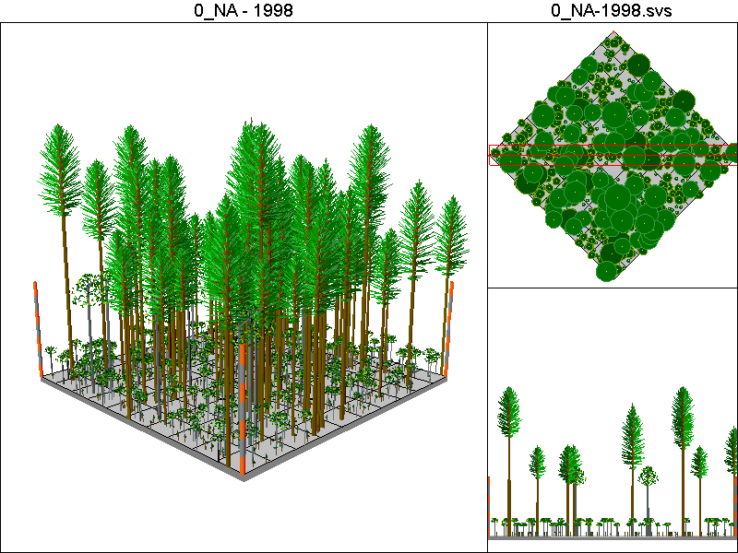

Stand Inventory Table:
Species | DBH | Height | CR | TPA
DF | 16.8 | 107.3 | 0.37 | 13
DF | 17.1 | 108.8 | 0.43 | 12.5
DF | 17.1 | 108.8 | 0.41 | 12.5
DF | 22.1 | 130.8 | 0.45 | 7.5
DF | 22.2 | 131.2 | 0.46 | 7.4
DF | 22.9 | 156 | 0.35 | 7
DF | 25.4 | 143 | 0.49 | 5.7
DF | 29.9 | 157.5 | 0.51 | 4.1
DF | 30.3 | 178 | 0.35 | 4
DF | 39.1 | 181.1 | 0.54 | 2.4
RA | 1.6 | 15.2 | 0.19 | 150
RA | 2.3 | 21 | 0.21 | 150
RA | 17.1 | 82.4 | 0.26 | 12.5
WH | 0.3 | 4.5 | 0.45 | 150
WH | 0.4 | 5.2 | 0.26 | 150
WH | 0.4 | 5.2 | 0.58 | 150

No Action Pathway

Harvest Operations:
None

Cover Type by Period:
1998 | C4
2003 | C4
2008 | C4
2013 | C4
2018 | C4
2023 | C4
2028 | C4
2033 | C4
2038 | C4
2043 | C4
2048 | C4
2053 | C4
2058 | C4
2063 | C4
2068 | C4
2073 | C4
2078 | C4
2083 | C4

Habitat Suitability Index for all four species:
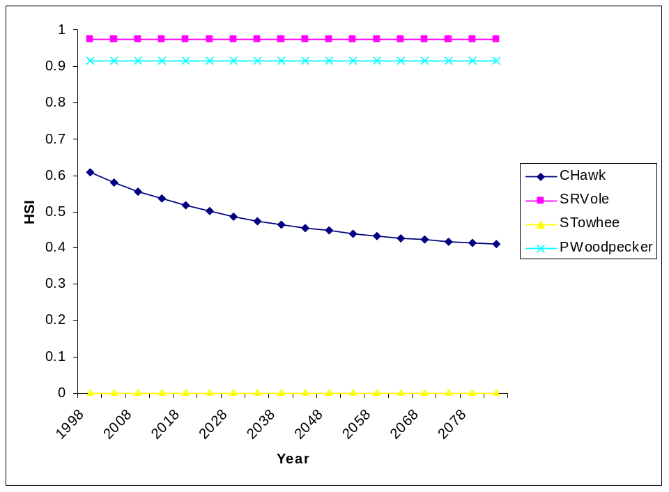
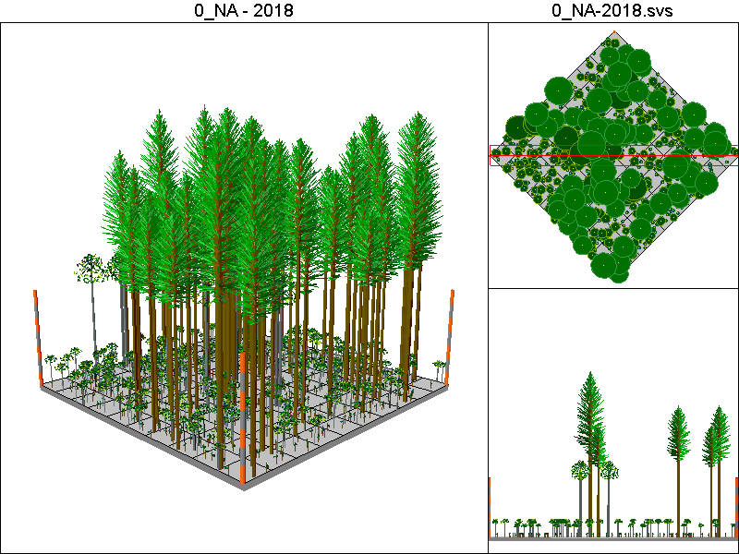
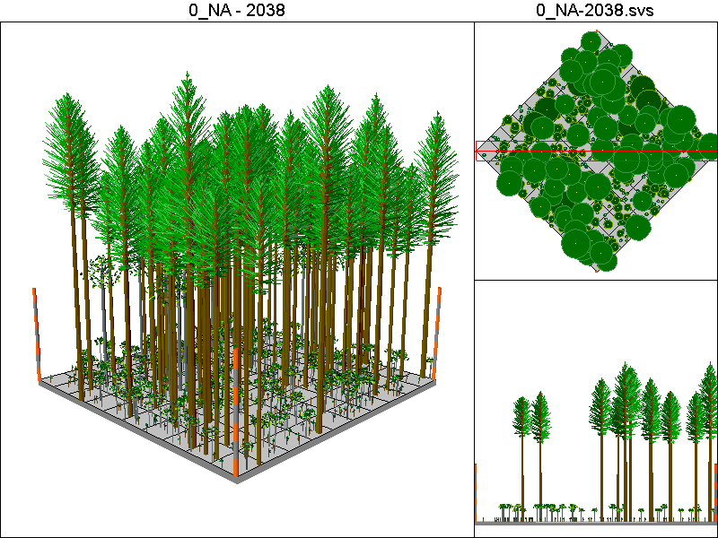
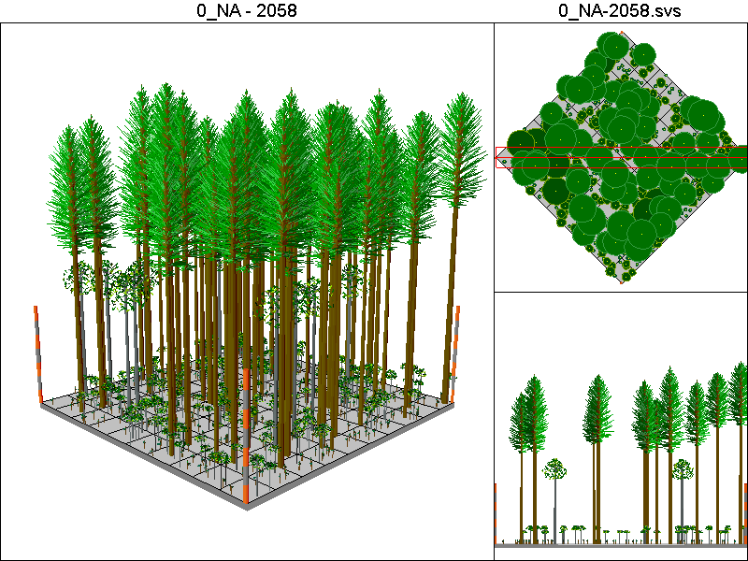
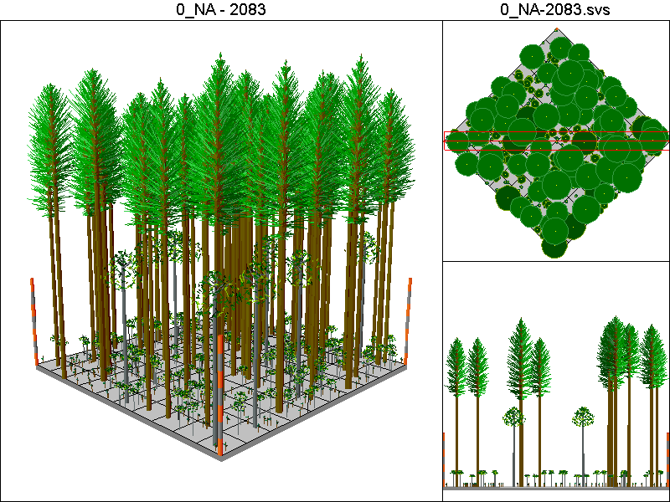

CC40_PCT Pathway

Harvest Operations:
2008: Harvest leaving 5 TPA, plant 400 TPA of Douglas-fir
2023: Thin to 300 TPA
2048: Harvest leaving 5 TPA, plant 400 TPA of Douglas-fir
2063: Thin to 300 TPA

Cover Type by Period:
1998 | C4
2003 | C4
2008 | C4T
2013 | B
2018 | C2
2023 | C3T
2028 | C3
2033 | C3
2038 | C3
2043 | C3
2048 | C4T
2053 | B
2058 | B
2063 | C3T
2068 | C3T
2073 | C3
2078 | C3
2083 | C3

Habitat Suitability Index values for all species:
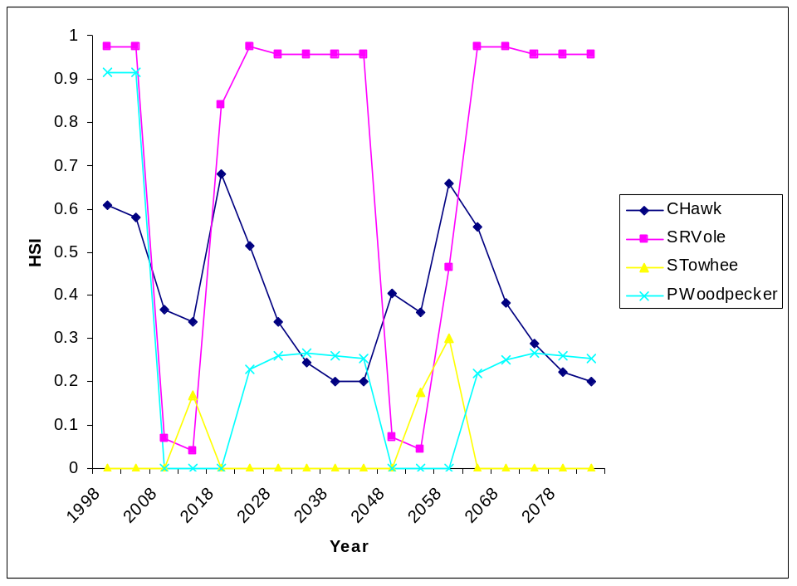
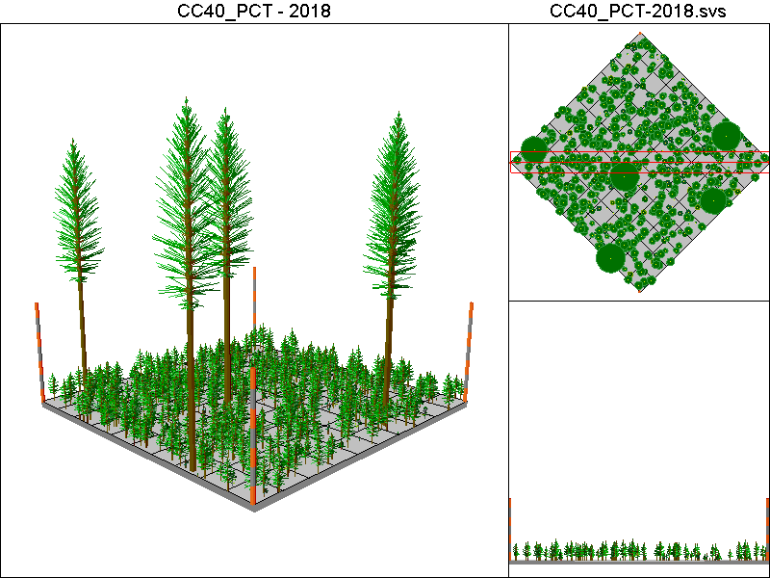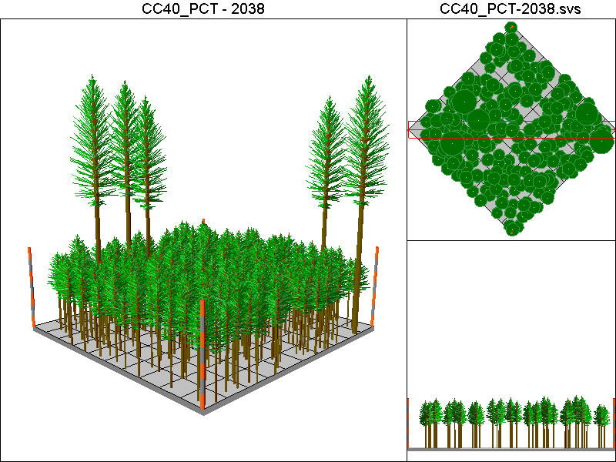
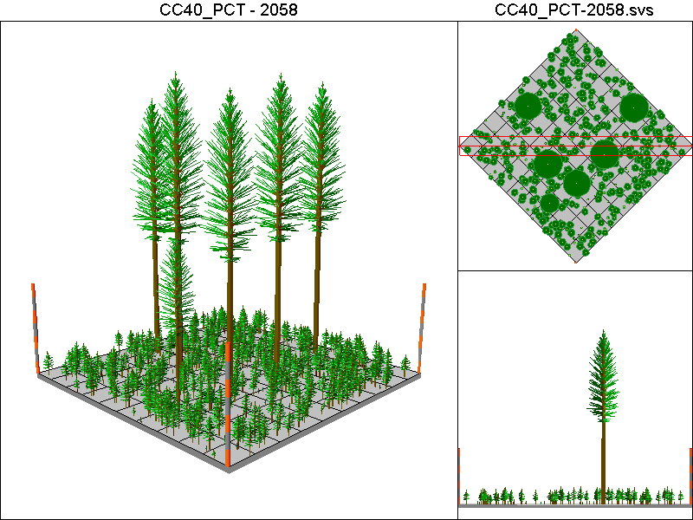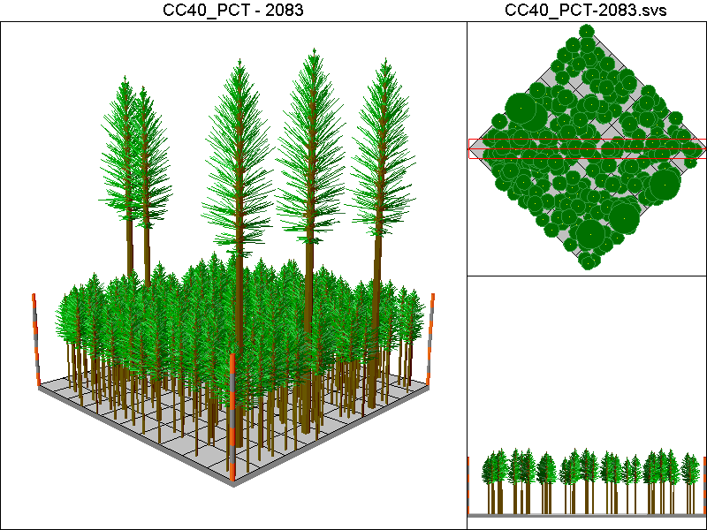

CC60_PCT_CT

Harvest Operations:
2008: Harvest leaving 5 TPA, plant 400 TPA of Douglas-fir
2023: Thin to 300 TPA
2038: Thin to 140ft²/ac of basal area
2068: Harvest leaving 5 TPA, plant 400 TPA of Douglas-fir

Cover Type by Period:
1998 | C4
2003 | C4
2008 | C4T
2013 | B
2018 | C2
2023 | C3T
2028 | C3
2033 | C3
2038 | C3T
2043 | C3T
2048 | C4T
2053 | C4T
2058 | C4T
2063 | C4T
2068 | C4T
2073 | B
2078 | B
2083 | C3T

Habitat Suitability Index values for all four species:
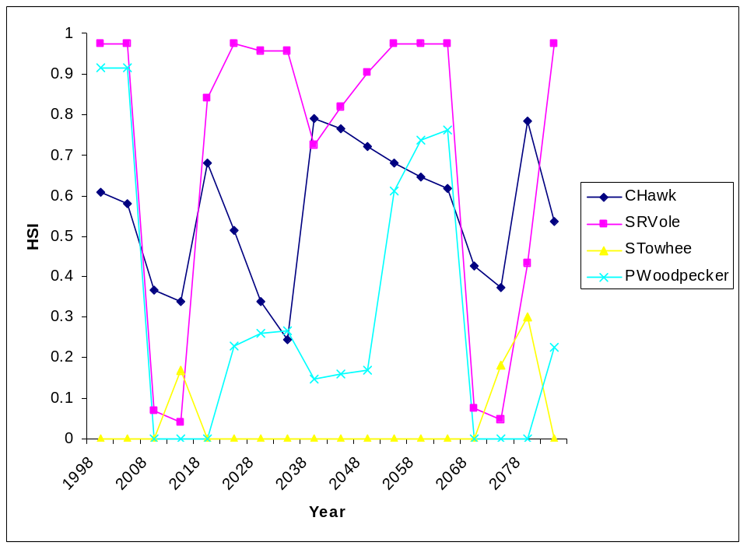
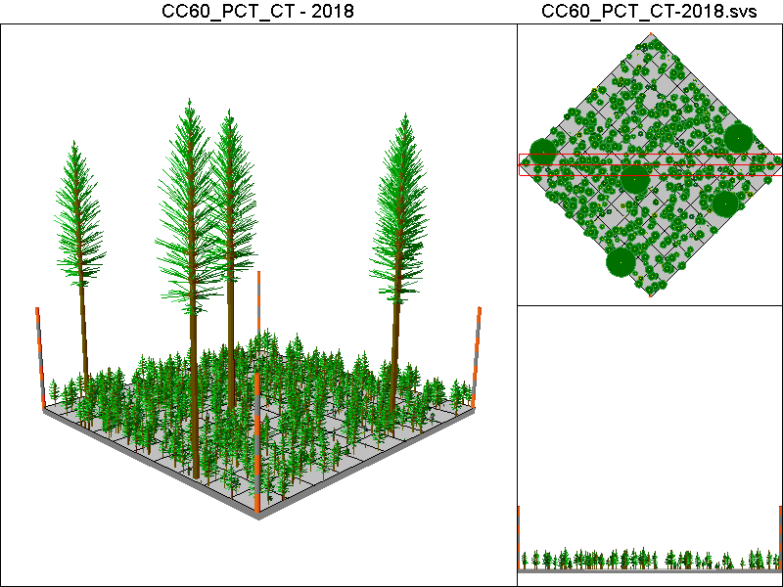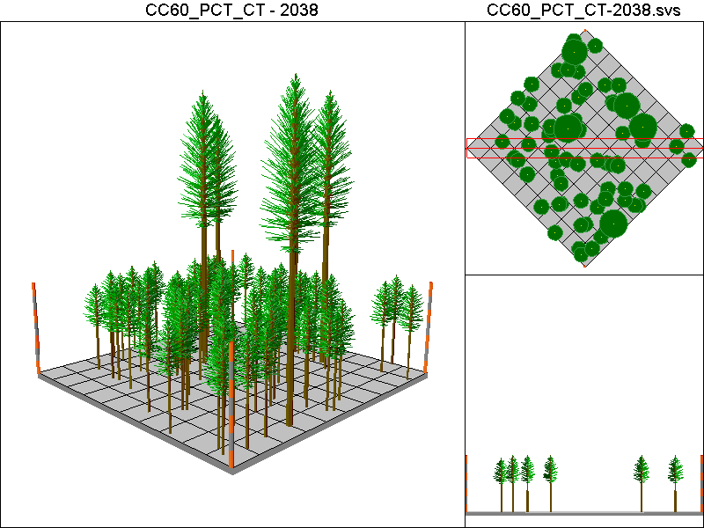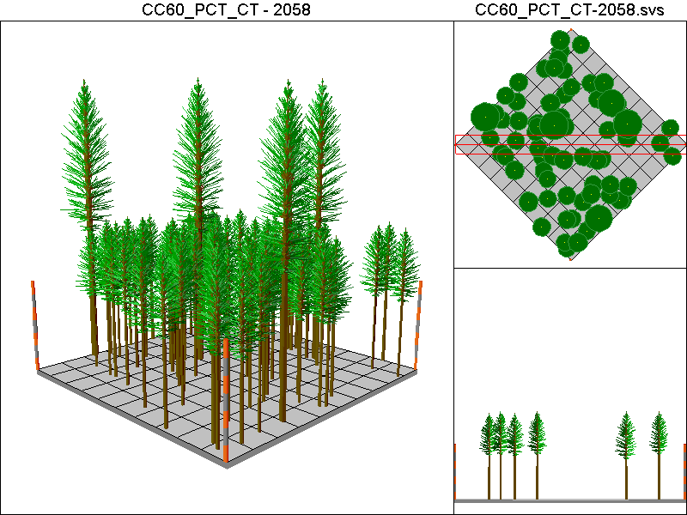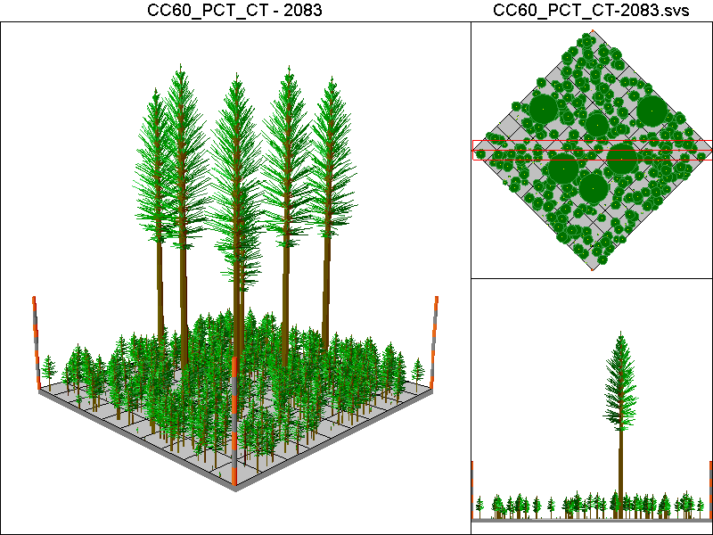

DEMO20 Pathway

Harvest Operations:
2008: Thin to 20% of the initial TPA

Cover Type by Period:
1998 | C4
2003 | C4
2008 | C4T
2013 | C4T
2018 | C4T
2023 | C4T
2028 | C4T
2033 | C4T
2038 | C4T
2043 | C4T
2048 | C4T
2053 | C4T
2058 | C4T
2063 | C4T
2068 | C4T
2073 | C4T
2078 | C4T
2083 | C4T

Habitat Suitability Index values for all four species:
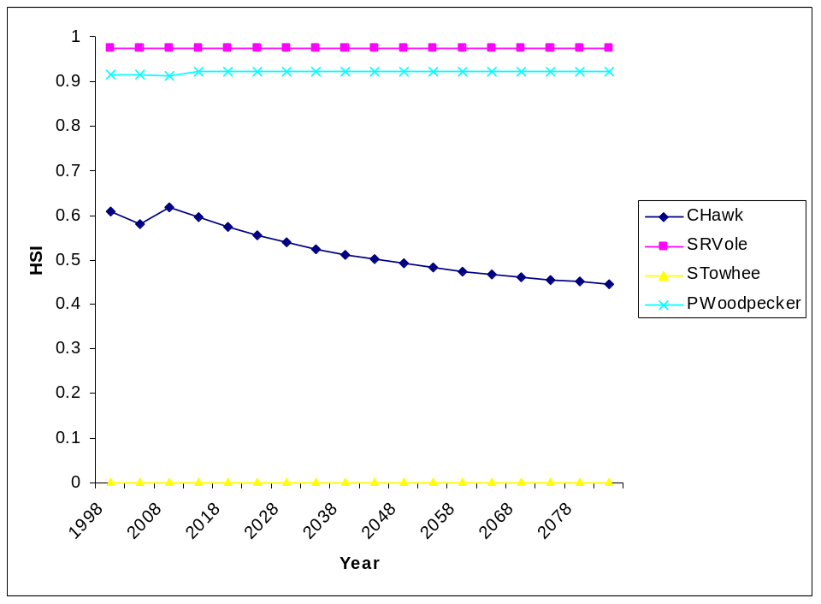
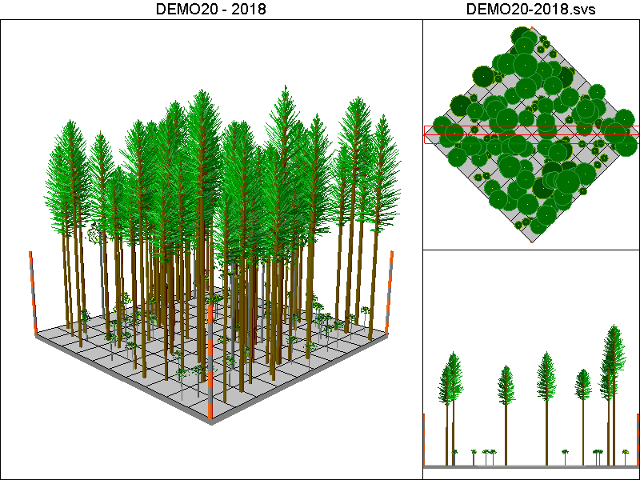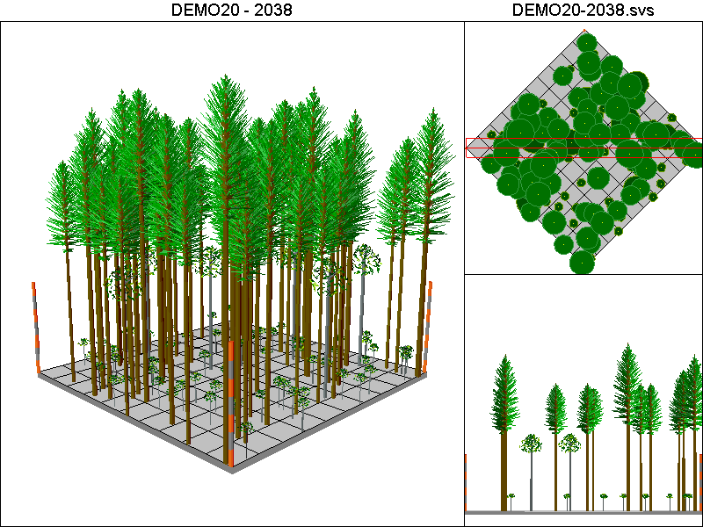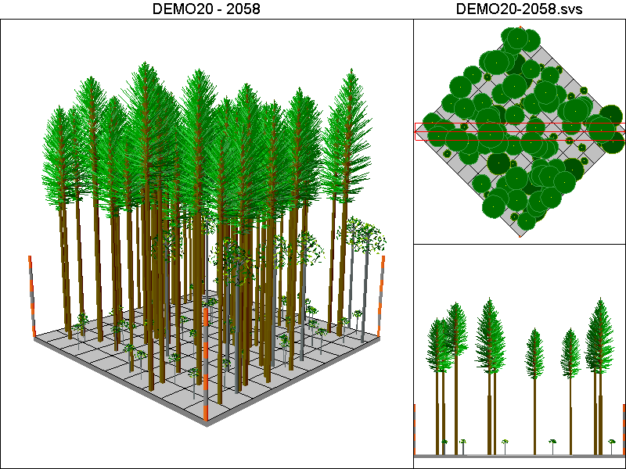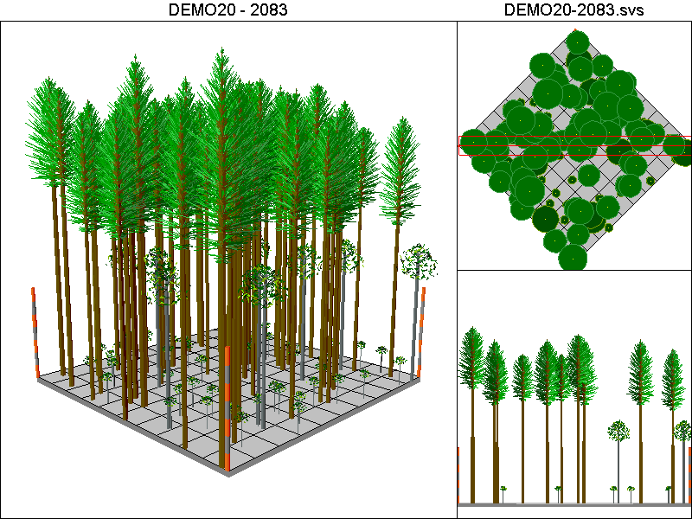

DEMO40 Pathway

Harvest Operations
2008: Thin to 40% of the original TPA

Cover Type by Period:
1998 | C4
2003 | C4
2008 | C4T
2013 | C4T
2018 | C4T
2023 | C4T
2028 | C4T
2033 | C4T
2038 | C4T
2043 | C4T
2048 | C4T
2053 | C4T
2058 | C4T
2063 | C4T
2068 | C4T
2073 | C4T
2078 | C4T
2083 | C4T

Habitat Suitability Index values for all four species:
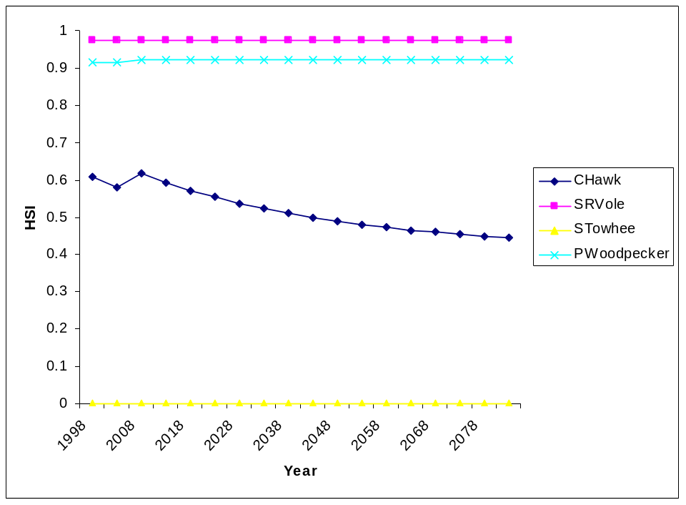
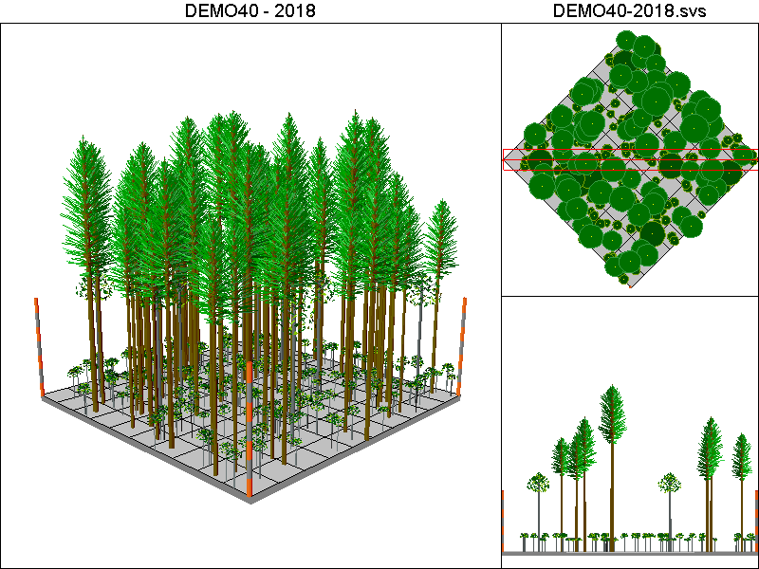
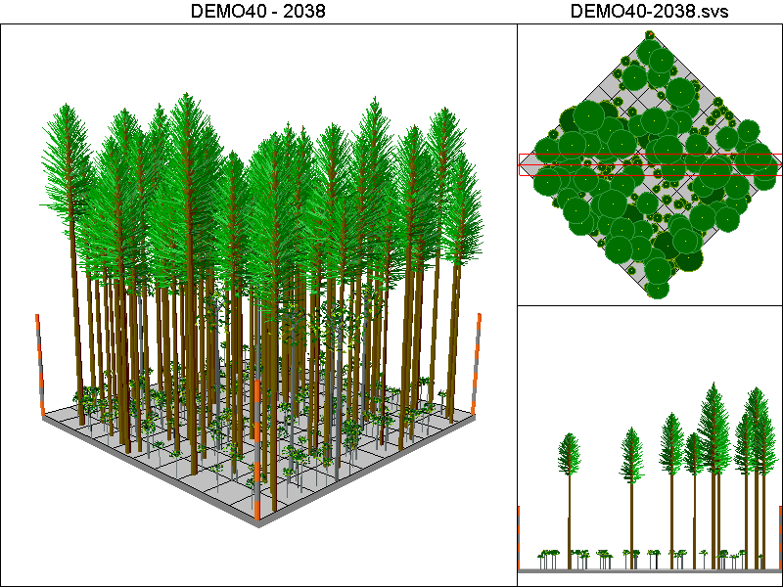
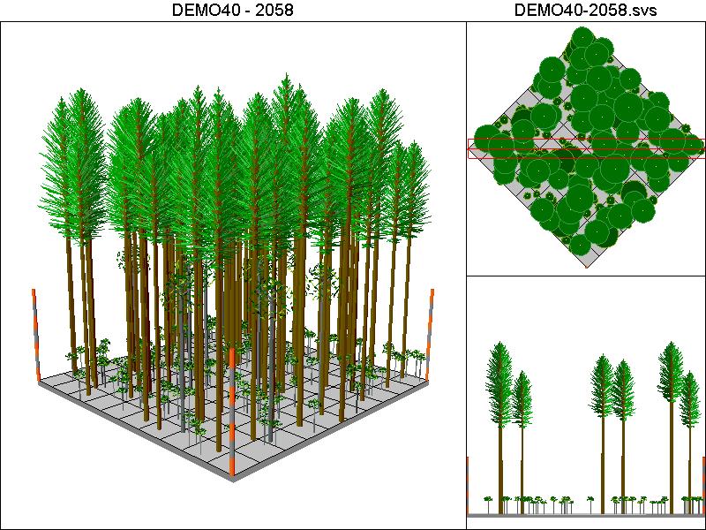
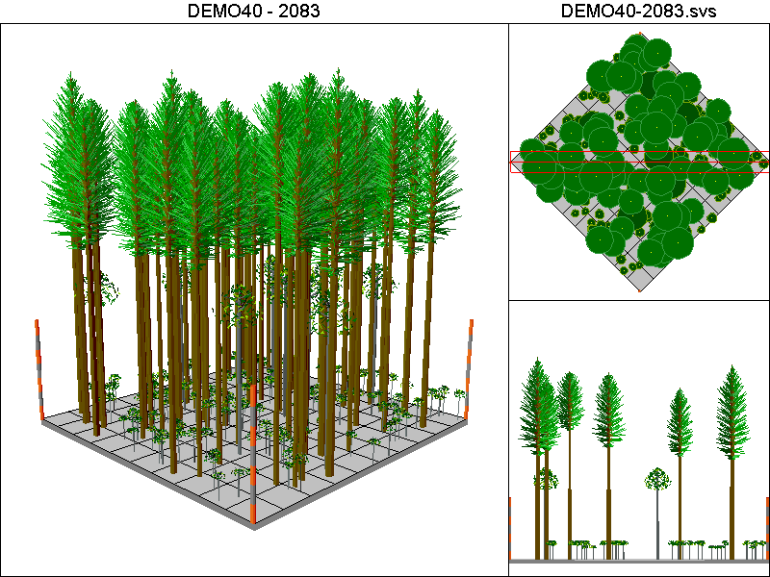

Hanseen10-40 Pathway:

Harvest Operations:
2008: Harvest leaving 4 TPA, plant 400 TPA of Douglas-fir
2023: Thin to 220 TPA <12”DBH leaving all trees >12”DBH
2038: Thin to 220 TPA <12”DBH leaving all trees >12”DBH
2048: Harvest leaving 4 TPA, plant 400 TPA of Douglas-fir
2063: Thin to 220 TPA <12”DBH leaving all trees >12”DBH
2078: Thin to 220 TPA <12”DBH leaving all trees >12”DBH

Cover Type by Period:
1998 | C4
2003 | C4
2008 | C4T
2013 | B
2018 | C2
2023 | C2
2028 | C3T
2033 | C3
2038 | C3
2043 | C3
2048 | C4T
2053 | B
2058 | B
2063 | C3T
2068 | C3T
2073 | C3T
2078 | C3
2083 | C3

Habitat Suitability Index values for all four species:
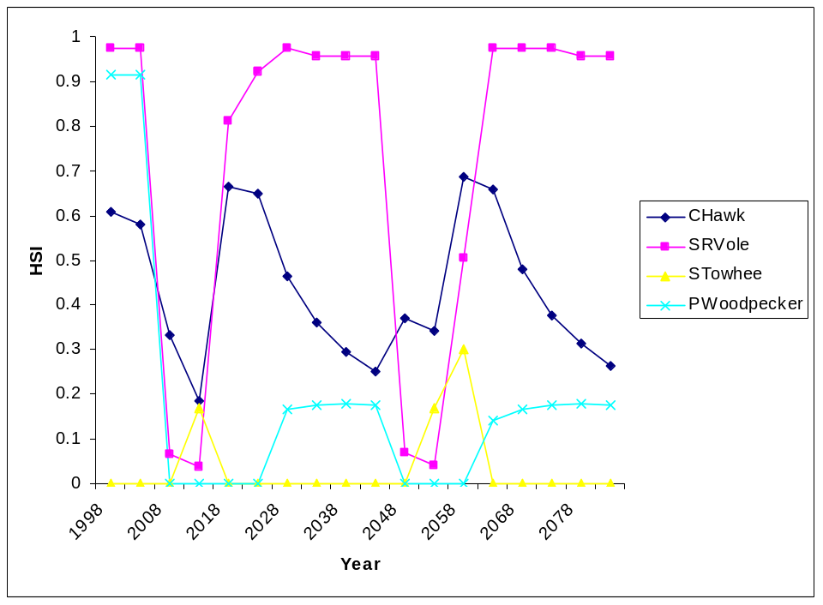
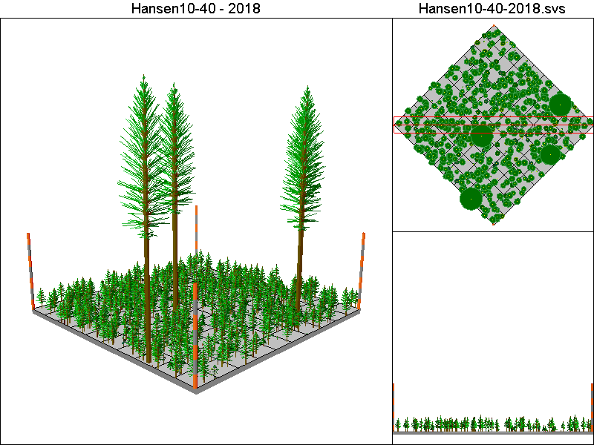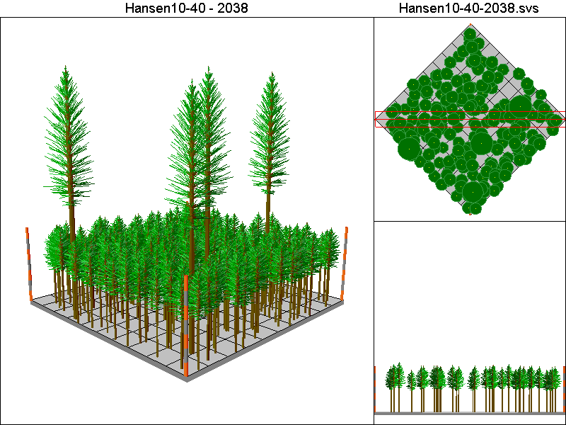
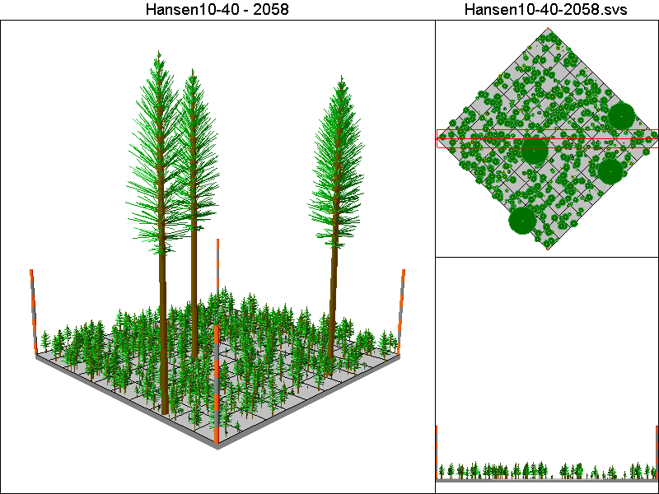
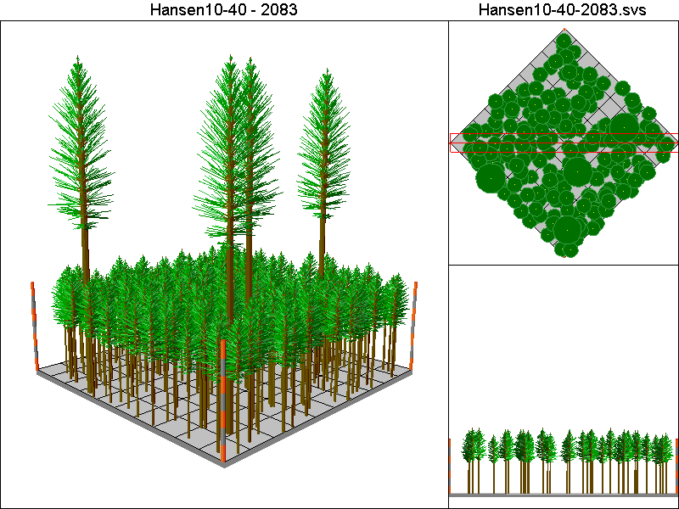

Hansen150-120 Pathway

Harvest Operations:
2008: Thin to 60 TPA, plant 400 TPA of Douglas-fir
2023: Thin to 220 TPA <12”DBH leaving all trees >12”DBH
2038: Thin to 220 TPA <12”DBH leaving all trees >12”DBH

Cover Type by Period:
1998 | C4
2003 | C4
2008 | C4T
2013 | C4T
2018 | C4T
2023 | C4T
2028 | C4T
2033 | C4T
2038 | C4T
2043 | C4T
2048 | C4T
2053 | C4T
2058 | C4T
2063 | C4T
2068 | C4T
2073 | C4T
2078 | C4T
2083 | C4T

Habitat Suitability Index values for all four species:
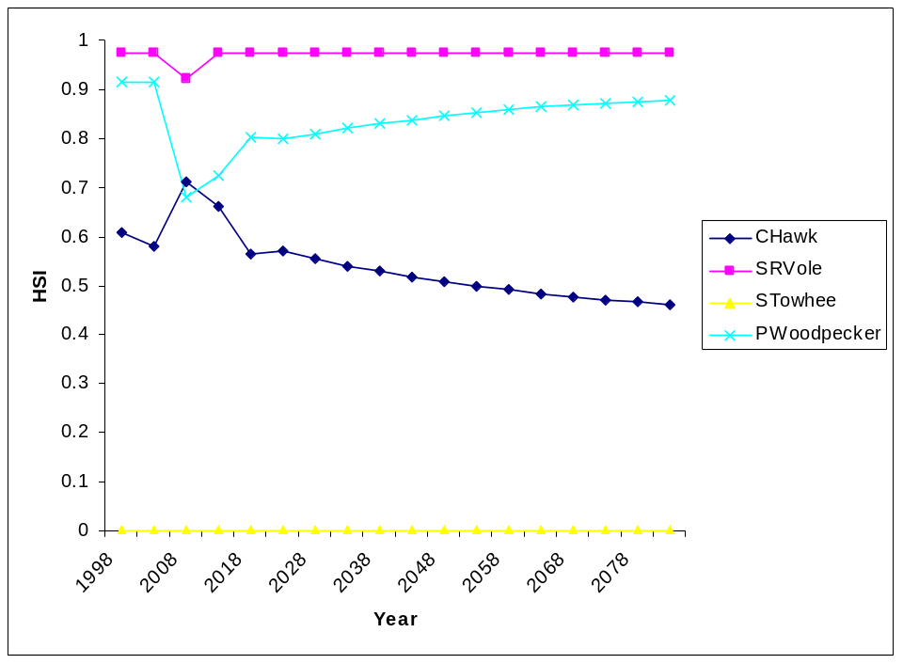
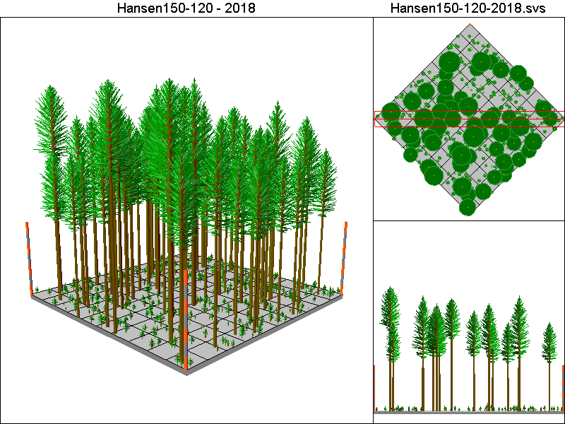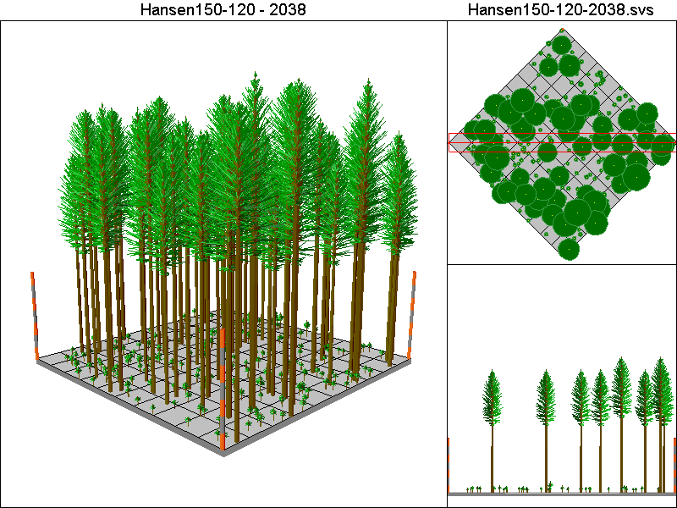
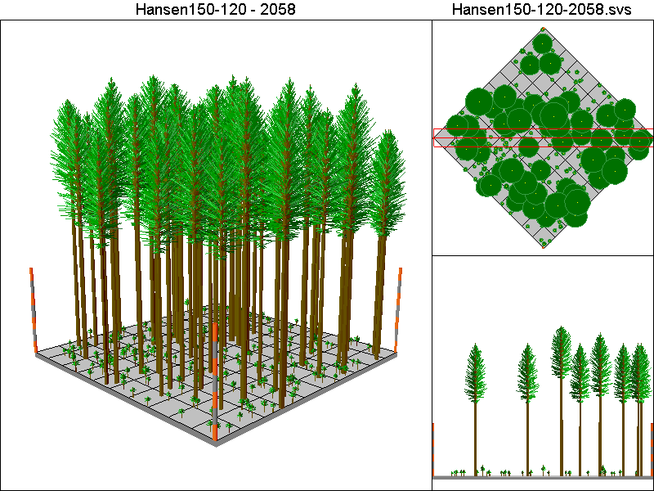
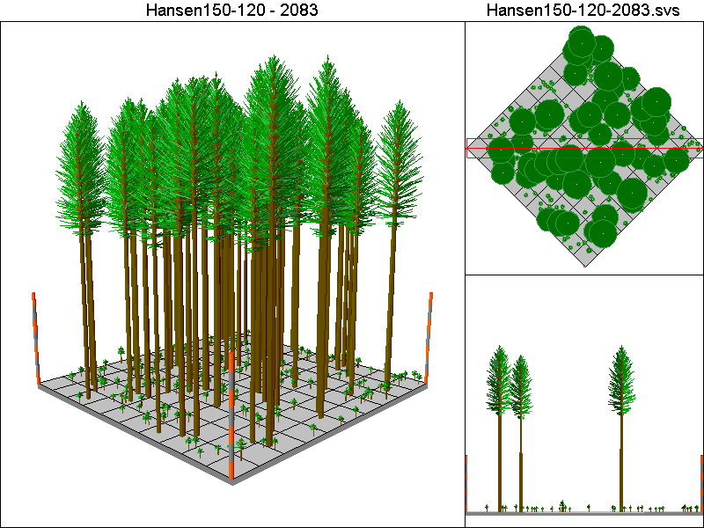

Hansen150-40 Pathway

Harvest Operations:
2008: Thin to 60 TPA, plant 400 TPA of Douglas-fir
2023: Thin to 220 TPA <12”DBH leaving all trees >12”DBH
2038: Thin to 220 TPA <12”DBH leaving all trees >12”DBH
2048: Thin to 60 TPA, plant 400 TPA of Douglas-fir
2063: Thin to 220 TPA <12”DBH leaving all trees >12”DBH
2078: Thin to 220 TPA <12”DBH leaving all trees >12”DBH

Cover Type by Period:
1998 | C4
2003 | C4
2008 | C4T
2013 | C4T
2018 | C4T
2023 | C4T
2028 | C4T
2033 | C4T
2038 | C4T
2043 | C4T
2048 | C4T
2053 | C4T
2058 | C4T
2063 | C4T
2068 | C4T
2073 | C4T
2078 | C4T
2083 | C4T

Habitat Suitability Index values for all four species:
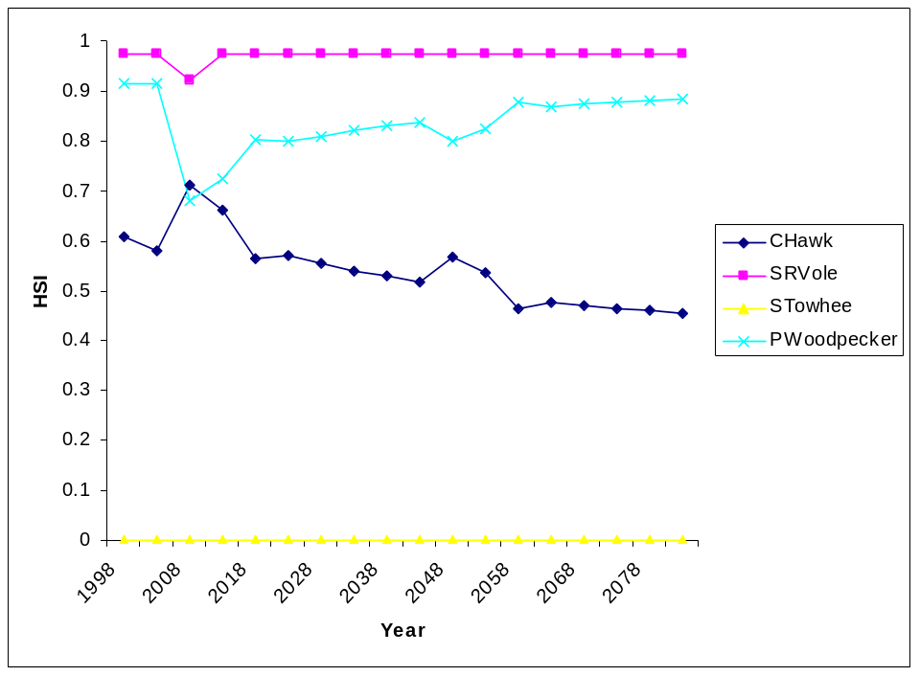
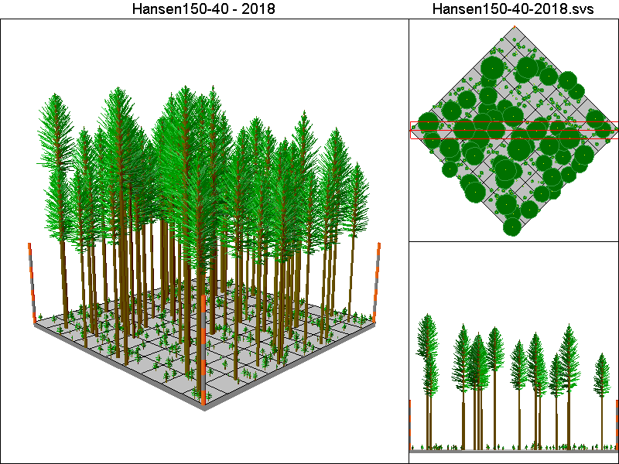
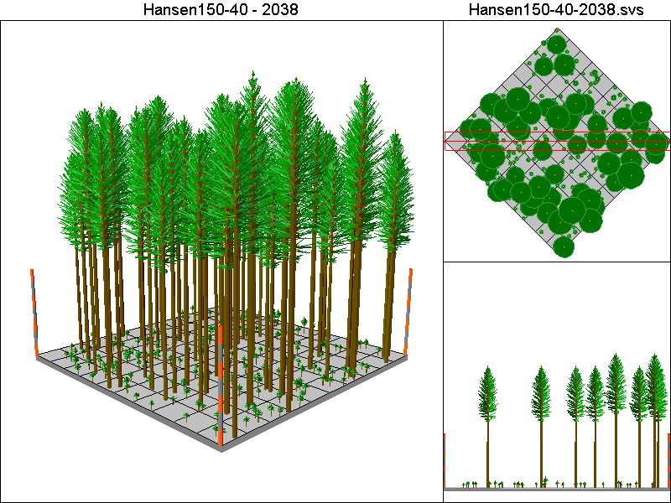
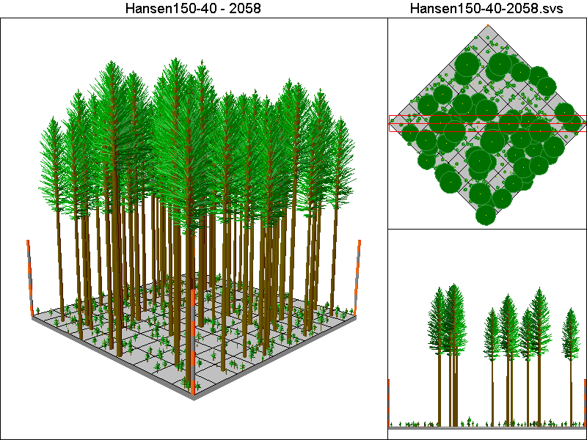
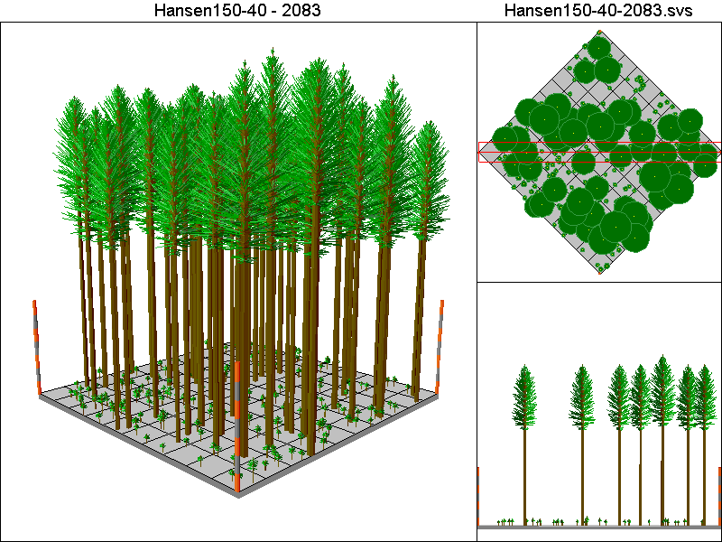

Hansen150-80 Pathway

Harvest Operations:
2008: Thin to 60 TPA, plant 400 TPA of Douglas-fir
2023: Thin to 220 TPA <12”DBH leaving all trees >12”DBH
2038: Thin to 220 TPA <12”DBH leaving all trees >12”DBH

Cover Type by Period:
1998 | C4
2003 | C4
2008 | C4T
2013 | C4T
2018 | C4T
2023 | C4T
2028 | C4T
2033 | C4T
2038 | C4T
2043 | C4T
2048 | C4T
2053 | C4T
2058 | C4T
2063 | C4T
2068 | C4T
2073 | C4T
2078 | C4T
2083 | C4T

Habitat Suitability Index values for all four species:
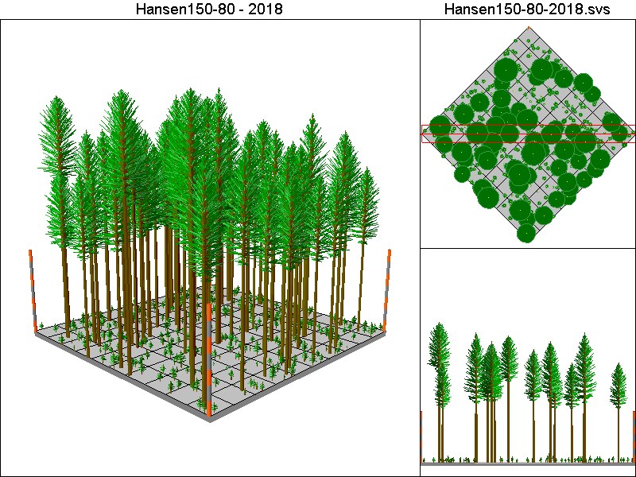
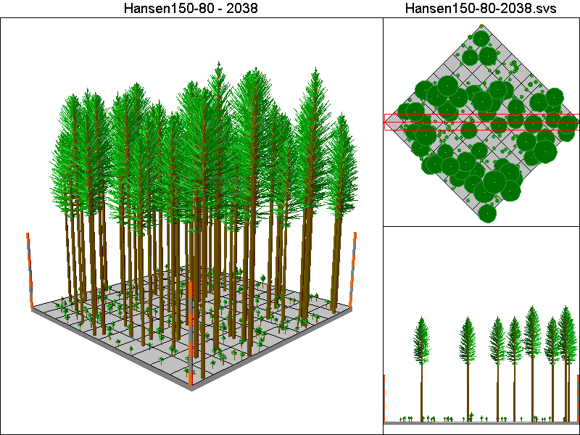
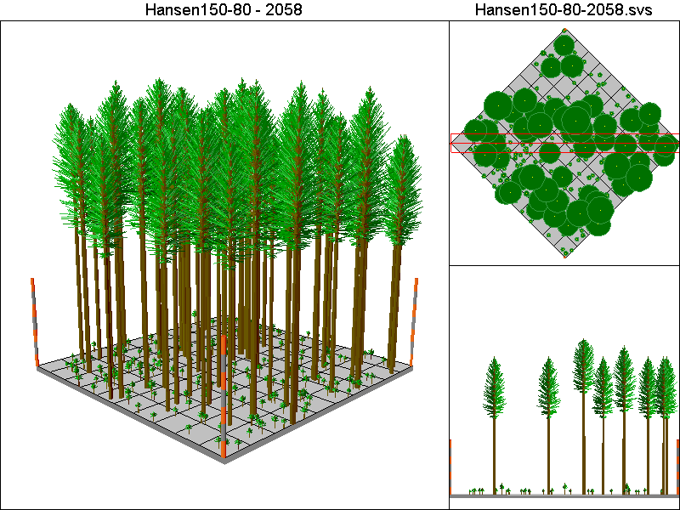
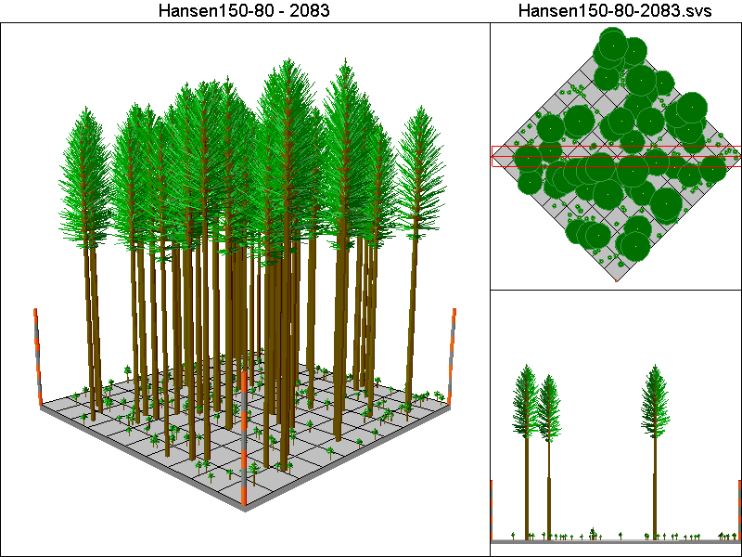

Hansen30-40 Pathway

Harvest Operations:
2008: Thin to 12 TPA, plant 400 TPA of Douglas-fir
2023: Thin to 220 TPA <12”DBH leaving all trees >12”DBH
2038: Thin to 220 TPA <12”DBH leaving all trees >12”DBH
2048: Thin to 12 TPA, plant 400 TPA of Douglas-fir
2063: Thin to 220 TPA <12”DBH leaving all trees >12”DBH
2078: Thin to 220 TPA <12”DBH leaving all trees >12”DBH

Cover Type by Period:
1998 | C4
2003 | C4
2008 | C4T
2013 | B
2018 | C3T
2023 | C3T
2028 | C3T
2033 | C3T
2038 | C4T
2043 | C4T
2048 | C4T
2053 | C3T
2058 | C3T
2063 | C3T
2068 | C3T
2073 | C4T
2078 | C4T
2083 | C4T

Habitat Suitability Index values for all four species:
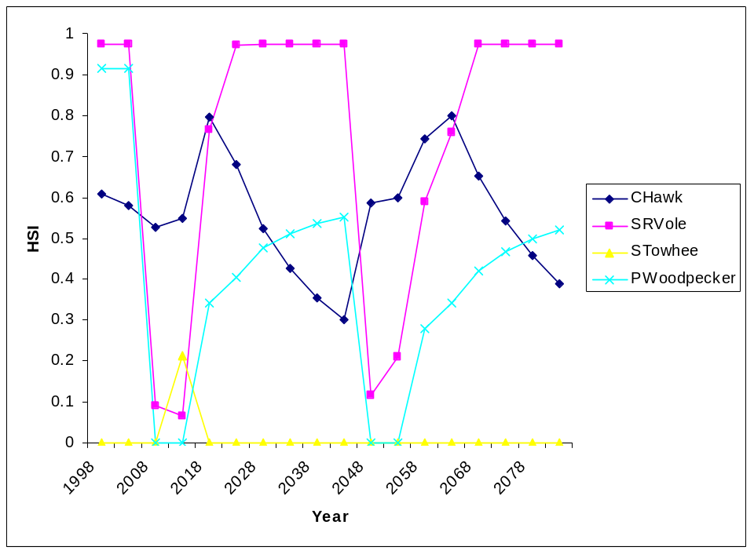
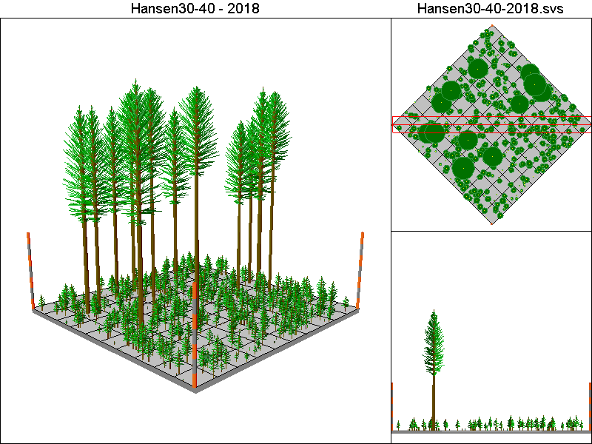
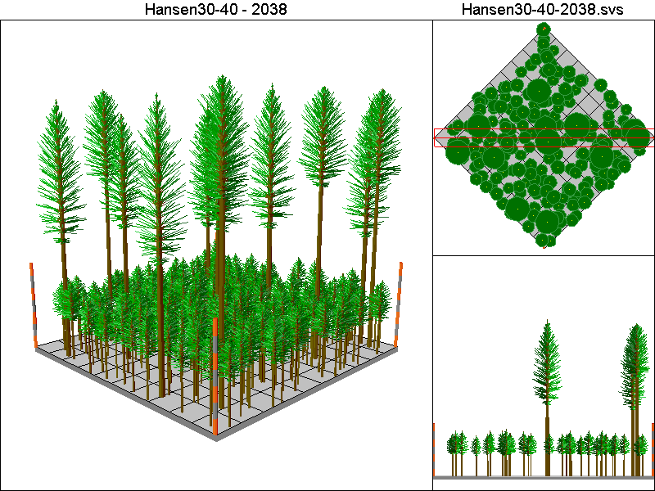
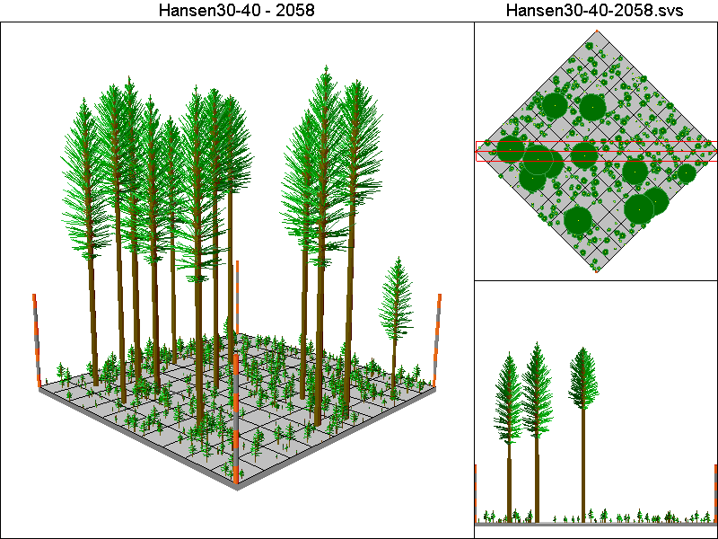
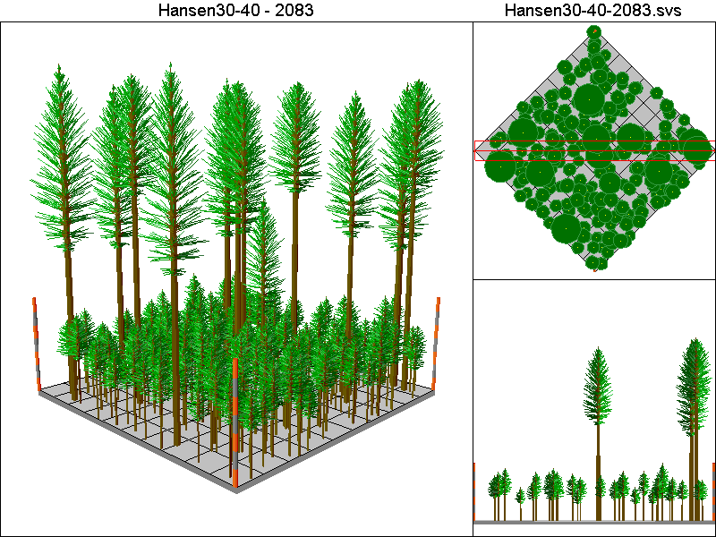

Hansen50-40 Pathway

Harvest Operations:
2008: Thin to 20 TPA, plant 400 TPA of Douglas-fir
2023: Thin to 220 TPA <12”DBH leaving all trees >12”DBH
2038: Thin to 220 TPA <12”DBH leaving all trees >12”DBH
2048: Thin to 20 TPA, plant 400 TPA of Douglas-fir
2063: Thin to 220 TPA <12”DBH leaving all trees >12”DBH
2078: Thin to 220 TPA <12”DBH leaving all trees >12”DBH

Cover Type by Period:
1998 | C4
2003 | C4
2008 | C4T
2013 | C3T
2018 | C3T
2023 | C3T
2028 | C4T
2033 | C4T
2038 | C4T
2043 | C4T
2048 | C4T
2053 | C3T
2058 | C4T
2063 | C4T
2068 | C4T
2073 | C4T
2078 | C4T
2083 | C4T

Habitat Suitability Index values for all four species:
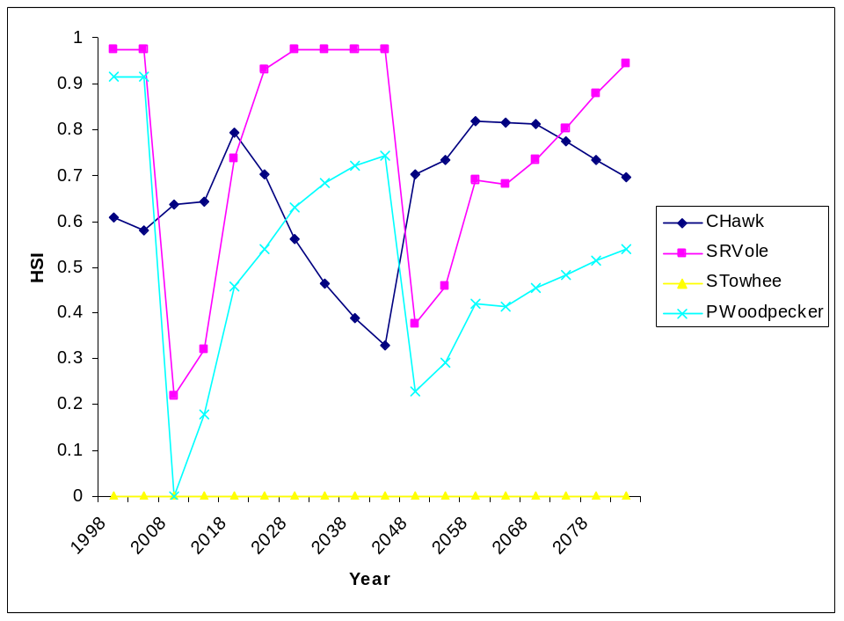
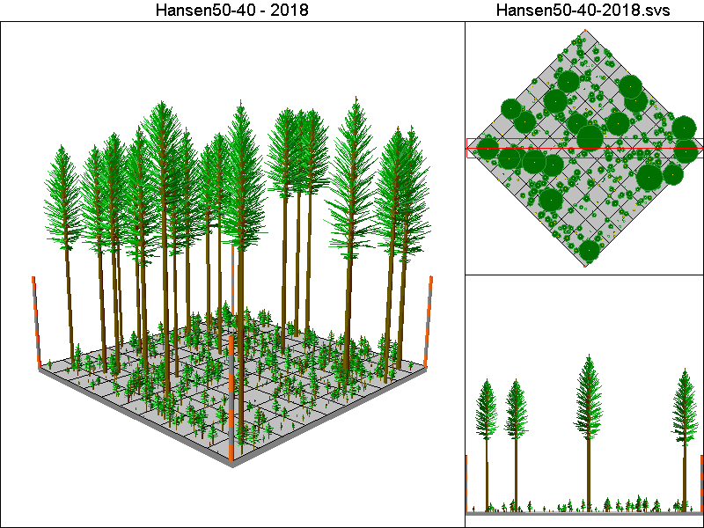
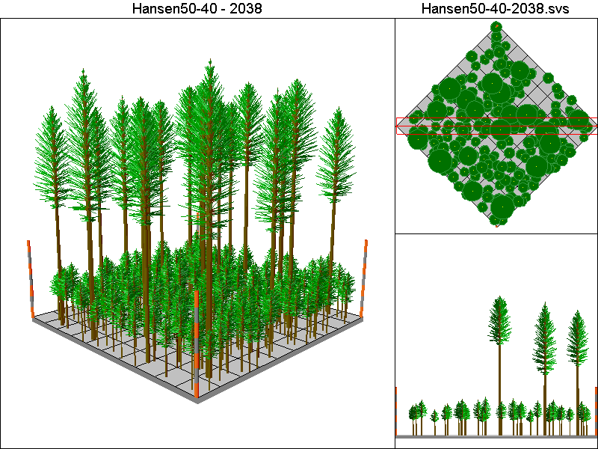

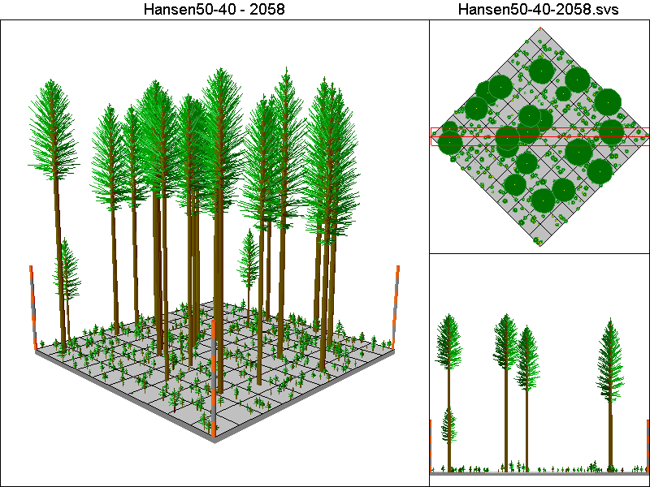
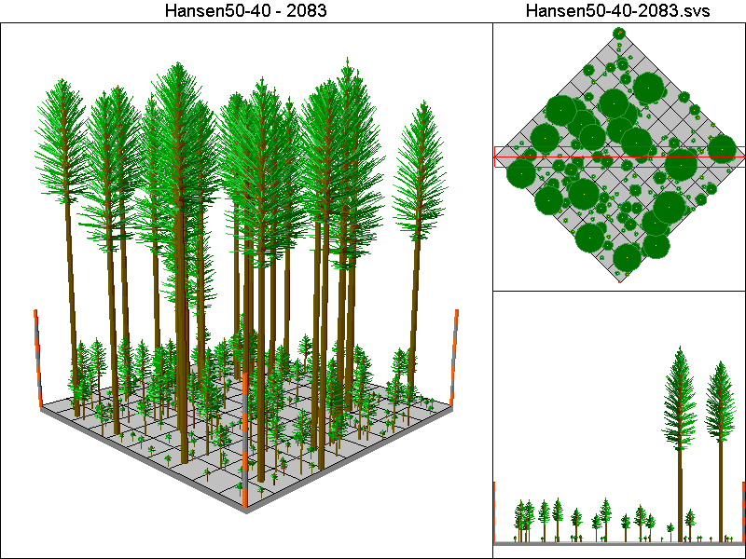

Hansen5-40 Pathway

Harvest Operations:
2008: Thin to 2 TPA, plant 400 TPA of Douglas-fir
2023: Thin to 220 TPA <12”DBH leaving all trees >12”DBH
2038: Thin to 220 TPA <12”DBH leaving all trees >12”DBH
2048: Thin to 2 TPA, plant 400 TPA of Douglas-fir
2063: Thin to 220 TPA <12”DBH leaving all trees >12”DBH
2078: Thin to 220 TPA <12”DBH leaving all trees >12”DBH

Cover Type by Period:
1998 | C4
2003 | C4
2008 | C4T
2013 | C1
2018 | C2
2023 | C2
2028 | C3T
2033 | C3
2038 | C3
2043 | C3
2048 | C4T
2053 | B
2058 | C2
2063 | C2
2068 | C3T
2073 | C3
2078 | C3
2083 | C3

Habitat Suitability index values for all four species:
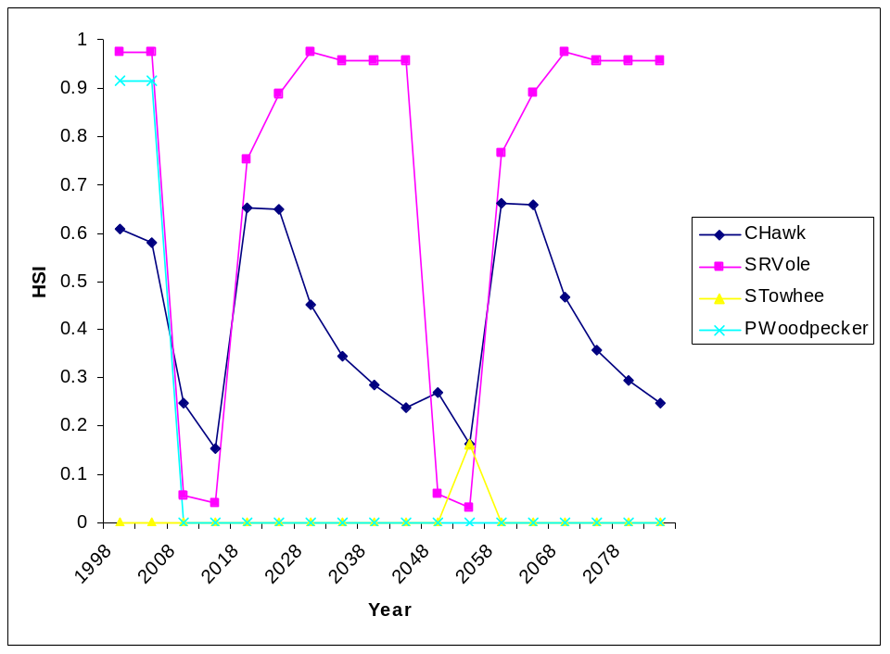
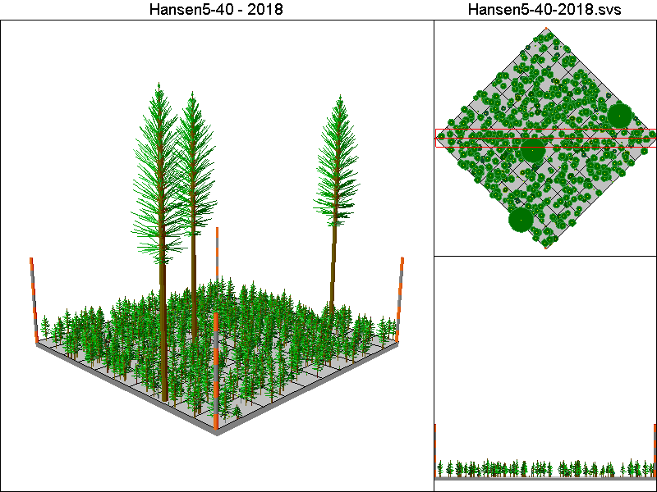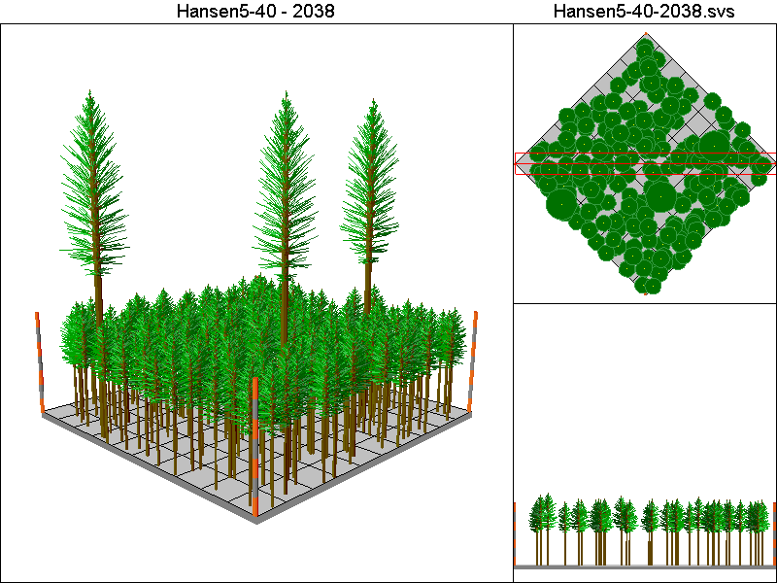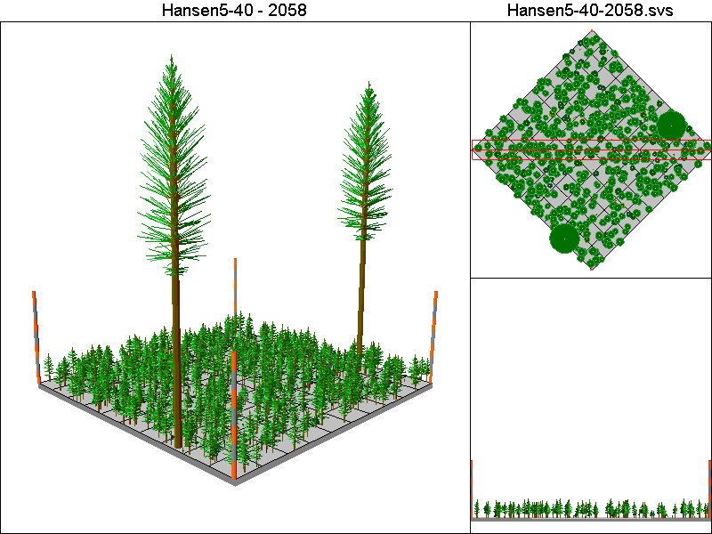
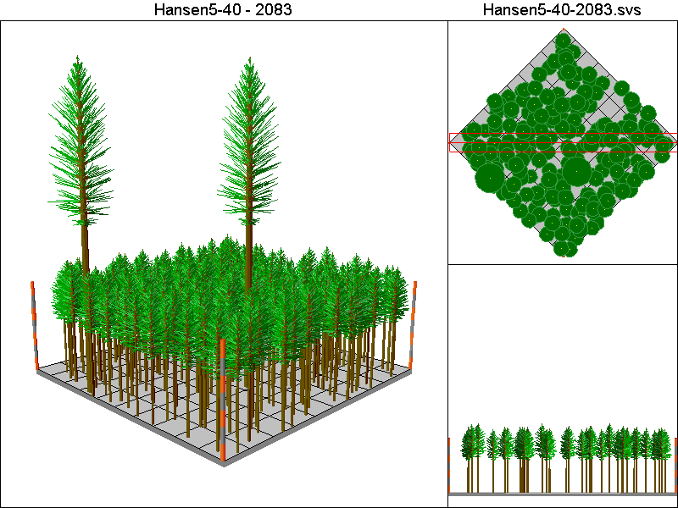

Marzluff-IE-G2 Pathway

Harvest Operations:
2008: Thin to 25 TPA in 8” – 20”DBH class, thin to 25 TPA >20”DBH
2084: Thin to 25 TPA in 8” – 20”DBH class

Cover Type by Period:
1998 | C4
2003 | C4
2008 | C4T
2013 | C4T
2018 | C4T
2023 | C4T
2028 | C4T
2033 | C4T
2038 | C4T
2043 | C4T
2048 | C4T
2053 | C4T
2058 | C4T
2063 | C4T
2068 | C4T
2073 | C4T
2078 | C4T
2083 | C4T

Habitat Suitability Index values for all four species:
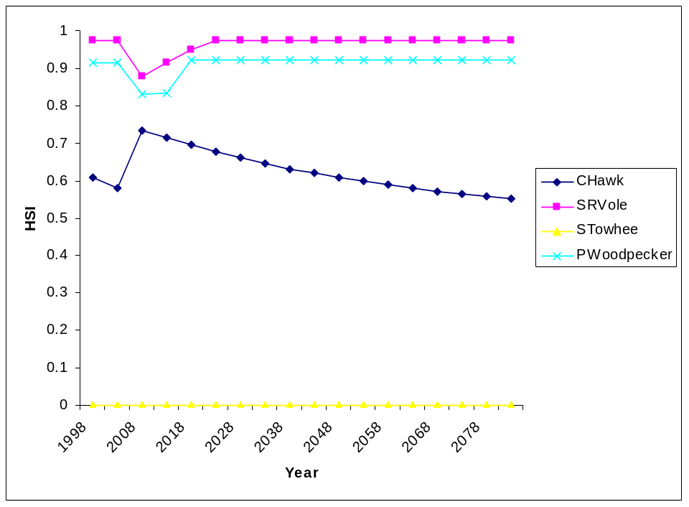

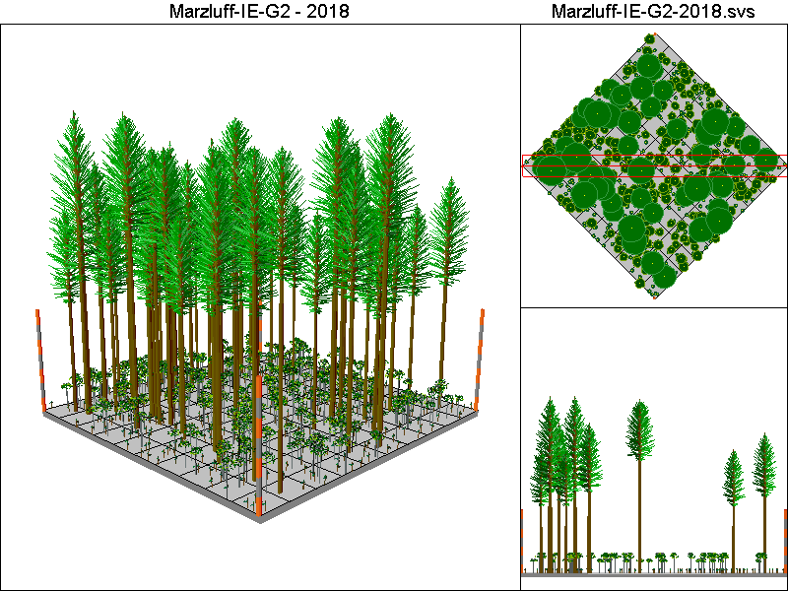
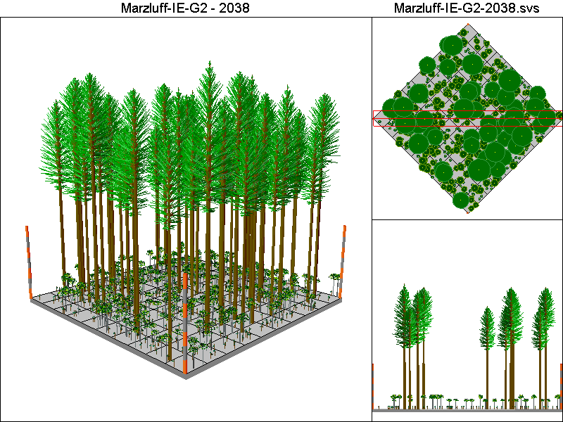
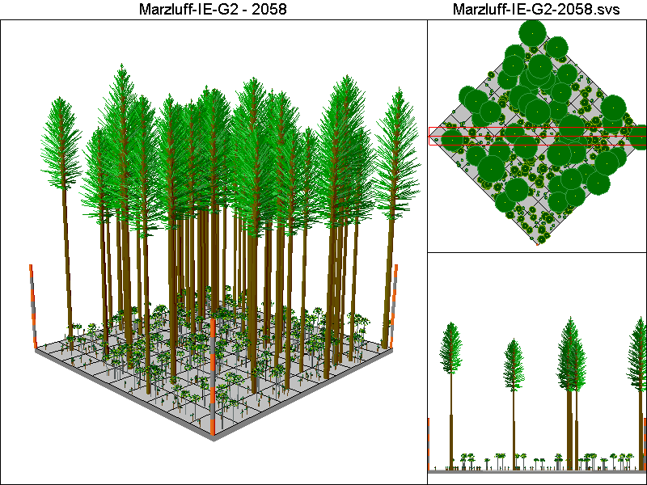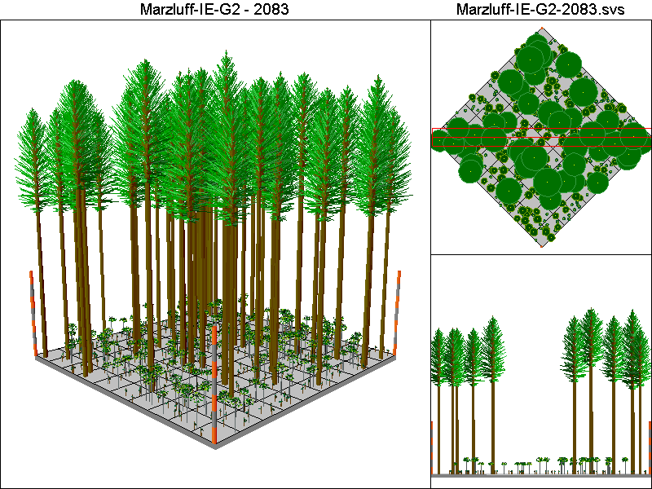

McCombMS Pathway

Harvest Operations:
2008: Thin to 24% of initial TPA, plant 16 TPA of Douglas-fir and 104 TPA of western hemlock
2033: Thin to 84% of initial TPA >12”DBH, thin to 55% of initial TPA <12”DBH, plant 16 TPA of Douglas-fir and 104 TPA of western hemlock
2058: Thin to 84% of initial TPA >12”DBH, thin to 55% of initial TPA <12”DBH, plant 16 TPA of Douglas-fir and 104 TPA of western hemlock
2083: Thin to 84% of initial TPA >12”DBH, thin to 55% of initial TPA <12”DBH, plant 16 TPA of Douglas-fir and 104 TPA of western hemlock

Cover Type by Period:
1998 | C4
2003 | C4
2008 | C4T
2013 | C4T
2018 | C4T
2023 | C4T
2028 | C4T
2033 | C4T
2038 | C4T
2043 | C4T
2048 | C4T
2053 | C4T
2058 | C4T
2063 | C4T
2068 | C4T
2073 | C4T
2078 | C4T
2083 | C4T

Habitat Suitability Index values for all four species:
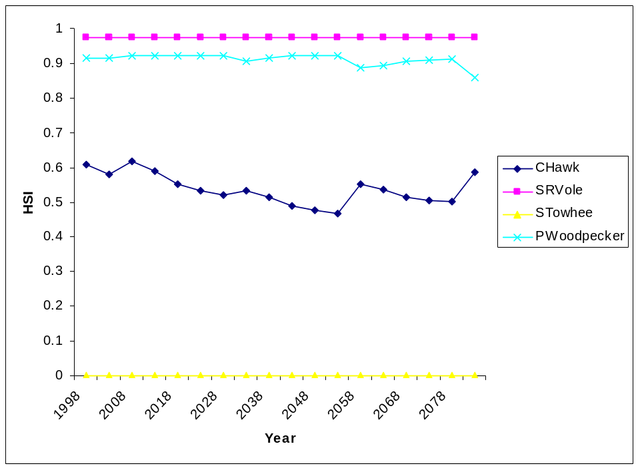
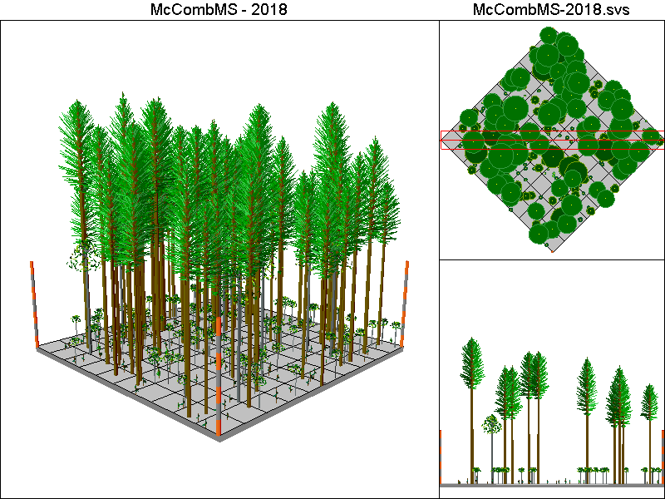
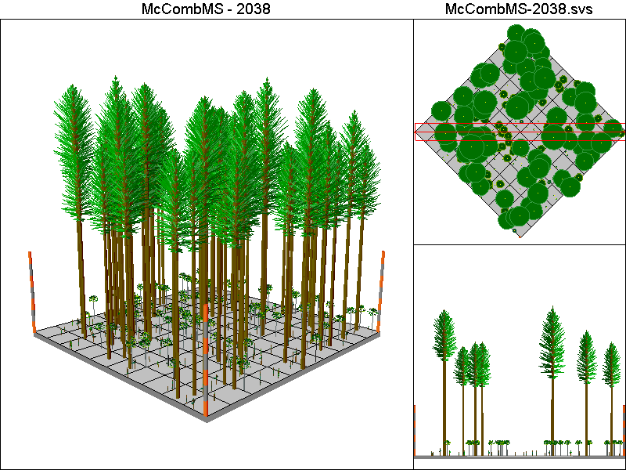
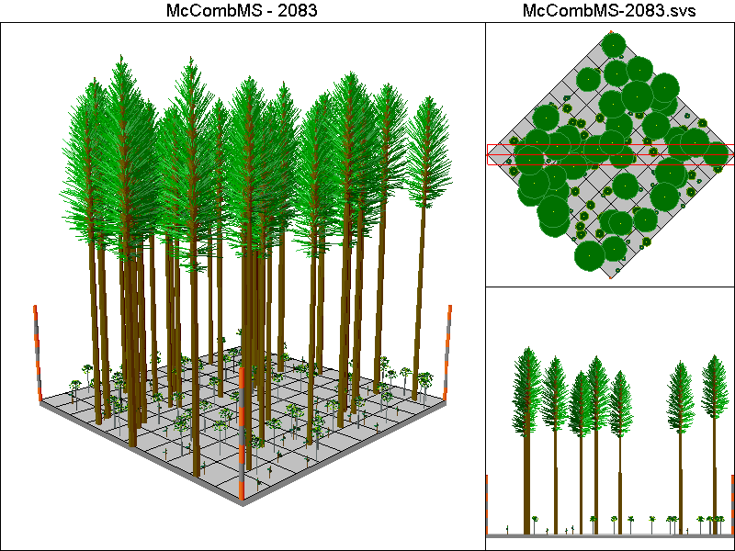

McCombSS Pathway

Harvest Operations:
2008: Harvest leaving 2 TPA, stand is allowed to regenerate naturally
2053: Thin to 70% of initial TPA <12”DBH
2078: Harvest leaving 2 TPA, stand is allowed to regenerate naturally

Cover Type by Period:
1998 | C4
2003 | C4
2008 | C4T
2013 | C1
2018 | B
2023 | B
2028 | C2
2033 | C3T
2038 | C3
2043 | C3
2048 | C4T
2053 | C4
2058 | C4
2063 | C4
2068 | C4
2073 | C4T
2078 | C4T
2083 | C1

Habitat Suitability Index values for all four species:


