C4T Group

Initial Conditions

Stands Age: 90 years
Site index: 120
Stand Density: 152 TPA

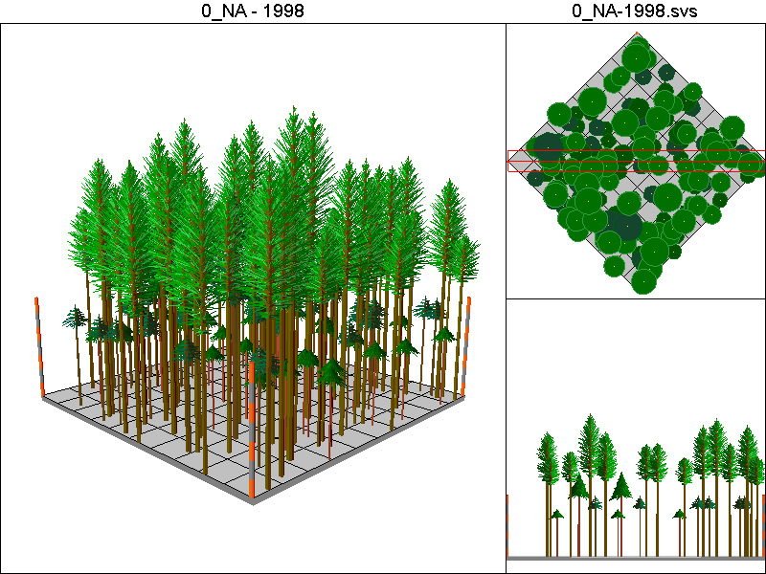

Stand Inventory Table:
Species | DBH | Height | CR | TPA
DF | 18 | 113.1 | 0.28 | 11.3
DF | 19.5 | 120 | 0.3 | 9.6
DF | 21.4 | 128 | 0.33 | 8
DF | 21.7 | 129.2 | 0.35 | 7.8
DF | 24.6 | 163 | 0.55 | 6.1
DF | 25.2 | 142.3 | 0.4 | 5.8
DF | 27.4 | 149.7 | 0.42 | 4.9
DF | 30 | 157.7 | 0.43 | 4.1
DF | 31.9 | 163.2 | 0.45 | 3.6
DF | 32 | 163.5 | 0.46 | 3.6
DF | 33.5 | 167.5 | 0.48 | 3.3
DF | 38 | 178.6 | 0.5 | 2.5
DF | 43.6 | 190.5 | 0.51 | 1.9
DF | 43.6 | 190.5 | 0.51 | 1.9
RC | 10.1 | 54.1 | 0.1 | 36
RC | 24.2 | 96.8 | 0.23 | 6.3
WH | 10.6 | 69.3 | 0.2 | 32.6
WH | 33.7 | 153.5 | 0.48 | 3.2

No Action Pathway

Harvest Operations:
None

Cover Type by Period:
1998 | C4T
2003 | C4T
2008 | C4T
2013 | C4T
2018 | C4T
2023 | C4T
2028 | C4T
2033 | C4T
2038 | C4T
2043 | C4T
2048 | C4T
2053 | C4T
2058 | C4T
2063 | C4T
2068 | C4T
2073 | C4T
2078 | C4T
2083 | C4T

Habitat Suitability Index for all four species:
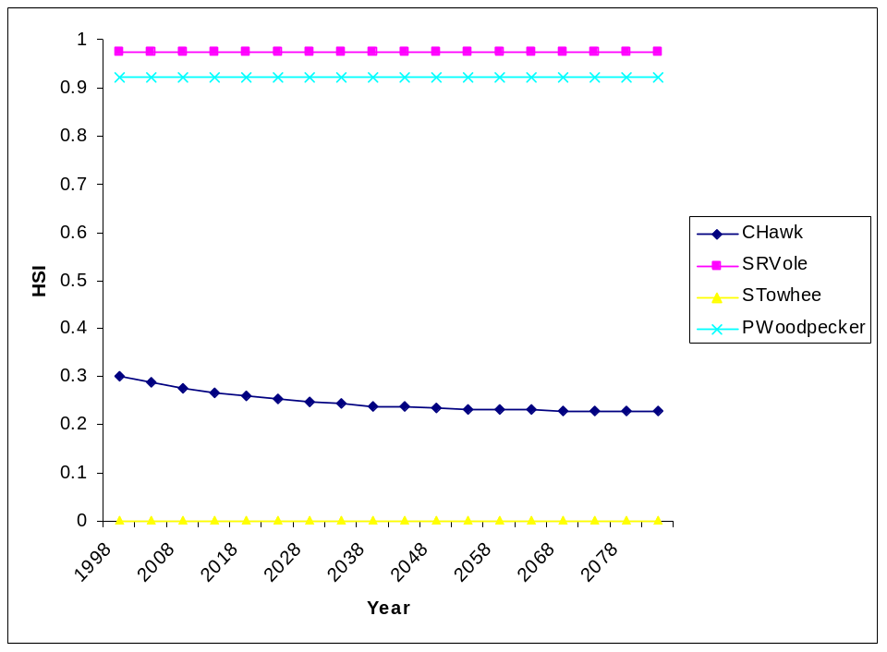

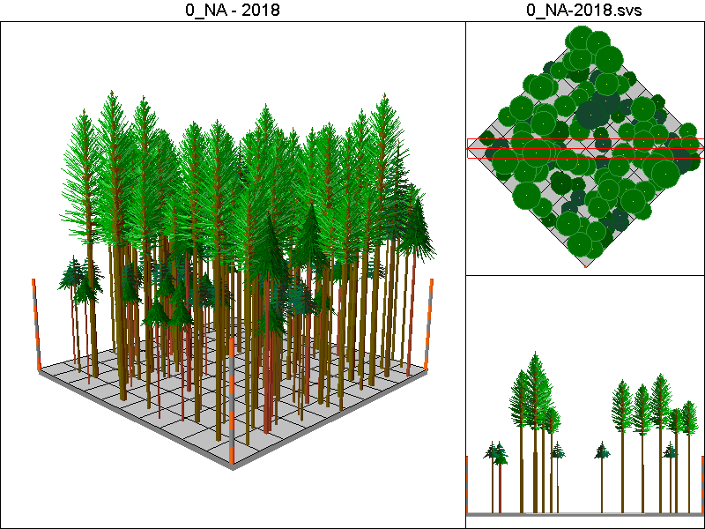
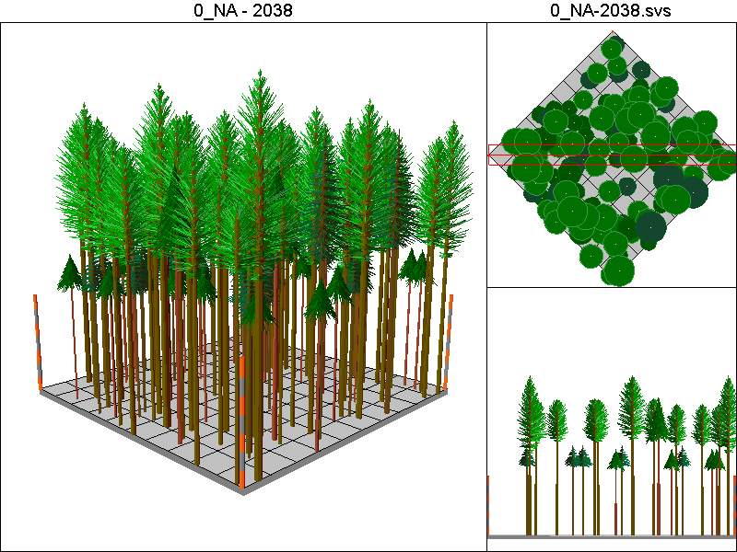
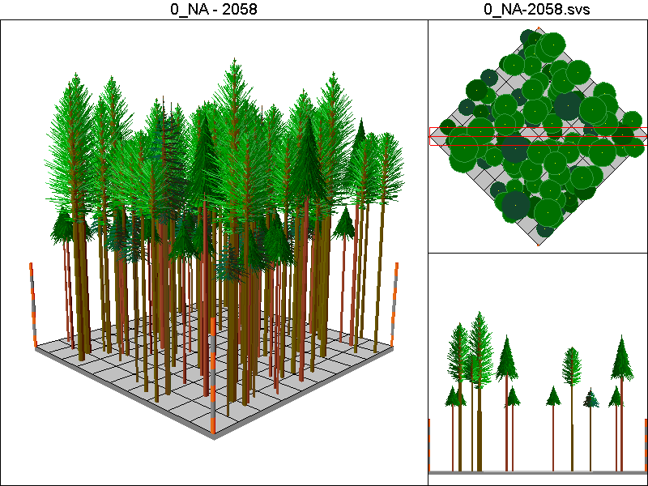
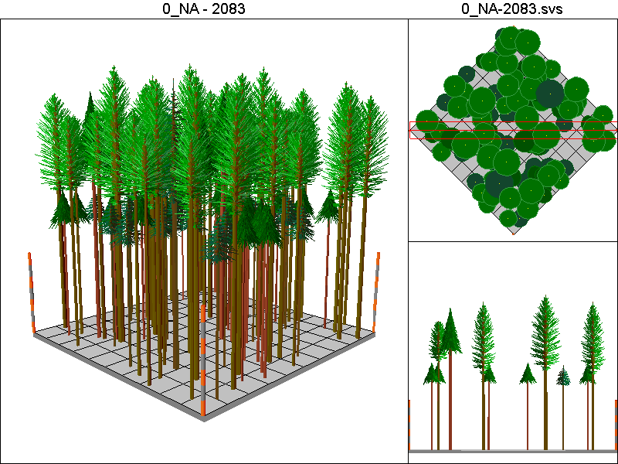

CC40_PCT Pathway

Harvest Operations:
1998: Harvest leaving 5 TPA, plant 400 TPA of Douglas-fir
2013: Thin to 300 TPA
2038: Harvest leaving 5 TPA, plant 400 TPA of Douglas-fir
2053: Thin to 300 TPA
2078: Harvest leaving 5 TPA, plant 400 TPA of Douglas-fir

Cover Type by Period:
1998 | C4T
2003 | B
2008 | B
2013 | C3T
2018 | C3T
2023 | C3
2028 | C3
2033 | C3
2038 | C4T
2043 | B
2048 | B
2053 | C3T
2058 | C3T
2063 | C3
2068 | C3
2073 | C3
2078 | C4T
2083 | B

Habitat Suitability Index values for all species:
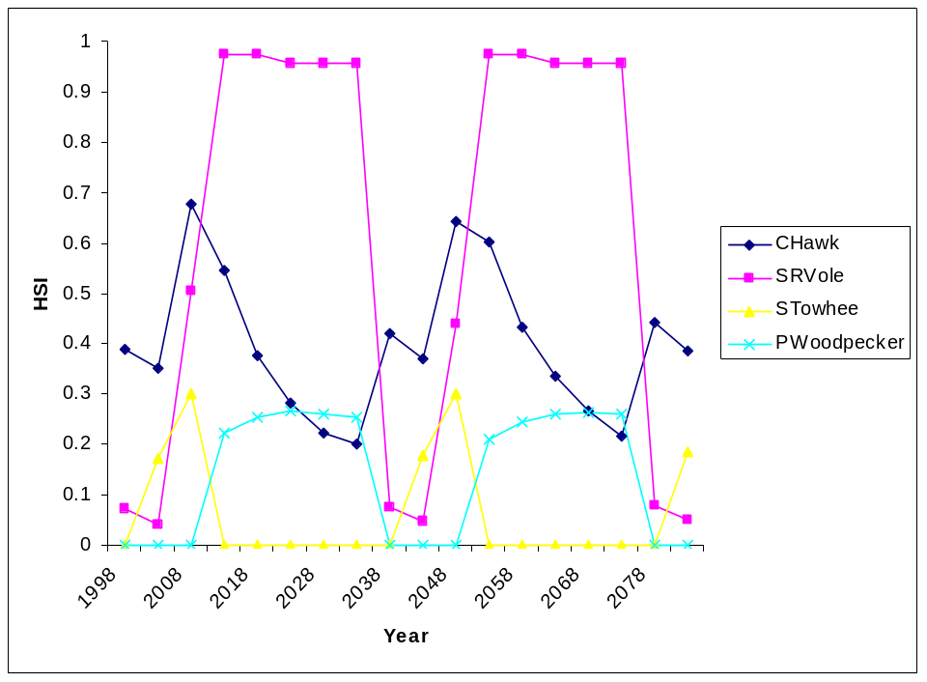

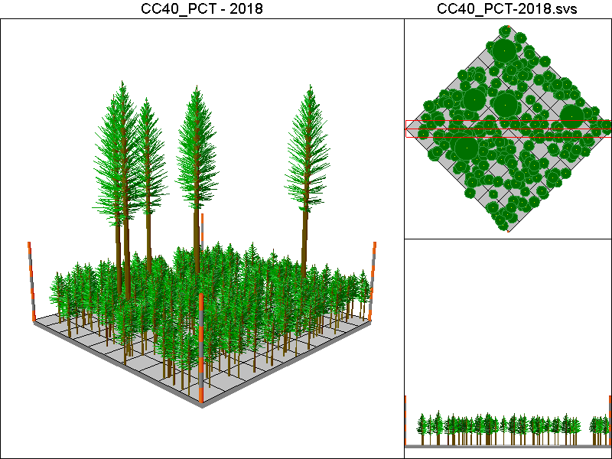
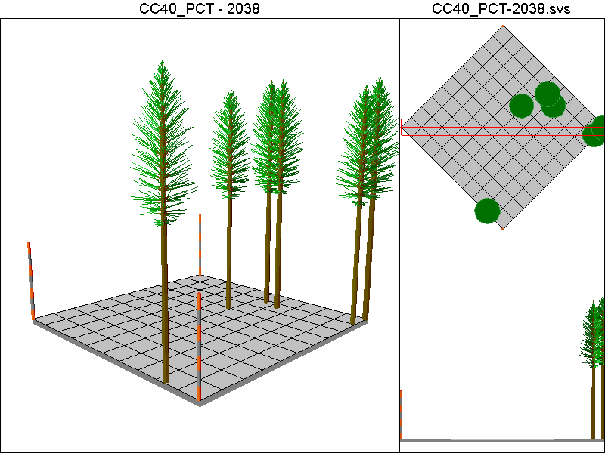
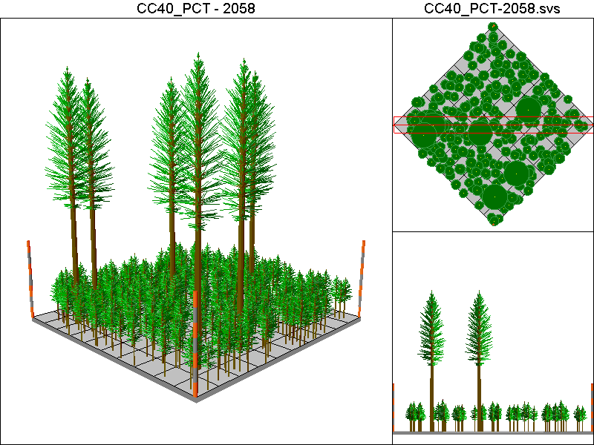
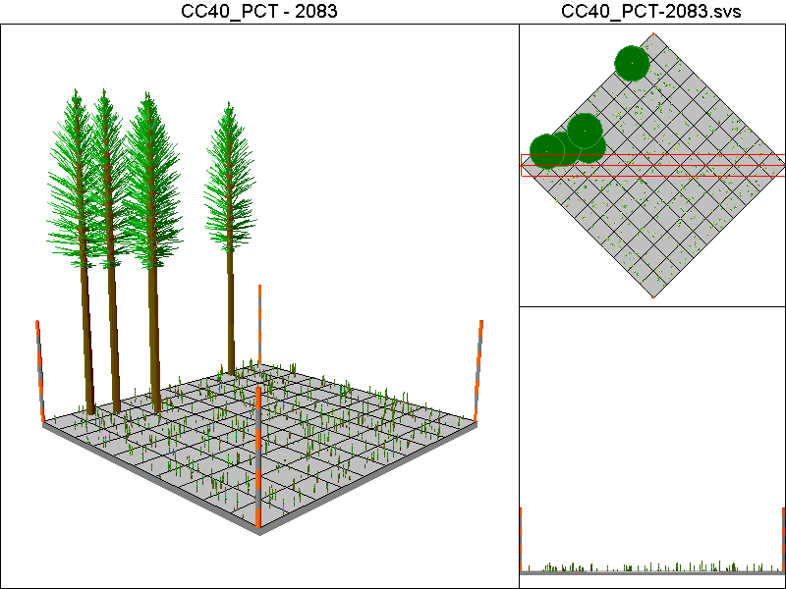

CC60_PCT_CT

Harvest Operations:
1998: Harvest leaving 5 TPA, plant 400 TPA of Douglas-fir
2013: Thin to 300 TPA
2028: Thin to 140ft²/ac of basal area
2058: Harvest leaving 5 TPA, plant 400 TPA of Douglas-fir

Cover Type by Period:
1998 | C4T
2003 | B
2008 | B
2013 | C3T
2018 | C3T
2023 | C3
2028 | C3T
2033 | C3T
2038 | C4T
2043 | C4T
2048 | C4T
2053 | C4T
2058 | C4T
2063 | B
2068 | B
2073 | C3T
2078 | C3T
2083 | C3

Habitat Suitability Index values for all four species:
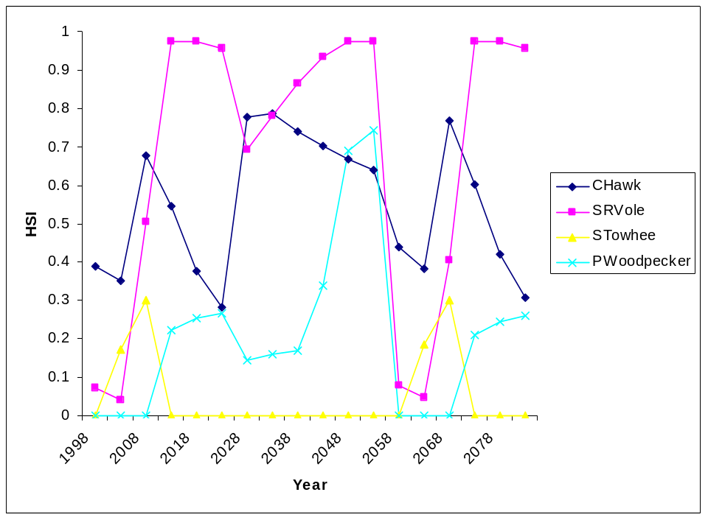
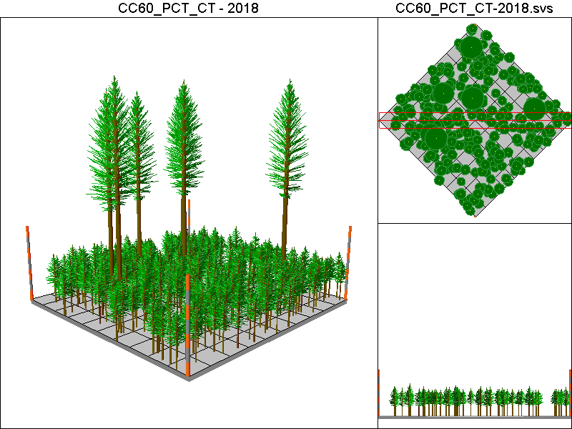
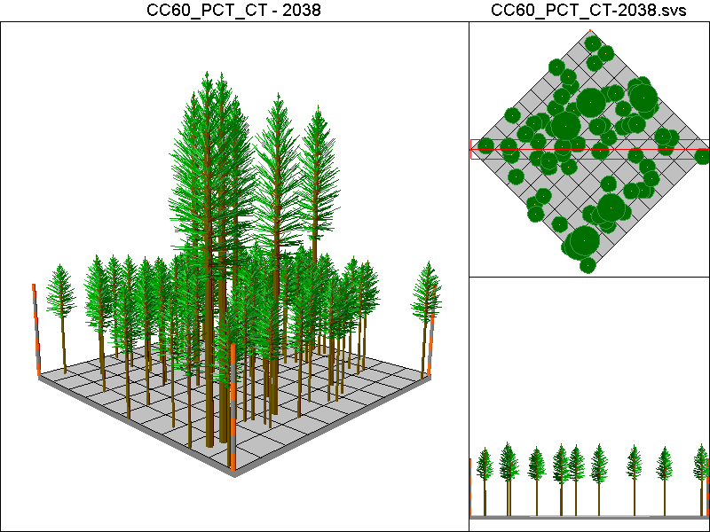
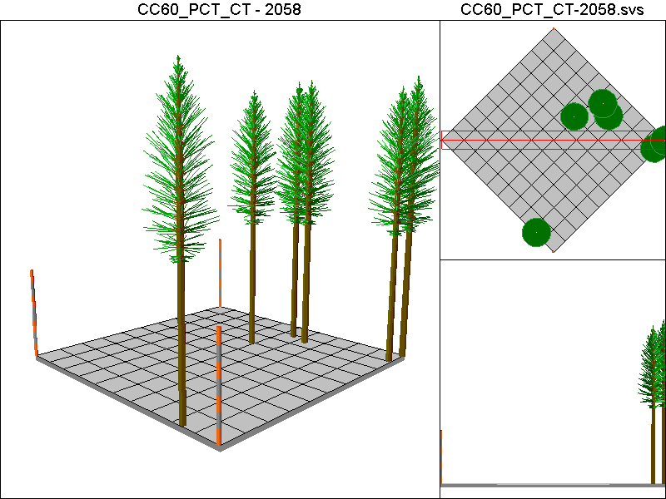
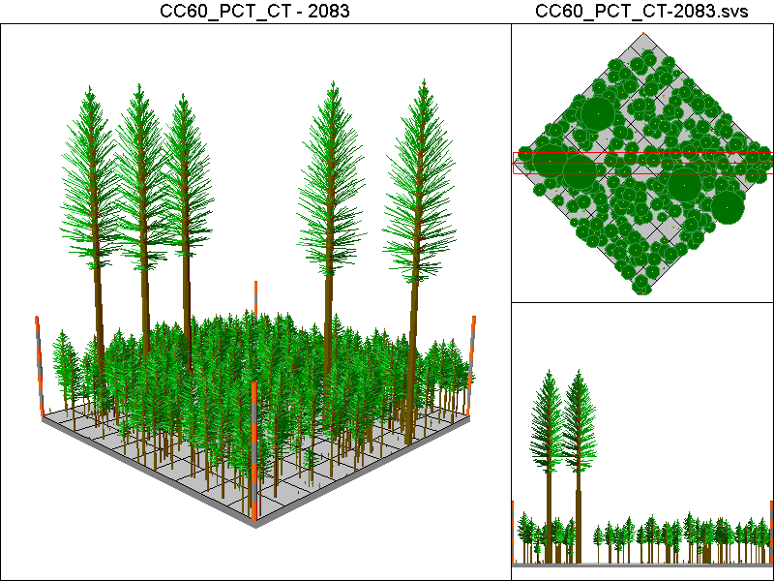

DEMO20 Pathway

Harvest Operations:
1998: Thin to 20% of the initial TPA

Cover Type by Period:
1998 | C4T
2003 | C4T
2008 | C4T
2013 | C4T
2018 | C4T
2023 | C4T
2028 | C4T
2033 | C4T
2038 | C4T
2043 | C4T
2048 | C4T
2053 | C4T
2058 | C4T
2063 | C4T
2068 | C4T
2073 | C4T
2078 | C4T
2083 | C4T

Habitat Suitability Index values for all four species:
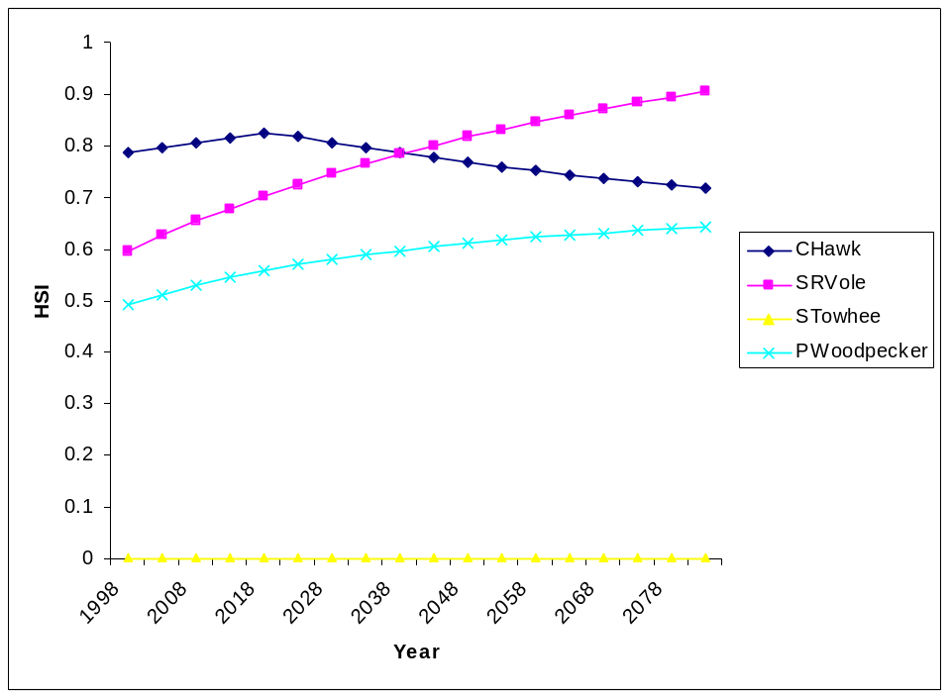
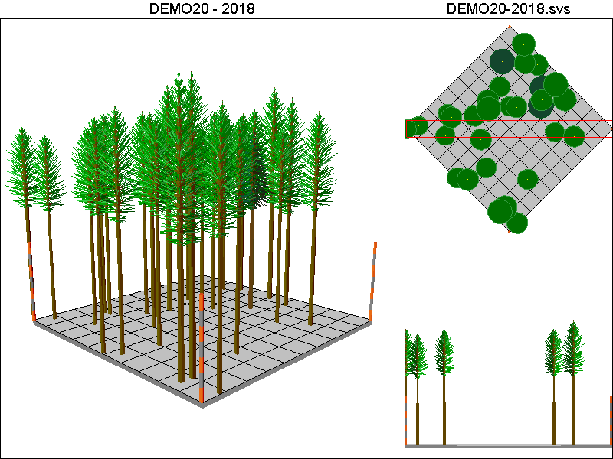
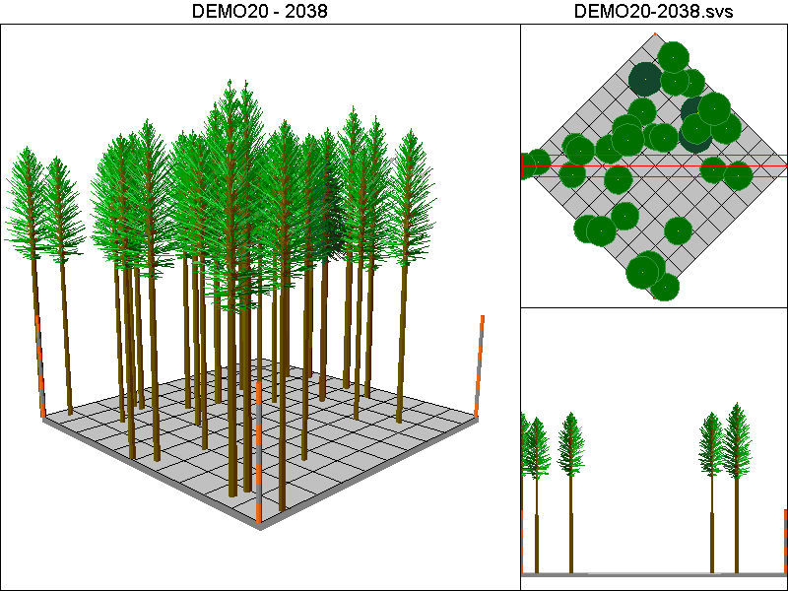
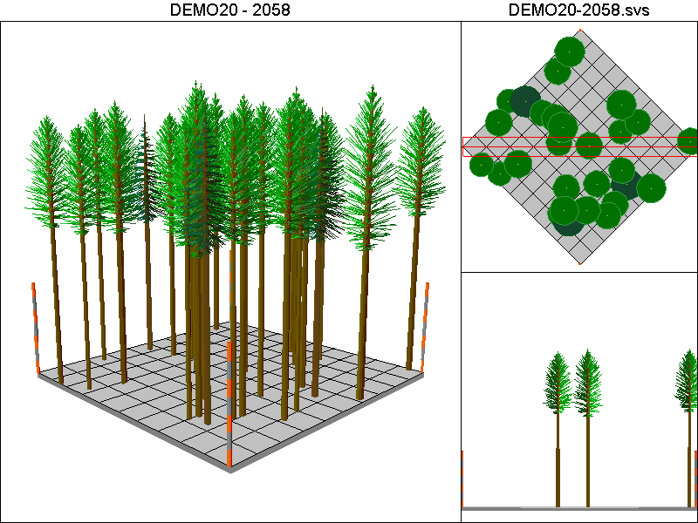
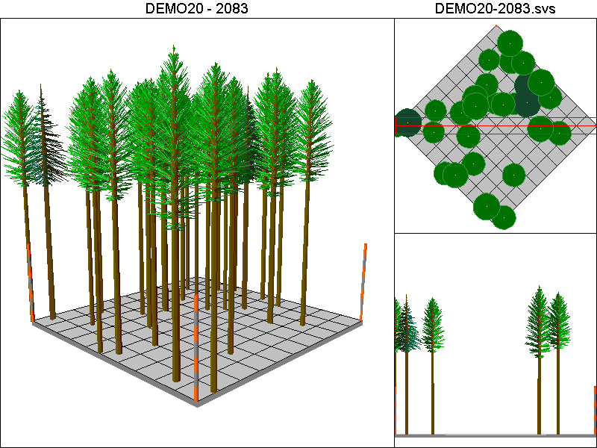

DEMO40 Pathway

Harvest Operations
19988: Thin to 40% of the original TPA

Cover Type by Period:
1998 | C4
2003 | C4
2008 | C4T
2013 | C4T
2018 | C4T
2023 | C4T
2028 | C4T
2033 | C4T
2038 | C4T
2043 | C4T
2048 | C4T
2053 | C4T
2058 | C4T
2063 | C4T
2068 | C4T
2073 | C4T
2078 | C4T
2083 | C4T

Habitat Suitability Index values for all four species:
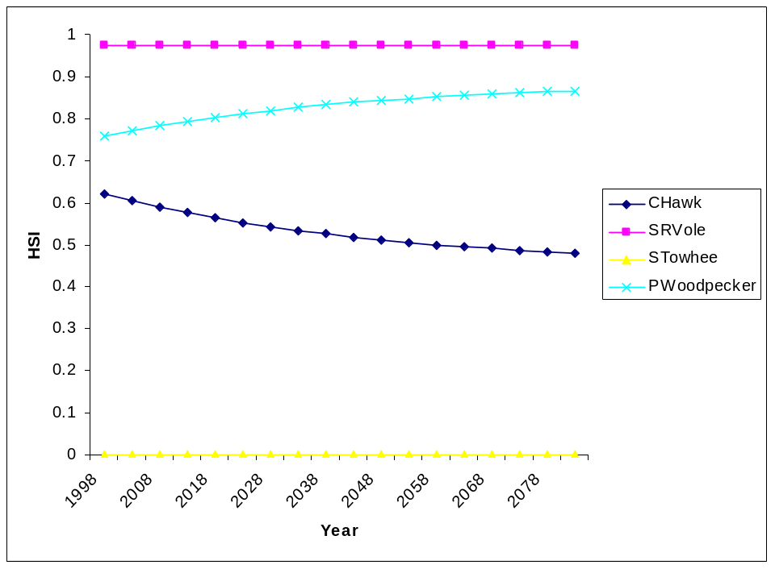

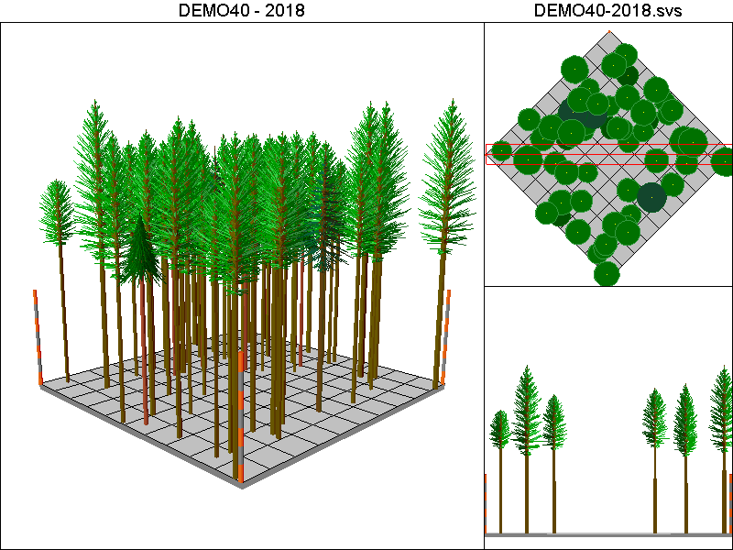
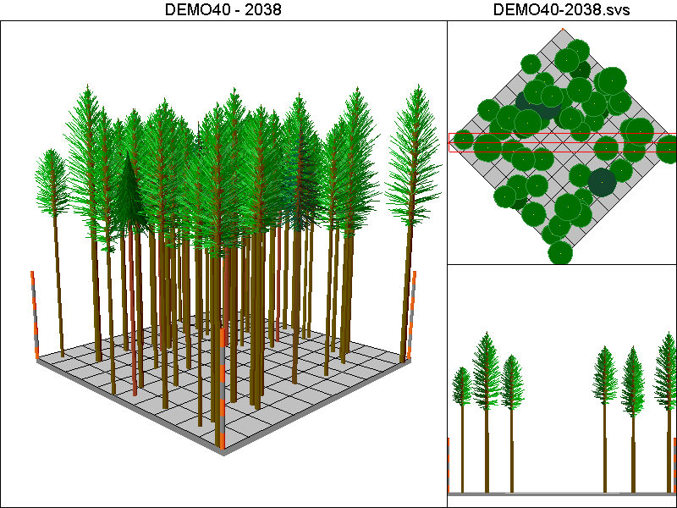
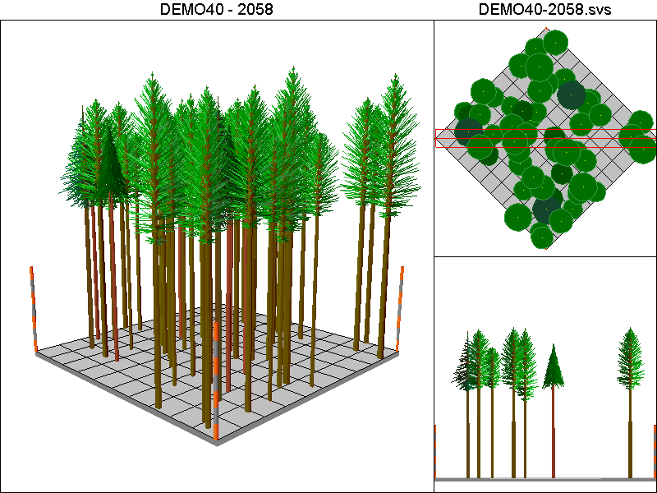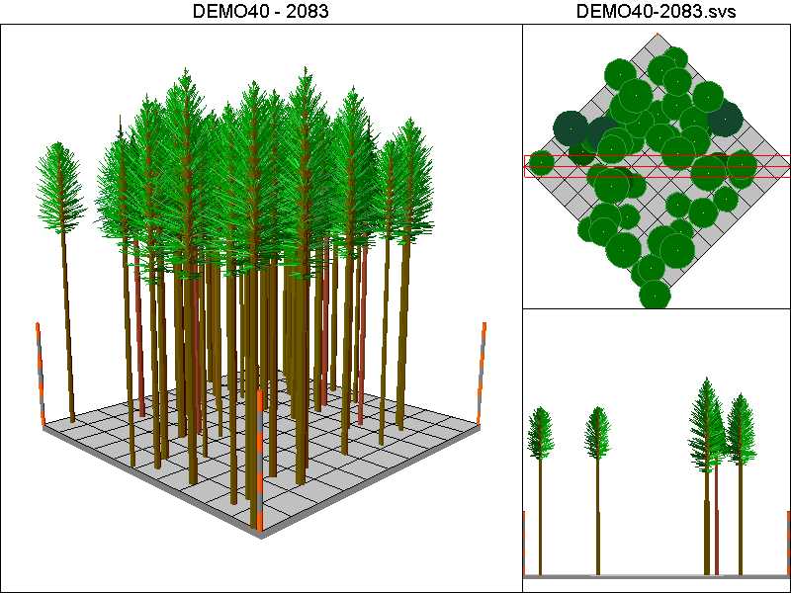

Hanseen10-40 Pathway:

Harvest Operations:
1998: Harvest leaving 4 TPA, plant 400 TPA of Douglas-fir
2013: Thin to 220 TPA <12”DBH leaving all trees >12”DBH
2028: Thin to 220 TPA <12”DBH leaving all trees >12”DBH
2038: Harvest leaving 4 TPA, plant 400 TPA of Douglas-fir
2053: Thin to 220 TPA <12”DBH leaving all trees >12”DBH
2068: Thin to 220 TPA <12”DBH leaving all trees >12”DBH
2078: Harvest leaving 4 TPA, plant 400 TPA of Douglas-fir

Cover Type by Period:
1998 | C4T
2003 | B
2008 | B
2013 | C2
2018 | C3T
2023 | C3T
2028 | C3
2033 | C3
2038 | C4T
2043 | B
2048 | B
2053 | C3T
2058 | C3T
2063 | C3T
2068 | C3T
2073 | C3
2078 | C4T
2083 | B

Habitat Suitability Index values for all four species:
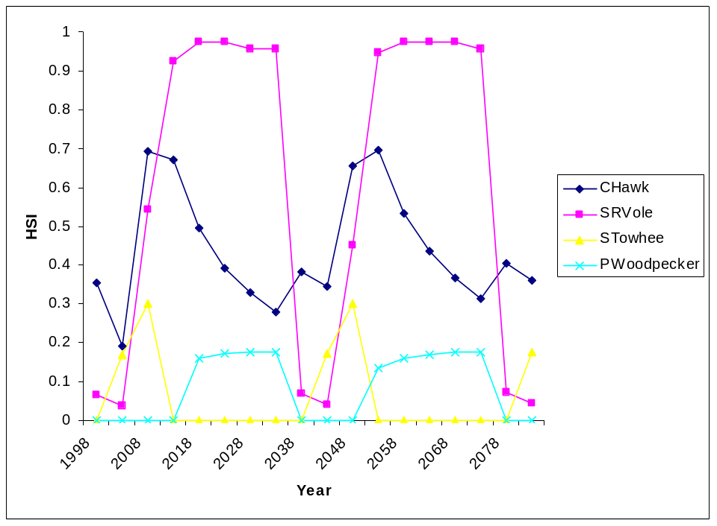

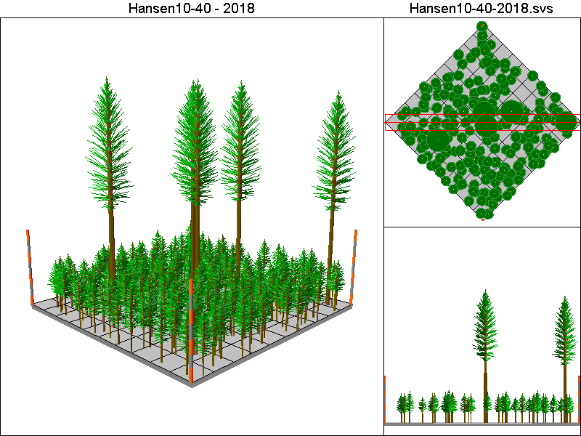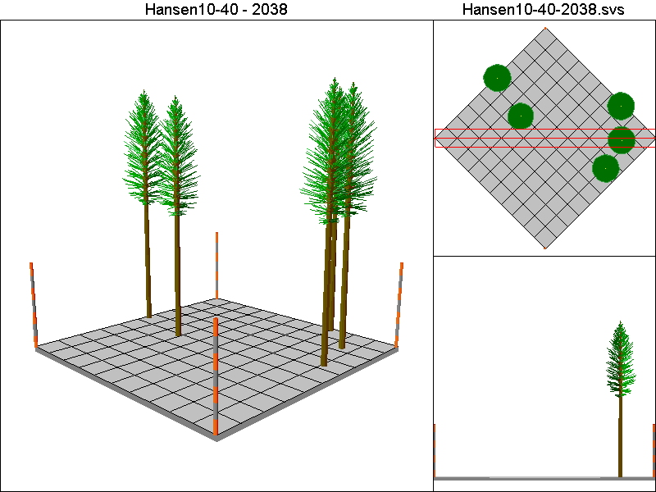
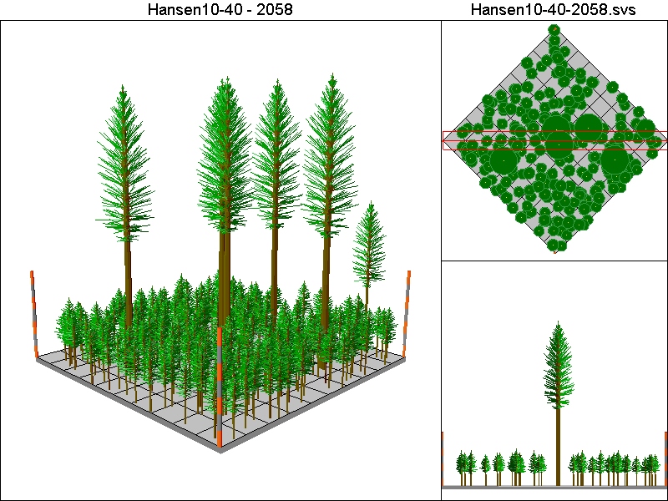
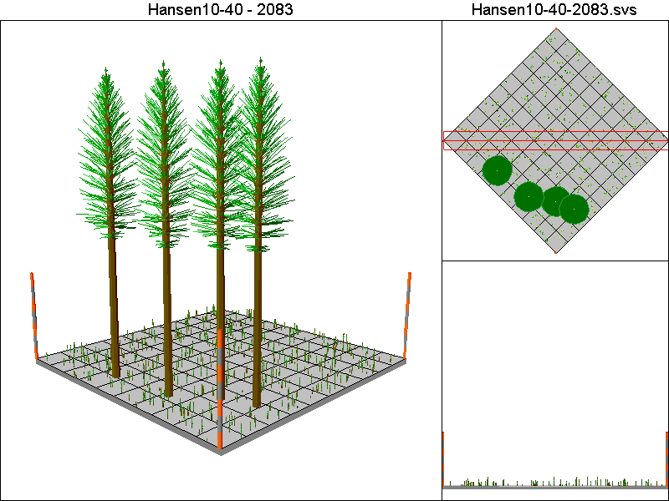

Hansen150-120 Pathway

Harvest Operations:
1998: Thin to 60 TPA, plant 400 TPA of Douglas-fir
2013: Thin to 220 TPA <12”DBH leaving all trees >12”DBH
2028: Thin to 220 TPA <12”DBH leaving all trees >12”DBH

Cover Type by Period:
1998 | C4T
2003 | C4T
2008 | C4T
2013 | C4T
2018 | C4T
2023 | C4T
2028 | C4T
2033 | C4T
2038 | C4T
2043 | C4T
2048 | C4T
2053 | C4T
2058 | C4T
2063 | C4T
2068 | C4T
2073 | C4T
2078 | C4T
2083 | C4T

Habitat Suitability Index values for all four species:
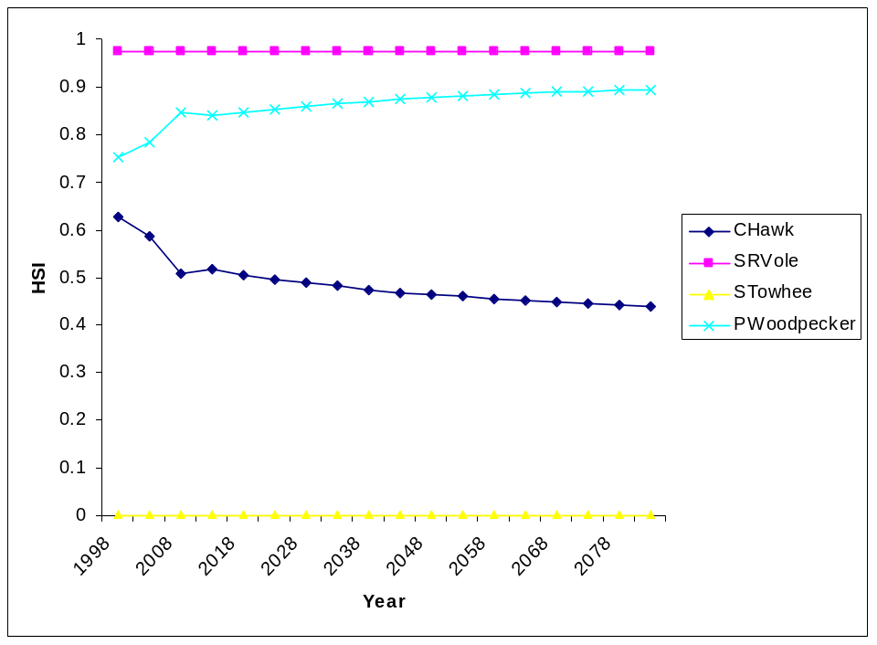

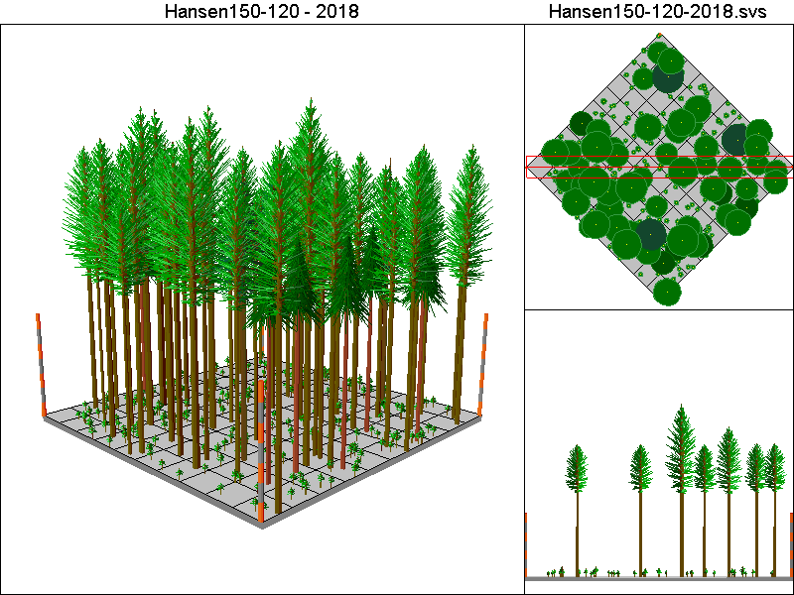
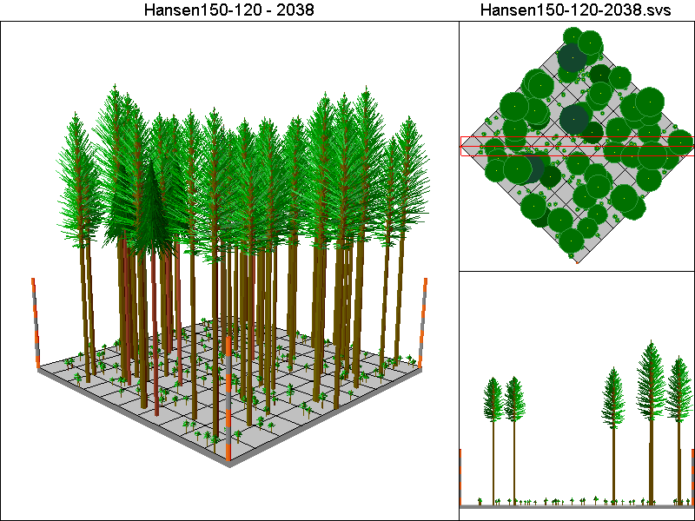
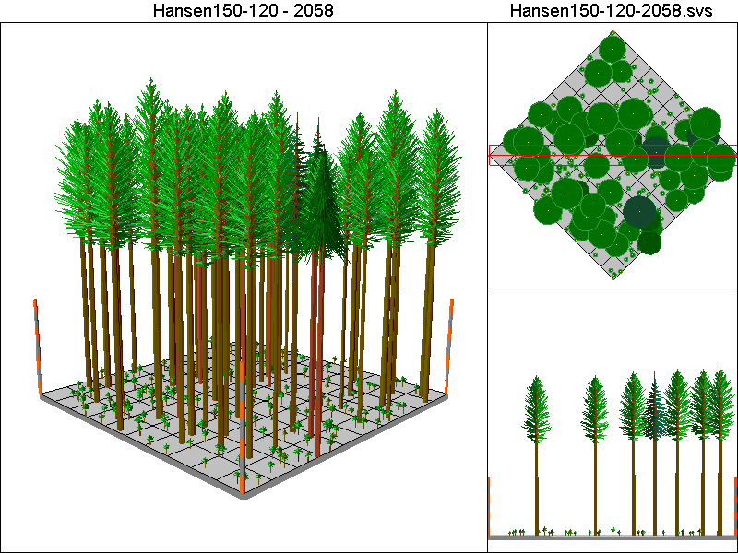
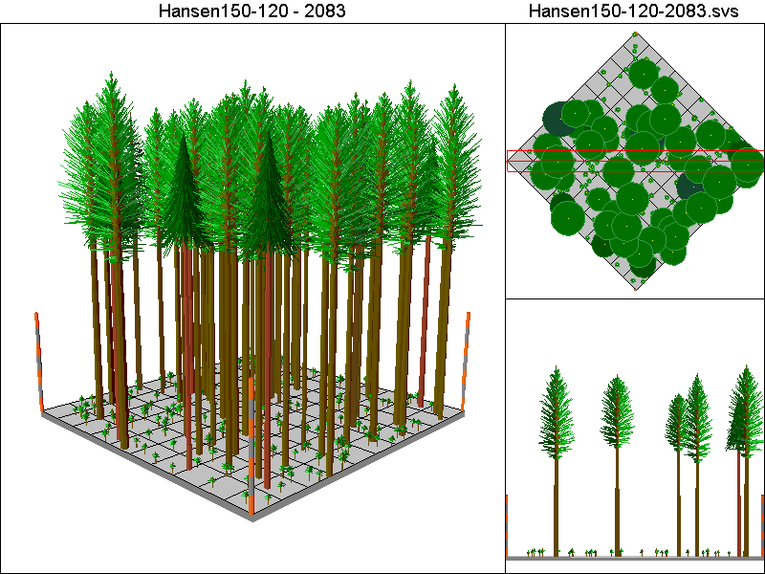

Hansen150-40 Pathway

Harvest Operations:
1998: Thin to 60 TPA, plant 400 TPA of Douglas-fir
2013: Thin to 220 TPA <12”DBH leaving all trees >12”DBH
2028: Thin to 220 TPA <12”DBH leaving all trees >12”DBH
2038: Thin to 60 TPA, plant 400 TPA of Douglas-fir
2053: Thin to 220 TPA <12”DBH leaving all trees >12”DBH
2068: Thin to 220 TPA <12”DBH leaving all trees >12”DBH
2078: Thin to 60 TPA, plant 400 TPA of Douglas-fir

Cover Type by Period:
1998 | C4T
2003 | C4T
2008 | C4T
2013 | C4T
2018 | C4T
2023 | C4T
2028 | C4T
2033 | C4T
2038 | C4T
2043 | C4T
2048 | C4T
2053 | C4T
2058 | C4T
2063 | C4T
2068 | C4T
2073 | C4T
2078 | C4T
2083 | C4T

Habitat Suitability Index values for all four species:
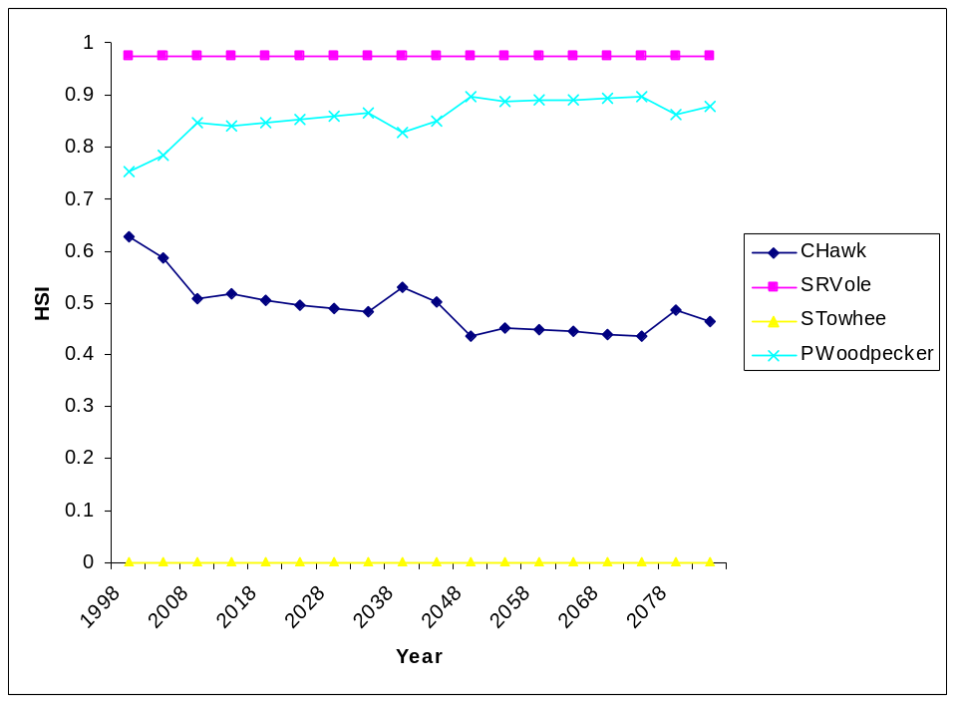

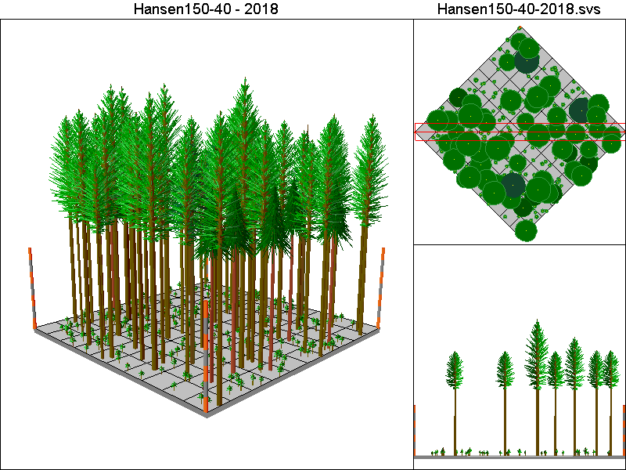
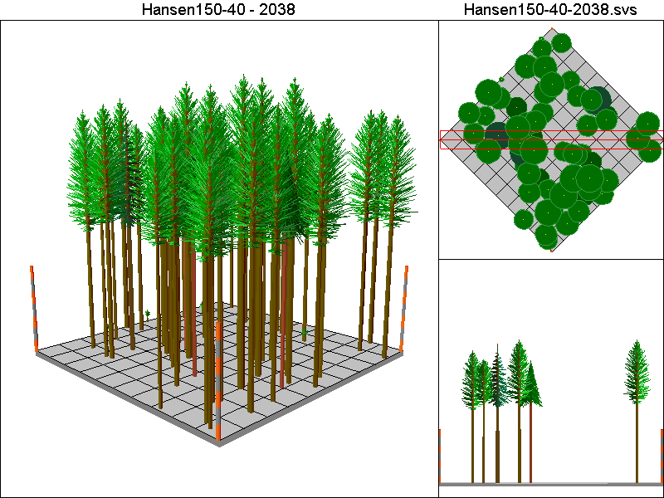
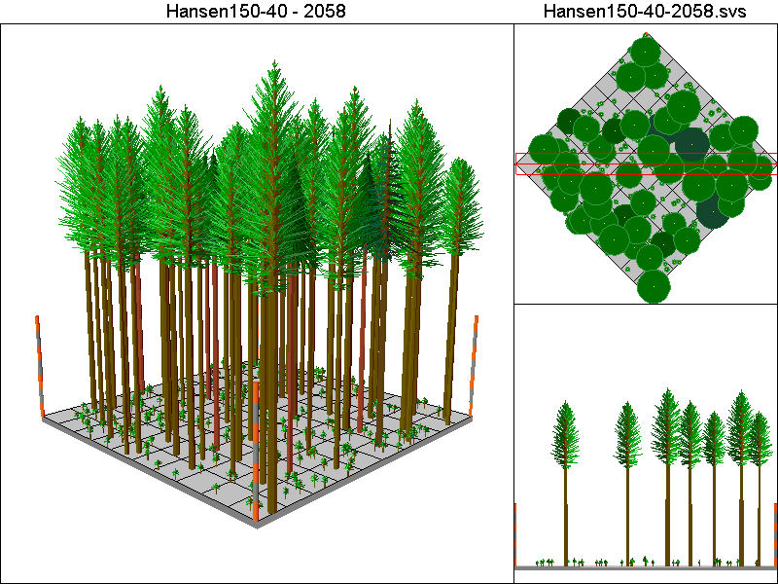
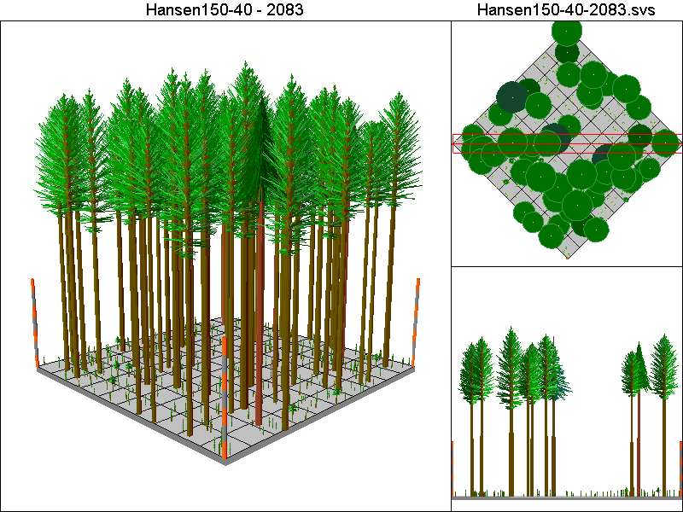

Hansen150-80 Pathway

Harvest Operations:
1998: Thin to 60 TPA, plant 400 TPA of Douglas-fir
2013: Thin to 220 TPA <12”DBH leaving all trees >12”DBH
2028: Thin to 220 TPA <12”DBH leaving all trees >12”DBH
2078: Thin to 60 TPA, plant 400 TPA of Douglas-fir

Cover Type by Period:
1998 | C4T
2003 | C4T
2008 | C4T
2013 | C4T
2018 | C4T
2023 | C4T
2028 | C4T
2033 | C4T
2038 | C4T
2043 | C4T
2048 | C4T
2053 | C4T
2058 | C4T
2063 | C4T
2068 | C4T
2073 | C4T
2078 | C4T
2083 | C4T

Habitat Suitability Index values for all four species:
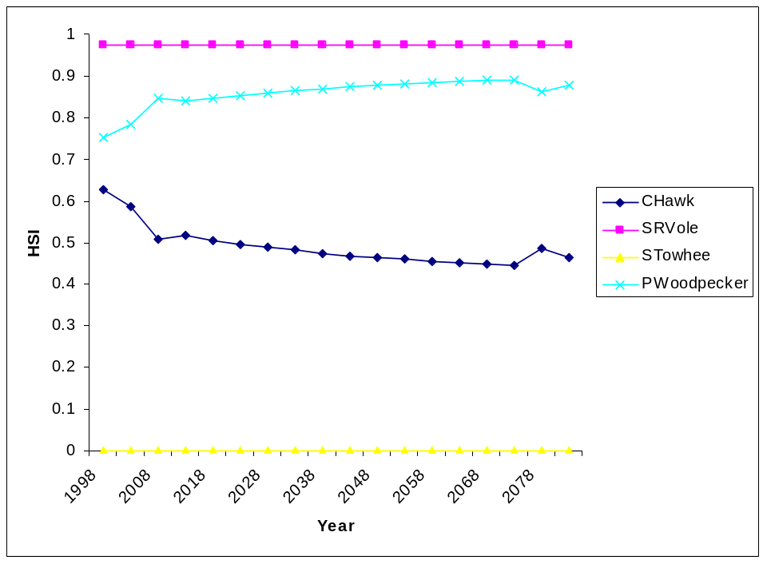

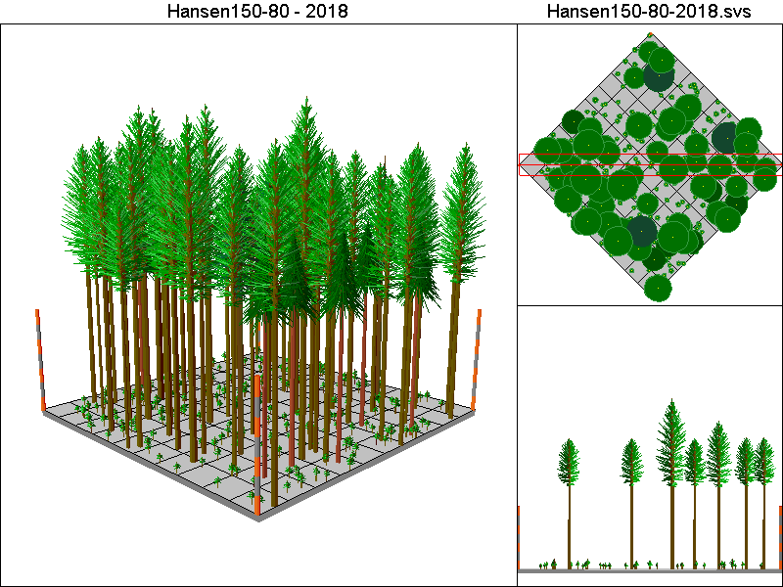
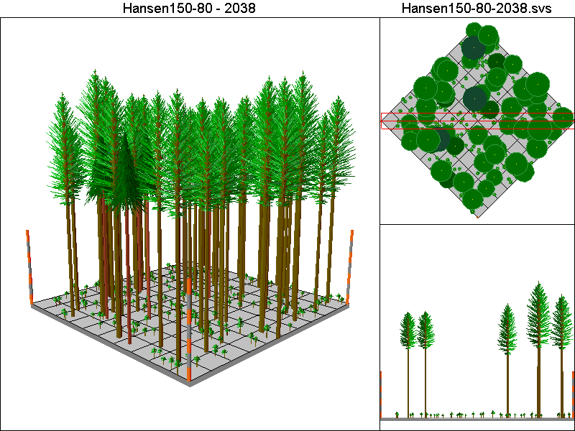
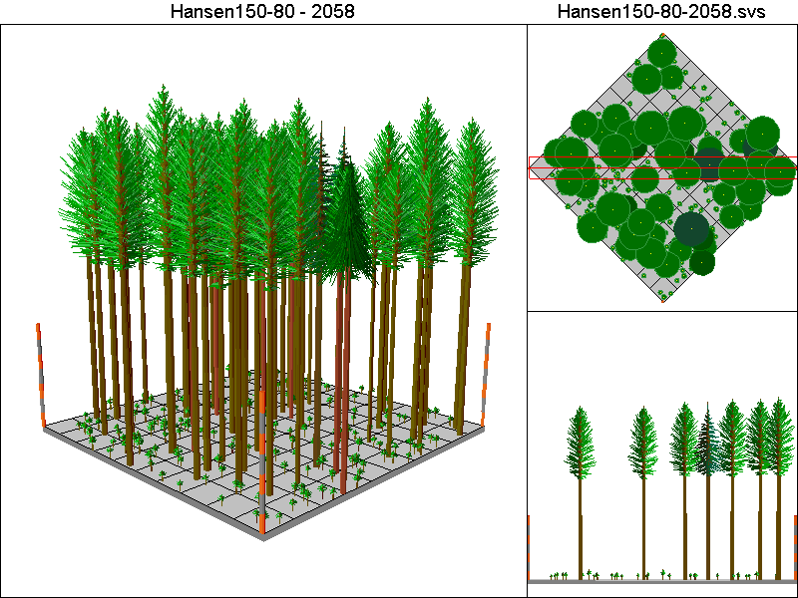
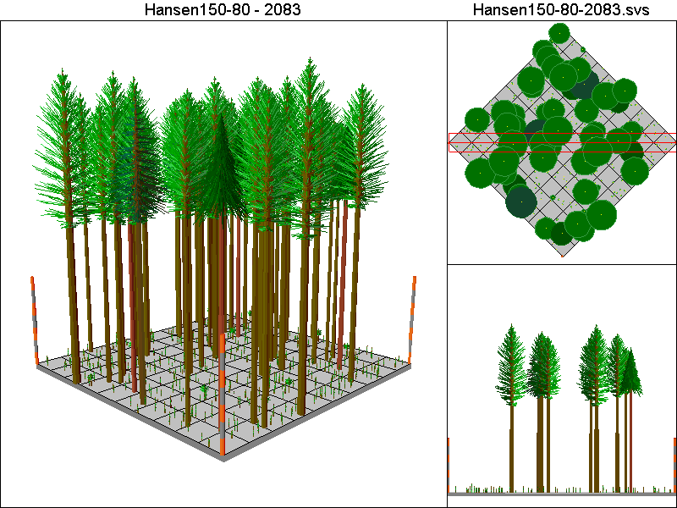

Hansen30-40 Pathway

Harvest Operations:
1998: Thin to 12 TPA, plant 400 TPA of Douglas-fir
2013: Thin to 220 TPA <12”DBH leaving all trees >12”DBH
2028: Thin to 220 TPA <12”DBH leaving all trees >12”DBH
2038: Thin to 12 TPA, plant 400 TPA of Douglas-fir
2053: Thin to 220 TPA <12”DBH leaving all trees >12”DBH
2068: Thin to 220 TPA <12”DBH leaving all trees >12”DBH
2038: Thin to 12 TPA, plant 400 TPA of Douglas-fir

Cover Type by Period:
1998 | C4T
2003 | C3T
2008 | C3T
2013 | C3T
2018 | C3T
2023 | C3T
2028 | C4T
2033 | C4T
2038 | C4T
2043 | C3T
2048 | C3T
2053 | C3T
2058 | C3T
2063 | C3T
2068 | C4T
2073 | C4T
2078 | C4T
2083 | C3T

Habitat Suitability Index values for all four species:
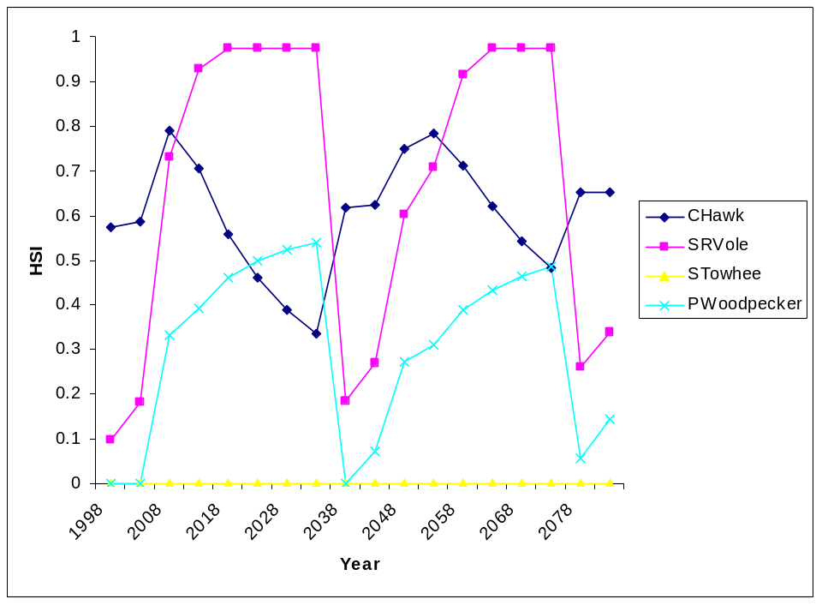

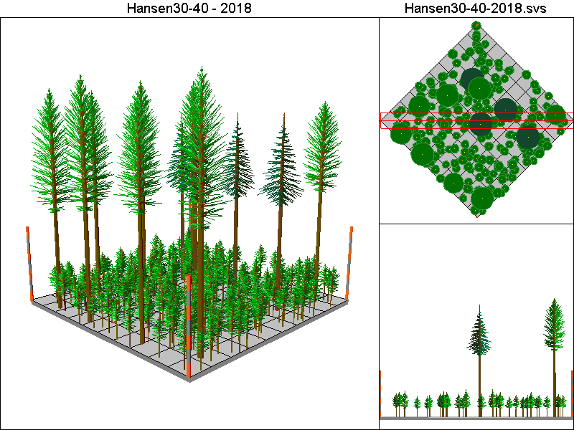
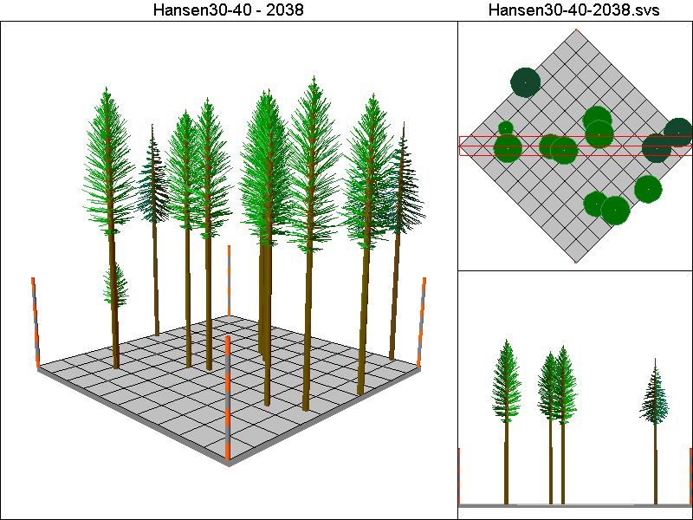
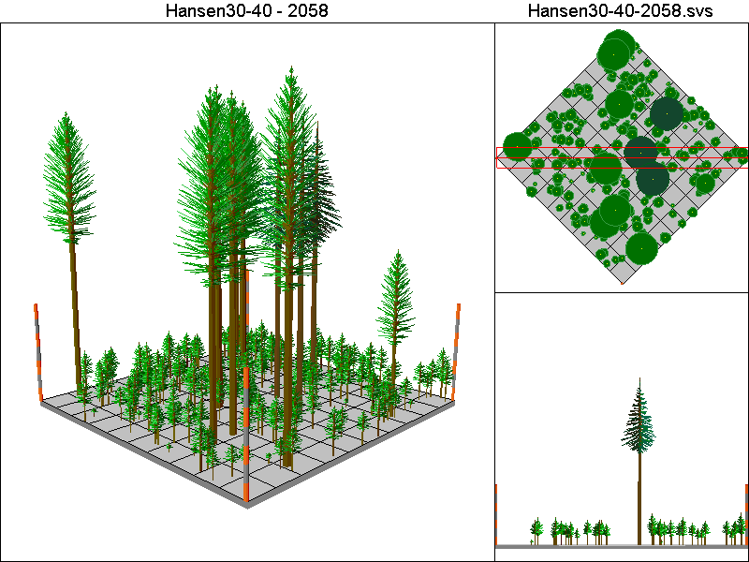
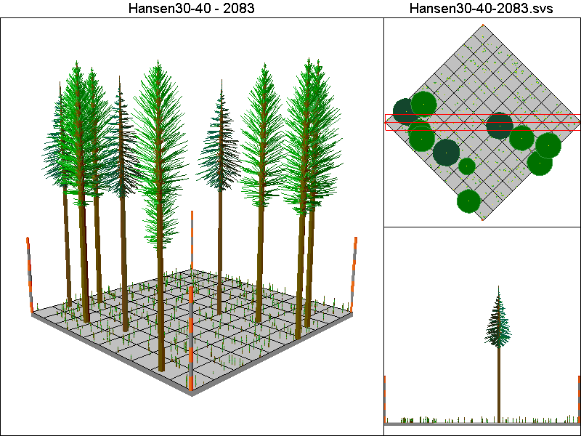

Hansen50-40 Pathway

Harvest Operations:
1998: Thin to 20 TPA, plant 400 TPA of Douglas-fir
2013: Thin to 220 TPA <12”DBH leaving all trees >12”DBH
2028: Thin to 220 TPA <12”DBH leaving all trees >12”DBH
2038: Thin to 20 TPA, plant 400 TPA of Douglas-fir
2053: Thin to 220 TPA <12”DBH leaving all trees >12”DBH
2068: Thin to 220 TPA <12”DBH leaving all trees >12”DBH
2078: Thin to 20 TPA, plant 400 TPA of Douglas-fir

Cover Type by Period:
1998 | C4T
2003 | C3T
2008 | C3T
2013 | C4T
2018 | C4T
2023 | C4T
2028 | C4T
2033 | C4T
2038 | C4T
2043 | C4T
2048 | C4T
2053 | C4T
2058 | C4T
2063 | C4T
2068 | C4T
2073 | C4T
2078 | C4T
2083 | C4T

Habitat Suitability Index values for all four species:
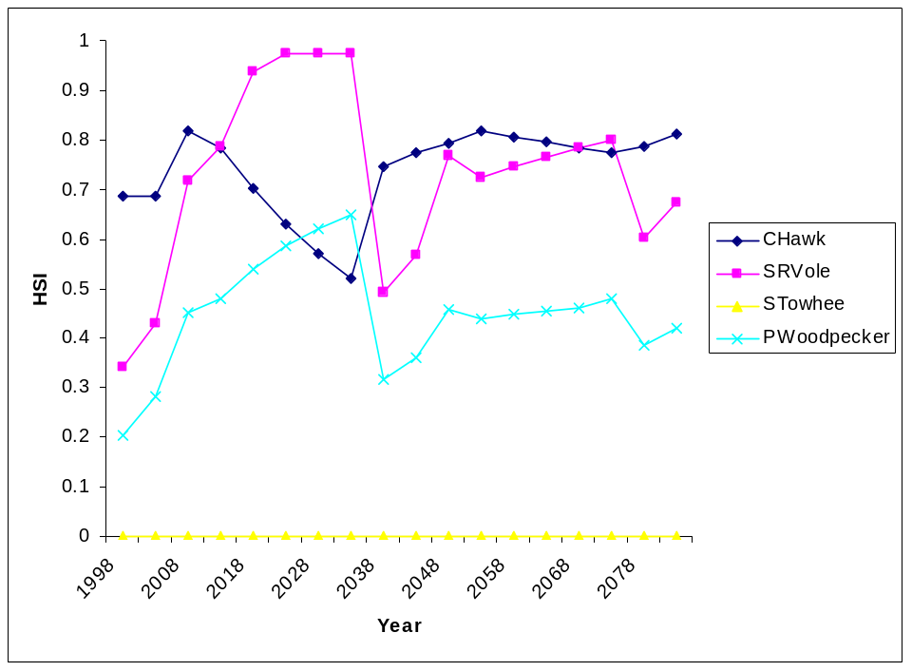

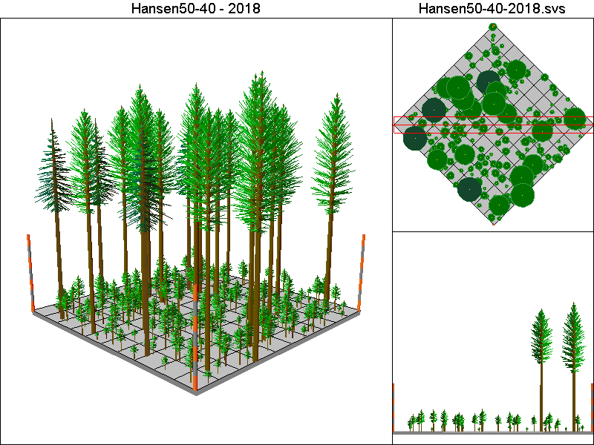
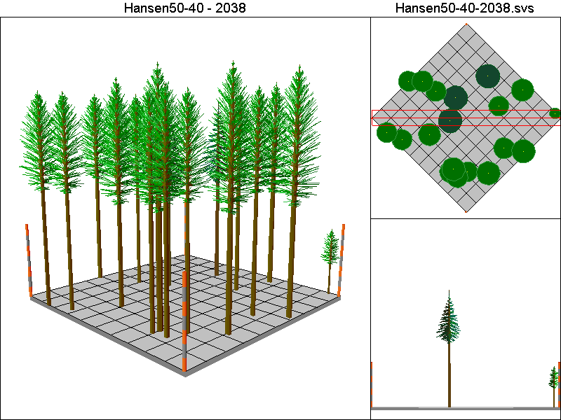
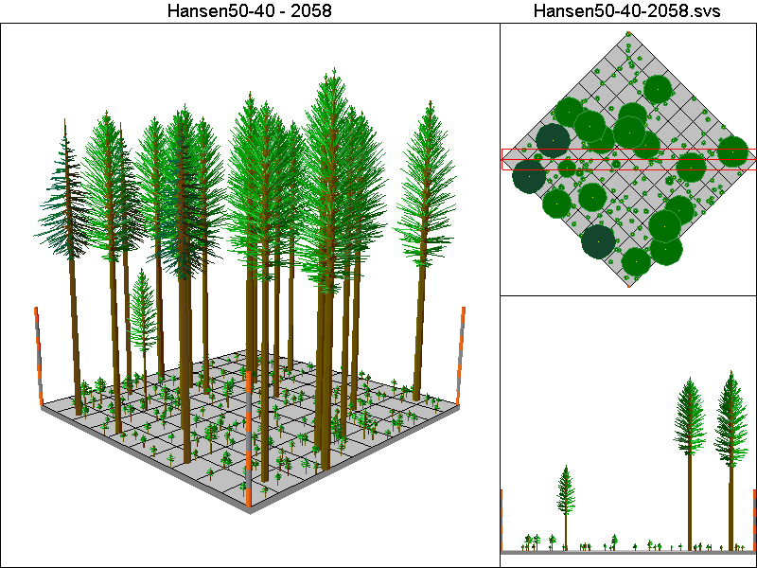
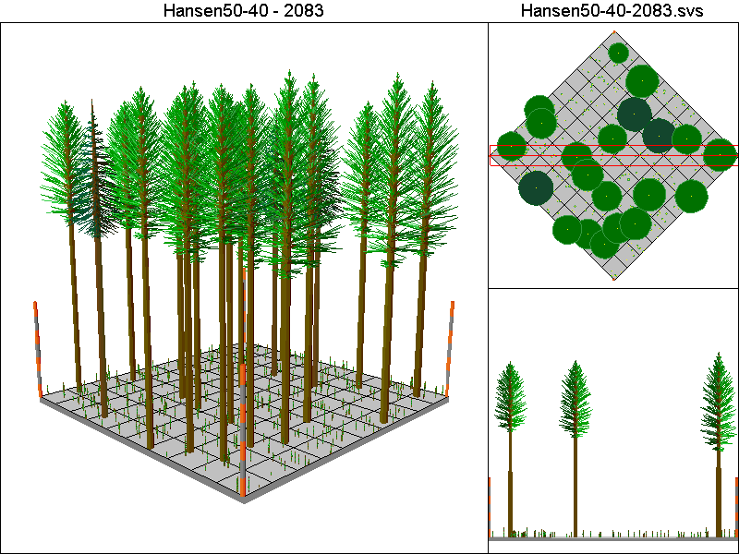

Hansen5-40 Pathway

Harvest Operations:
1998: Thin to 2 TPA, plant 400 TPA of Douglas-fir
2013: Thin to 220 TPA <12”DBH leaving all trees >12”DBH
2028: Thin to 220 TPA <12”DBH leaving all trees >12”DBH
2038: Thin to 2 TPA, plant 400 TPA of Douglas-fir
2053: Thin to 220 TPA <12”DBH leaving all trees >12”DBH
2068: Thin to 220 TPA <12”DBH leaving all trees >12”DBH
2038: Thin to 2 TPA, plant 400 TPA of Douglas-fir

Cover Type by Period:
1998 | C4T
2003 | C1
2008 | C2
2013 | C2
2018 | C3T
2023 | C3T
2028 | C3
2033 | C3
2038 | C4T
2043 | B
2048 | C2
2053 | C2
2058 | C3T
2063 | C3T
2068 | C3
2073 | C3
2078 | C4T
2083 | B

Habitat Suitability index values for all four species:
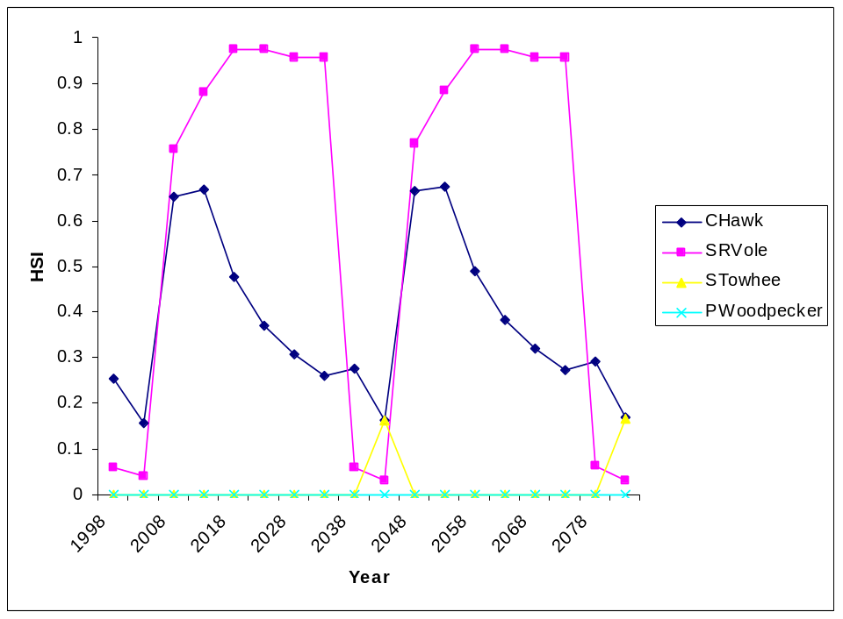

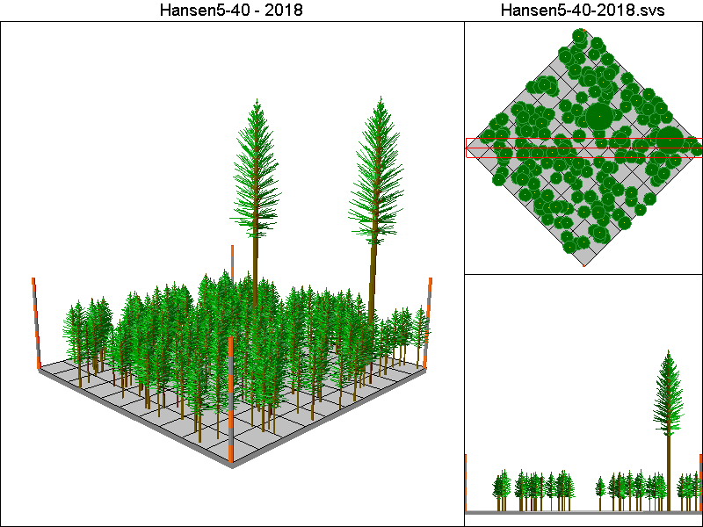
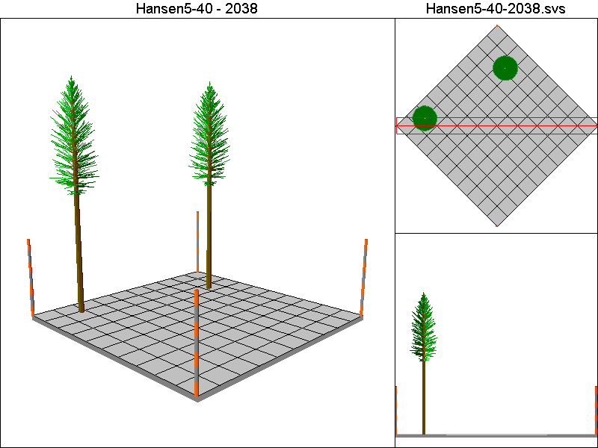
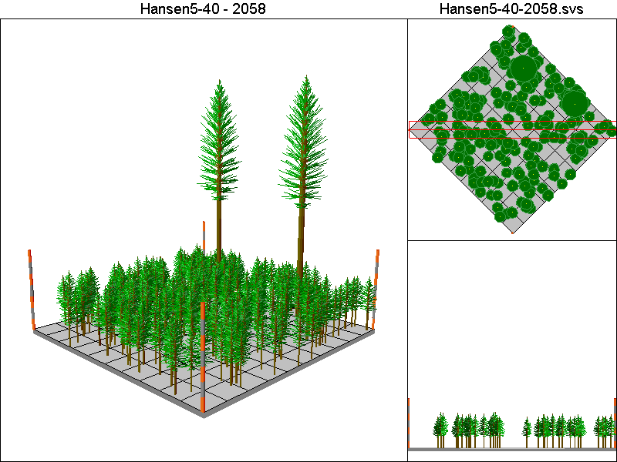
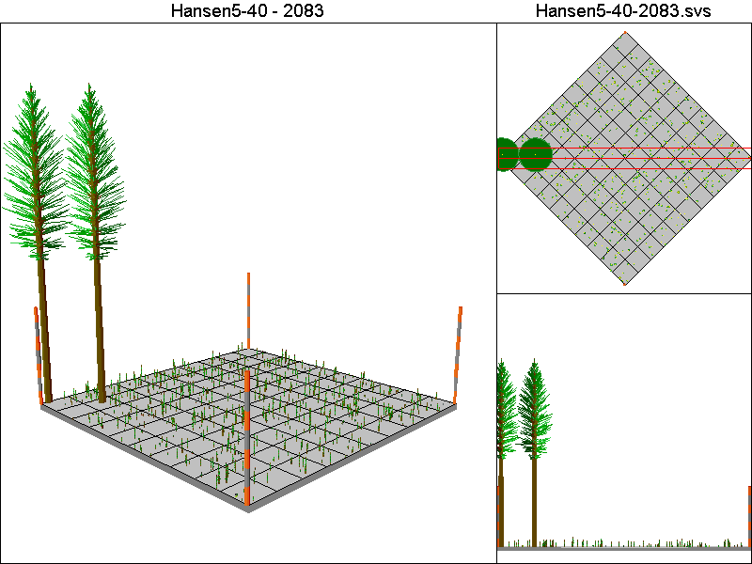

Marzluff-IE-G2 Pathway

Harvest Operations:
1998: Thin to 25 TPA in 8” – 20”DBH class, thin to 25 TPA >20”DBH
2038: Thin to 25 TPA in 8” – 20”DBH class

Cover Type by Period:
1998 | C4T
2003 | C4T
2008 | C4T
2013 | C4T
2018 | C4T
2023 | C4T
2028 | C4T
2033 | C4T
2038 | C4T
2043 | C4T
2048 | C4T
2053 | C4T
2058 | C4T
2063 | C4T
2068 | C4T
2073 | C4T
2078 | C4T
2083 | C4T

Habitat Suitability Index values for all four species:
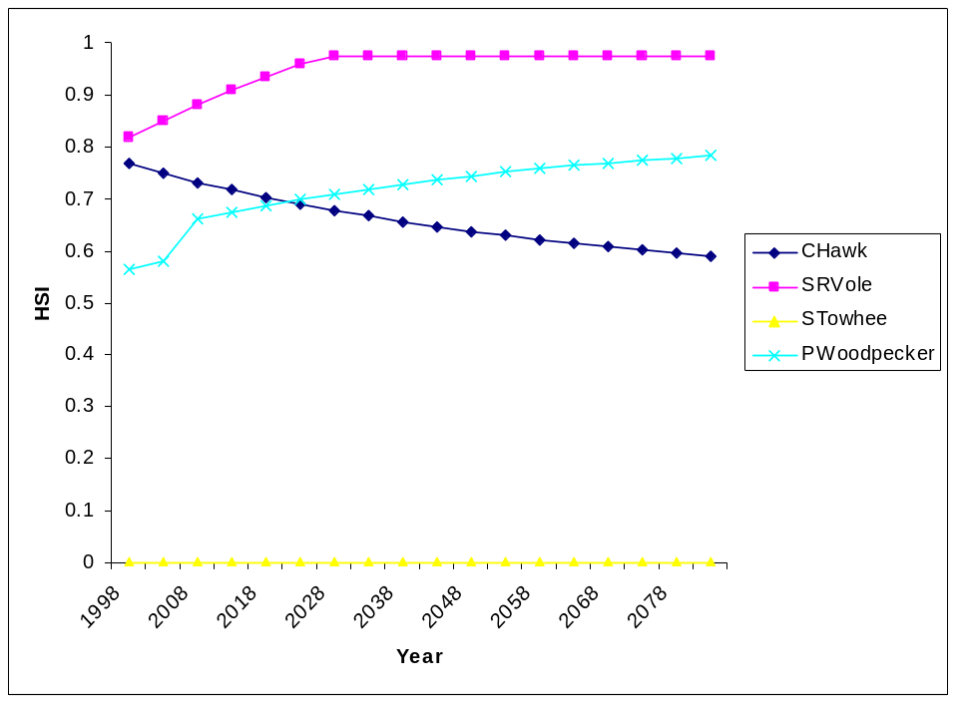

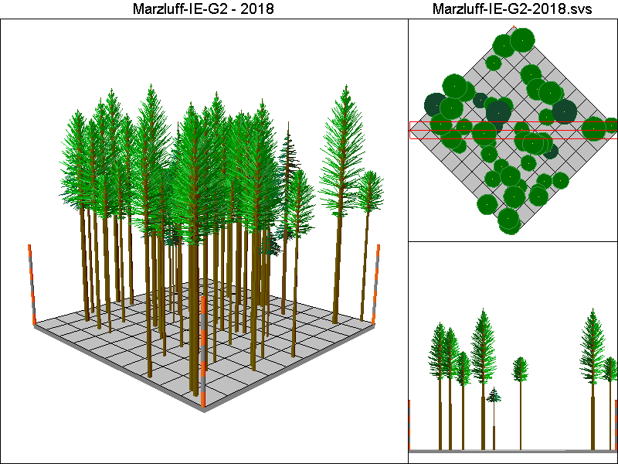
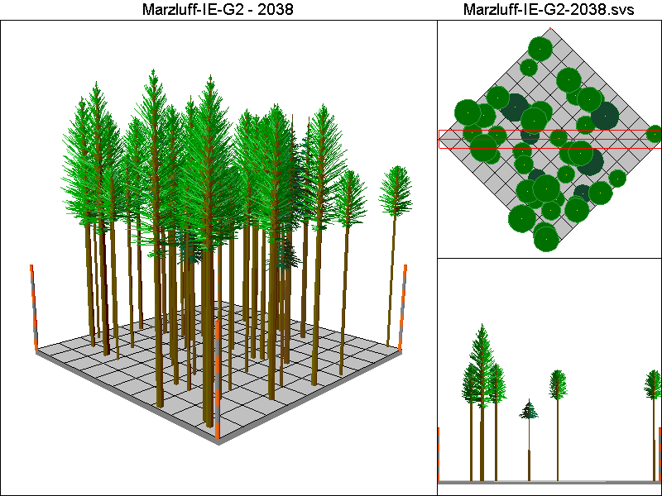
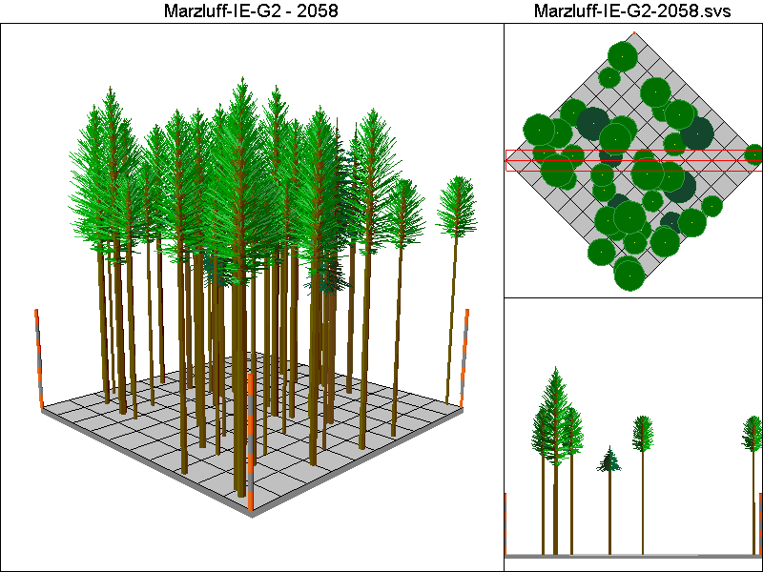
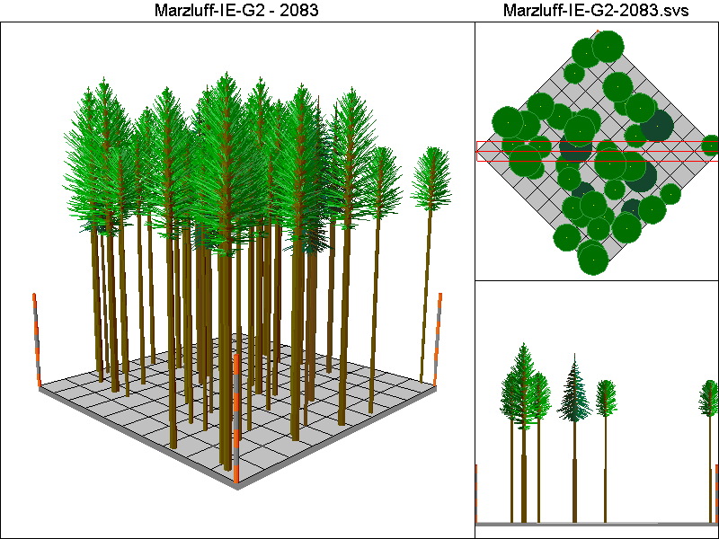

McCombMS Pathway

Harvest Operations:
1998: Thin to 24% of initial TPA, plant 16 TPA of Douglas-fir and 104 TPA of western hemlock
2023: Thin to 84% of initial TPA >12”DBH, thin to 55% of initial TPA <12”DBH, plant 16 TPA of Douglas-fir and 104 TPA of western hemlock
2058: Thin to 84% of initial TPA >12”DBH, thin to 55% of initial TPA <12”DBH, plant 16 TPA of Douglas-fir and 104 TPA of western hemlock
2073: Thin to 84% of initial TPA >12”DBH, thin to 55% of initial TPA <12”DBH, plant 16 TPA of Douglas-fir and 104 TPA of western hemlock

Cover Type by Period:
1998 | C4T
2003 | C4T
2008 | C4T
2013 | C4T
2018 | C4T
2023 | C4T
2028 | C4T
2033 | C4T
2038 | C4T
2043 | C4T
2048 | C4T
2053 | C4T
2058 | C4T
2063 | C4T
2068 | C4T
2073 | C4T
2078 | C4T
2083 | C4T

Habitat Suitability Index values for all four species:
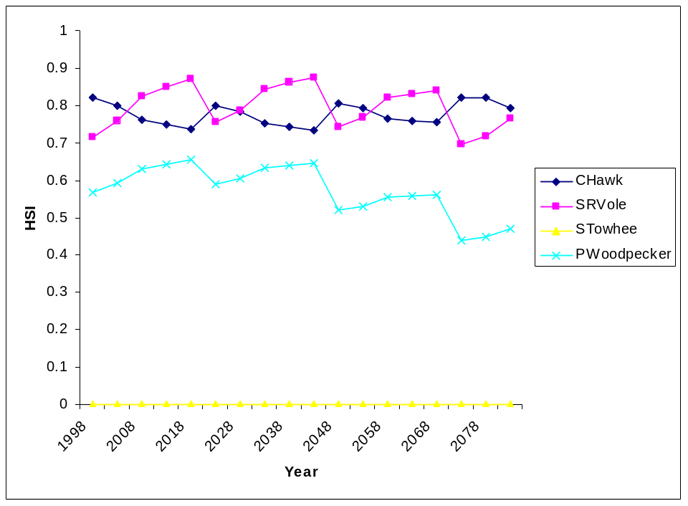

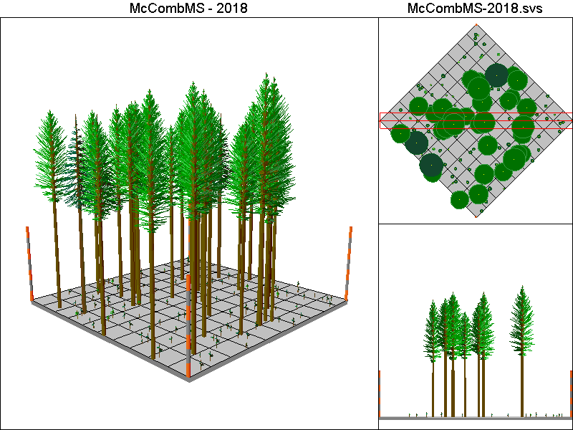
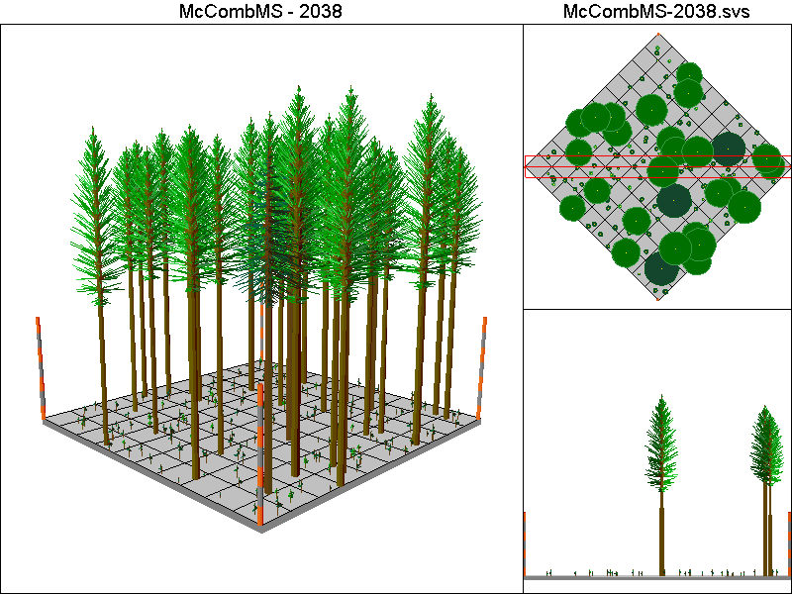
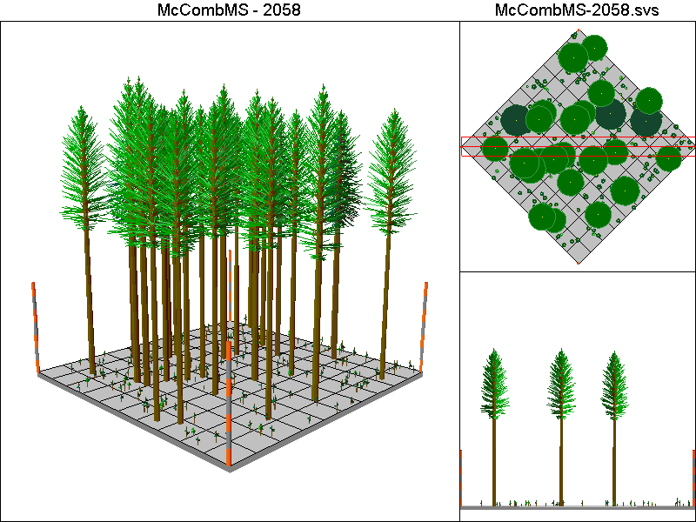
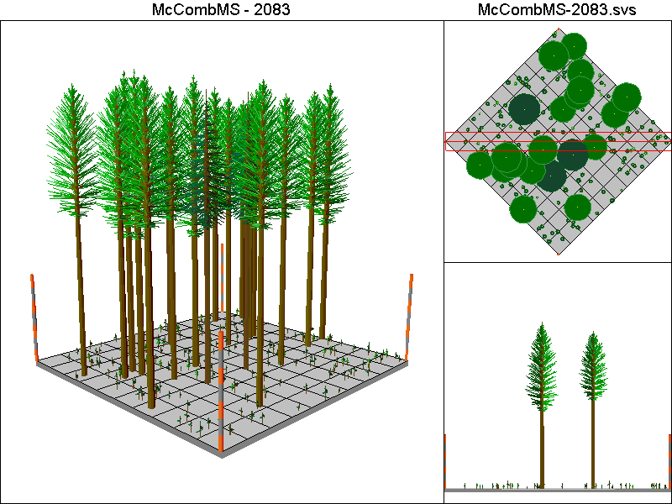

McCombSS Pathway

Harvest Operations:
1998: Harvest leaving 2 TPA, stand is allowed to regenerate naturally
2043: Thin to 70% of initial TPA <12”DBH
2068: Harvest leaving 2 TPA, stand is allowed to regenerate naturally

Cover Type by Period:
1998 | C4T
2003 | C1
2008 | B
2013 | B
2018 | C2
2023 | C3T
2028 | C3
2033 | C3
2038 | C4T
2043 | C4
2048 | C4
2053 | C4
2058 | C4
2063 | C4T
2068 | C4T
2073 | C1
2078 | B
2083 | B

Habitat Suitability Index values for all four species:
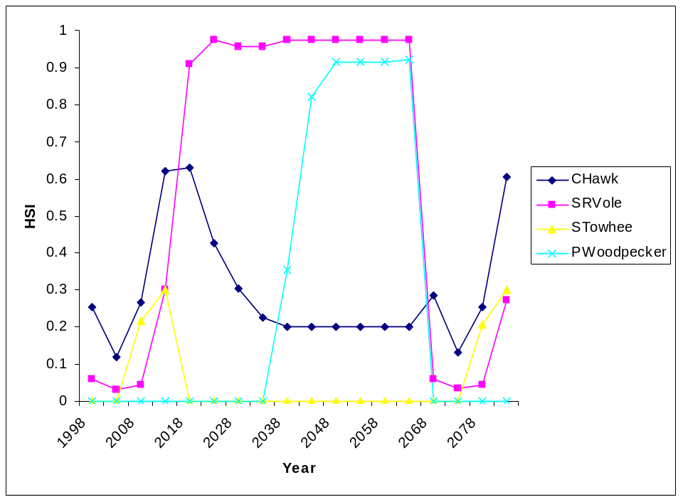i



