H3 Group

Initial Conditions

Stands Age: 78 years
Site index: 90
Stand Density: 263 TPA

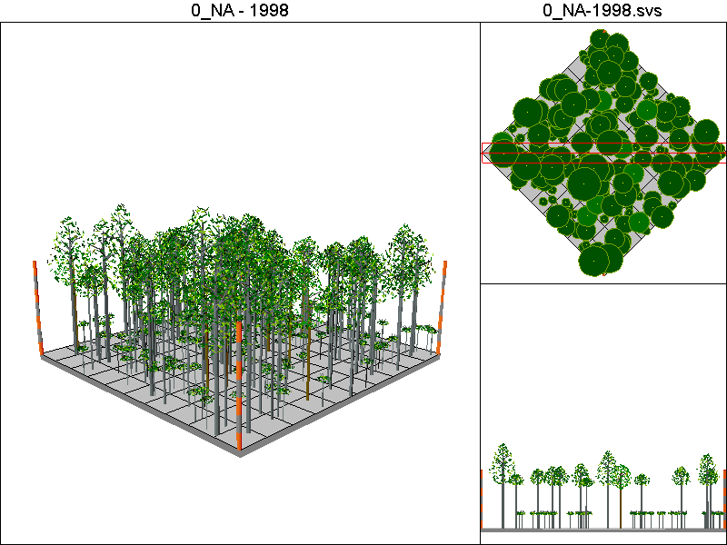

Stand Inventory Table:
Species | DBH | Height | CR | TPA
BM | 15 | 76 | 0.37 | 8.1
RA | 2.1 | 19.3 | 0.11 | 150
RA | 9.6 | 61 | 0.16 | 19.9
RA | 10.7 | 64.9 | 0.19 | 16
RA | 12.5 | 70.6 | 0.23 | 11.7
RA | 13 | 85 | 0.26 | 10.9
RA | 13.7 | 74 | 0.29 | 9.8
RA | 15.1 | 77.7 | 0.34 | 8
RA | 16.5 | 81 | 0.37 | 6.7
RA | 17.7 | 83.7 | 0.39 | 5.8
RA | 20.6 | 89.6 | 0.42 | 4.3
RA | 22.1 | 92.3 | 0.44 | 3.8
RA | 28 | 101.5 | 0.47 | 2.3
RA | 29.5 | 103.5 | 0.5 | 2.1
RA | 31.2 | 105.7 | 0.54 | 1.9
RA | 39 | 114.3 | 0.58 | 1.2

No Action Pathway

Harvest Operations:
None

Cover Type by Period:
1998 | H3
2003 | H3
2008 | H3
2013 | H3
2018 | H3
2023 | H3
2028 | H3
2033 | H3
2038 | H3
2043 | H3
2048 | H3
2053 | H3
2058 | H3
2063 | H3
2068 | H3
2073 | H3
2078 | H3
2083 | H3

Habitat Suitability Index for all four species:
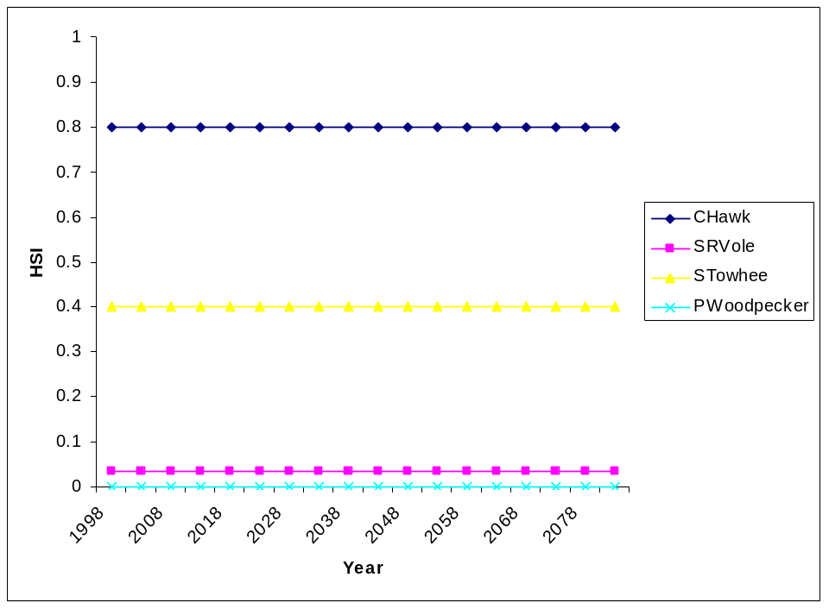

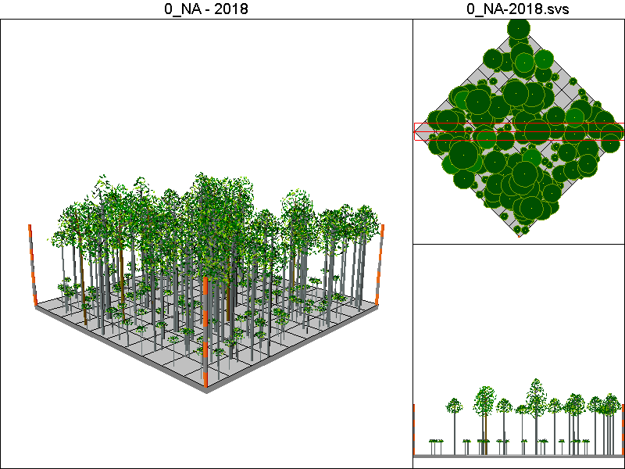
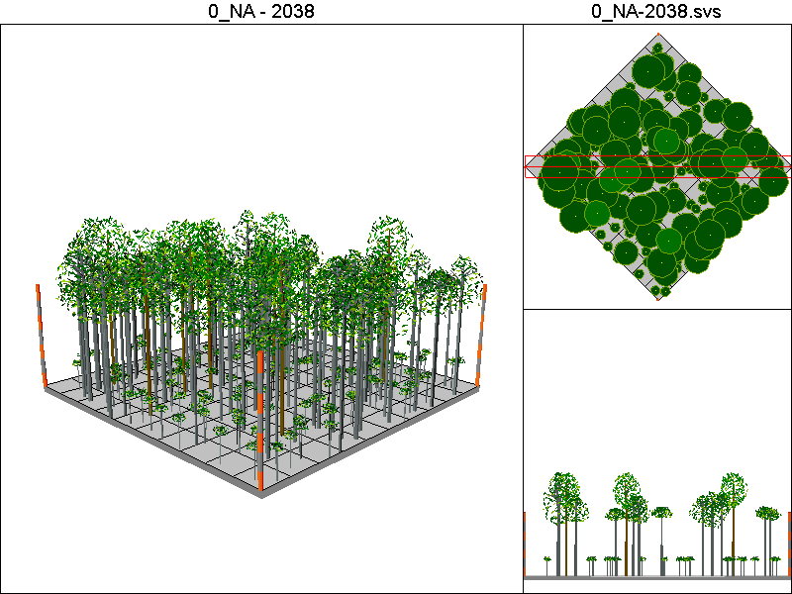
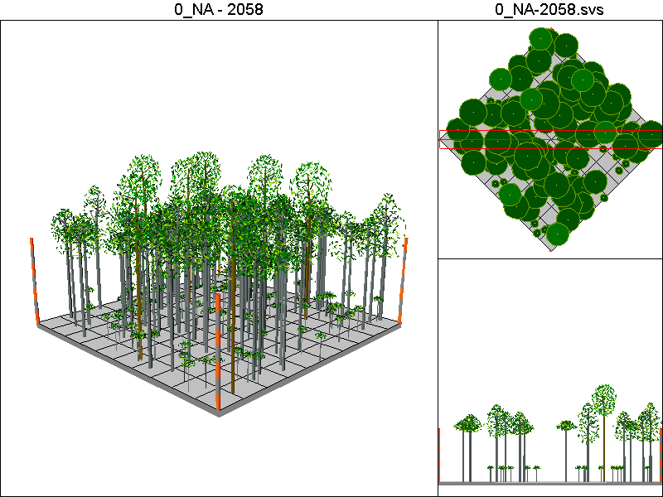
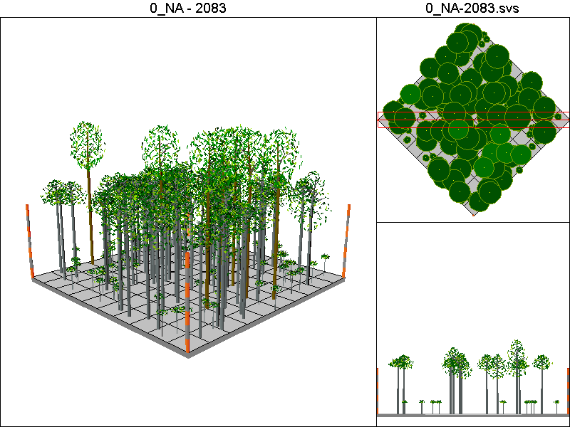

CC40_PCT Pathway

Harvest Operations:
2008: Harvest leaving 5 TPA, plant 400 TPA of Douglas-fir
2023: Thin to 300 TPA
2048: Harvest leaving 5 TPA, plant 400 TPA of Douglas-fir
2063: Thin to 300 TPA

Cover Type by Period:
2008 | B
2013 | B
2018 | M2
2023 | M2
2028 | C3T
2033 | C3
2038 | C3
2043 | C3
2048 | B
2053 | B
2058 | M2
2063 | M2
2068 | C3T
2073 | C3
2078 | C3
2083 | C3
2008 | B
2013 | B

Habitat Suitability Index values for all species:
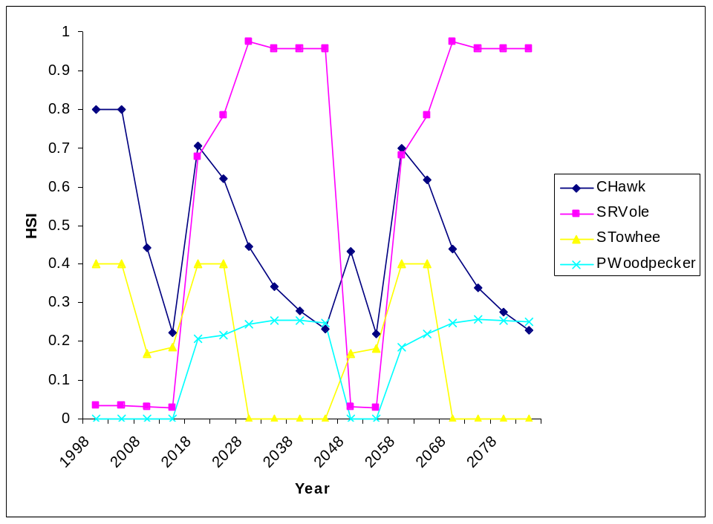

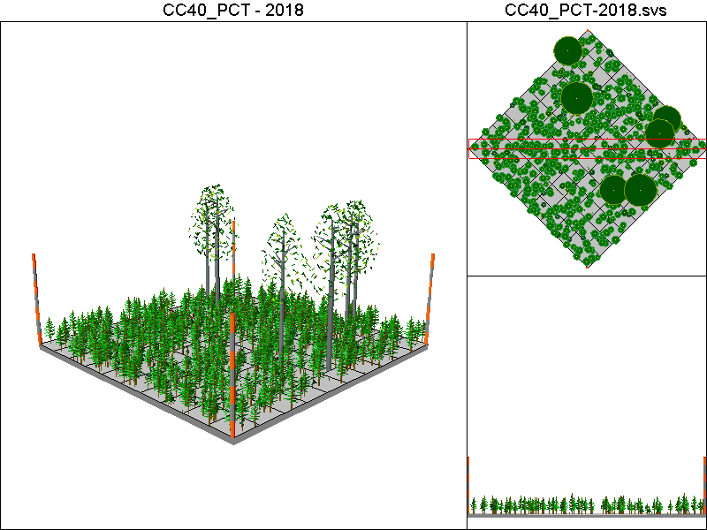
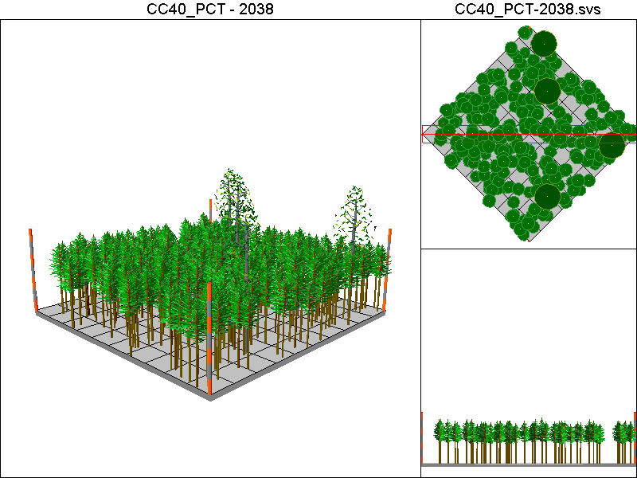
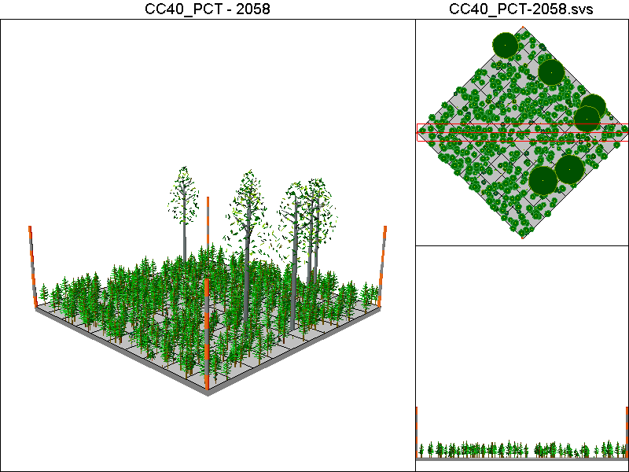
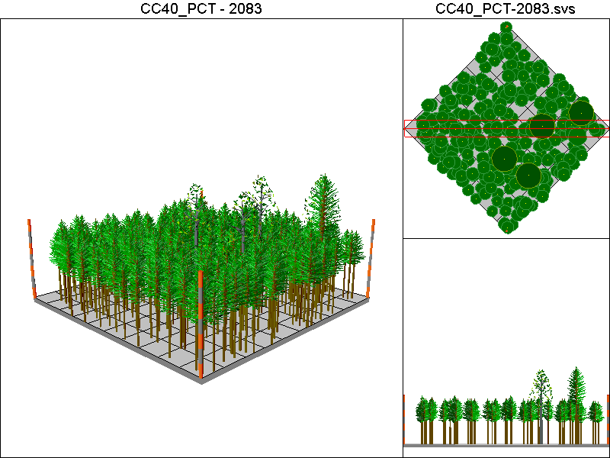

CC60_PCT_CT

Harvest Operations:
2008: Harvest leaving 5 TPA, plant 400 TPA of Douglas-fir
2023: Thin to 300 TPA
2038: Thin to 140ft²/ac of basal area
2068: Harvest leaving 5 TPA, plant 400 TPA of Douglas-fir

Cover Type by Period:
1998 | H3
2003 | H3
2008 | B
2013 | B
2018 | M2
2023 | M2
2028 | C3T
2033 | C3
2038 | C3T
2043 | C3T
2048 | C3T
2053 | C3T
2058 | C4T
2063 | C4T
2068 | B
2073 | B
2078 | M2
2083 | C2

Habitat Suitability Index values for all four species:
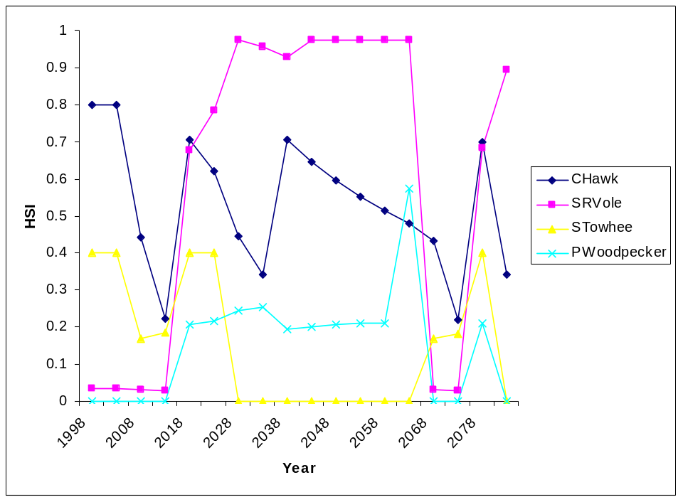
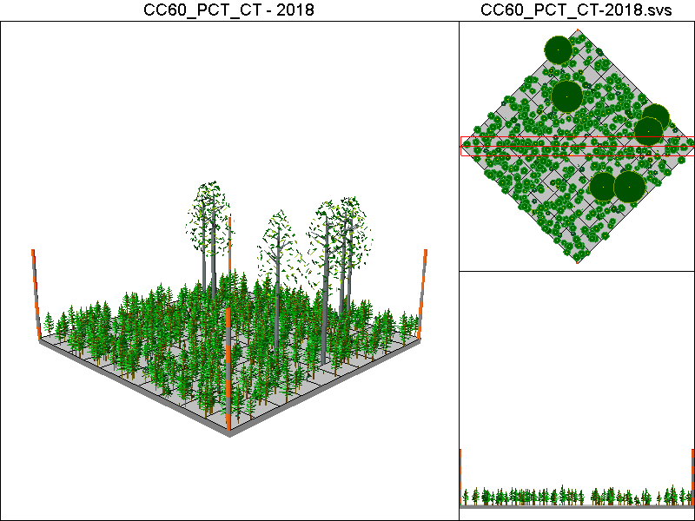
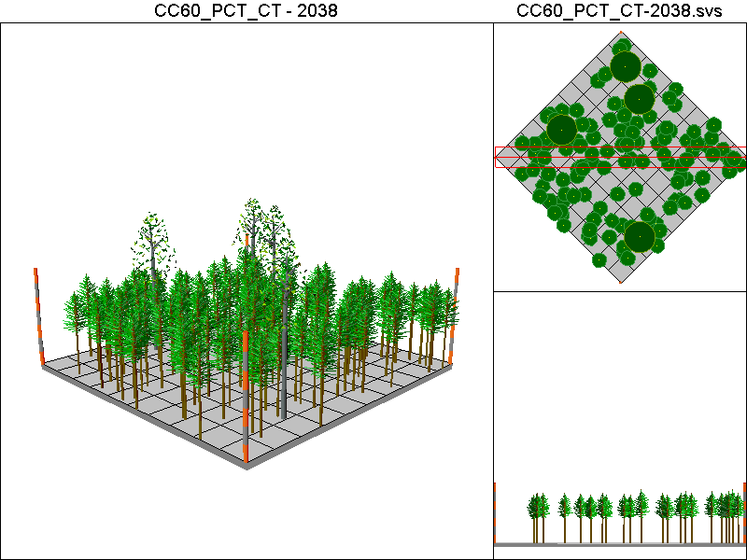
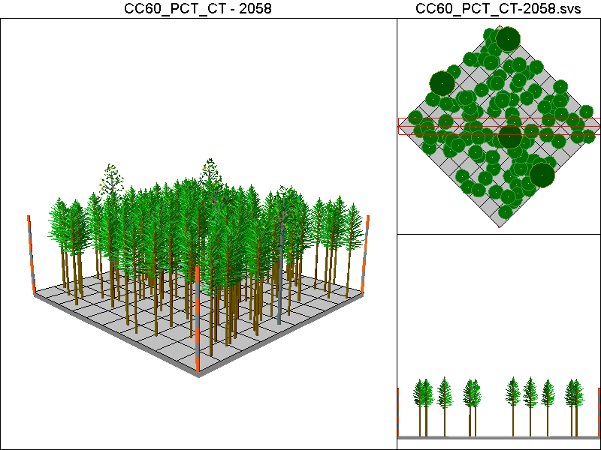
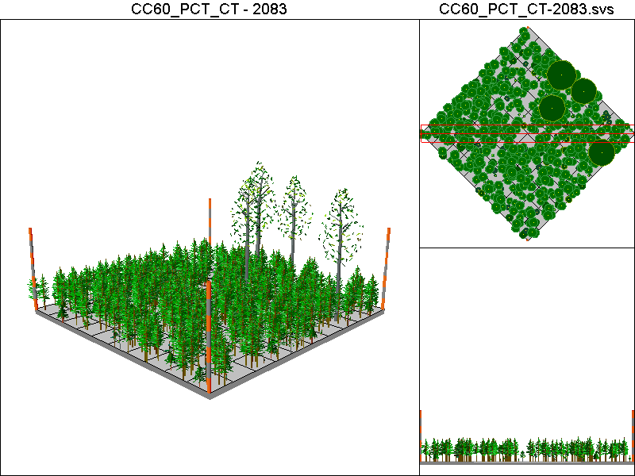

DEMO20 Pathway

Harvest Operations:
2008: Thin to 20% of the initial TPA

Cover Type by Period:
1998 | H3
2003 | H3
2008 | H3
2013 | H3
2018 | H3
2023 | H3
2028 | H3
2033 | H3
2038 | H3
2043 | H3
2048 | H3
2053 | H3
2058 | H3
2063 | H3
2068 | H3
2073 | H3
2078 | H3
2083 | H3

Habitat Suitability Index values for all four species:
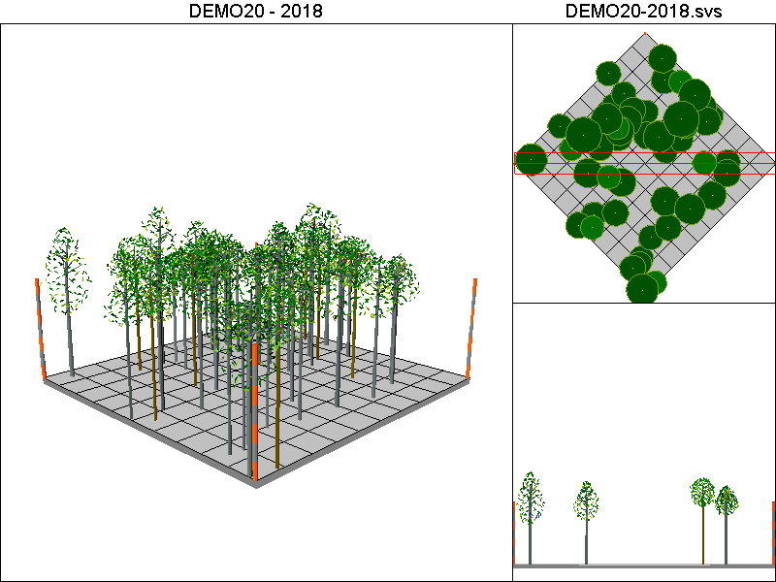
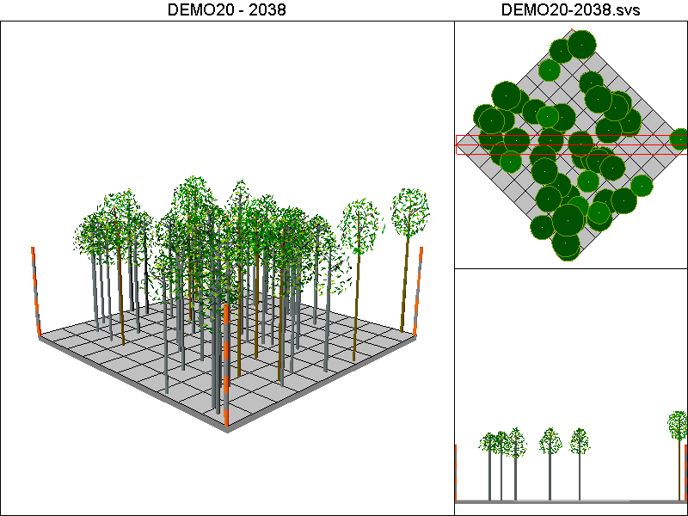
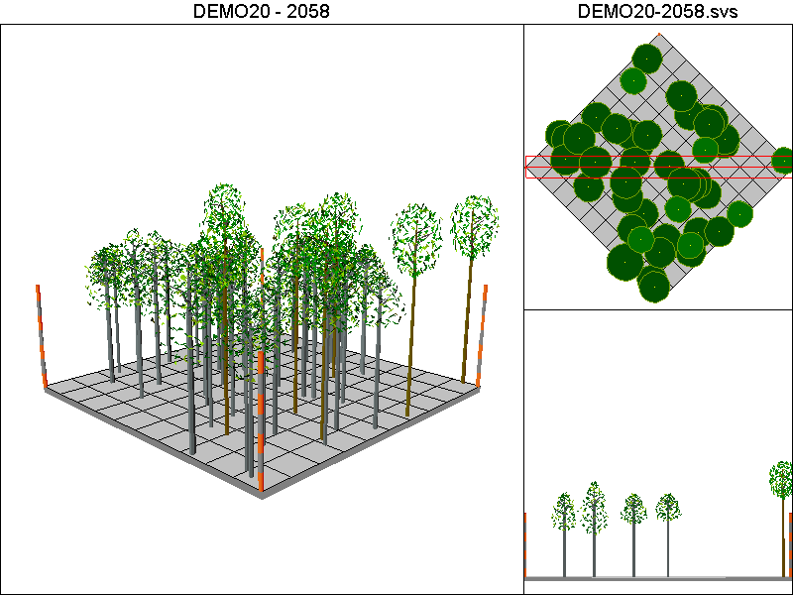
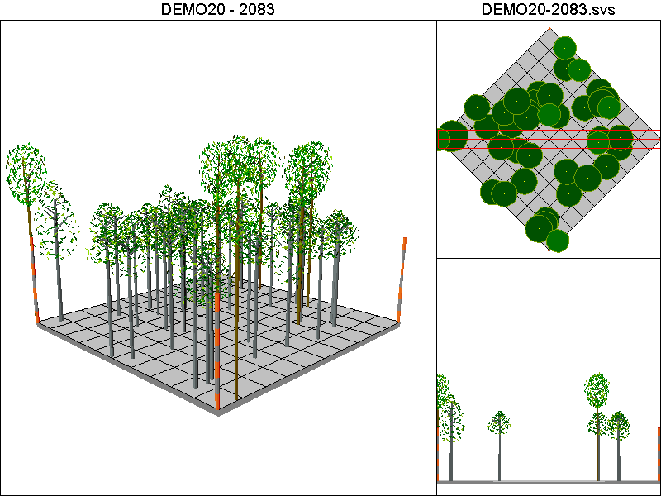

DEMO40 Pathway

Harvest Operations
2008: Thin to 40% of the original TPA

Cover Type by Period:
1998 | H3
2003 | H3
2008 | H3
2013 | H3
2018 | H3
2023 | H3
2028 | H3
2033 | H3
2038 | H3
2043 | H3
2048 | H3
2053 | H3
2058 | H3
2063 | H3
2068 | H3
2073 | H3
2078 | H3
2083 | H3

Habitat Suitability Index values for all four species:

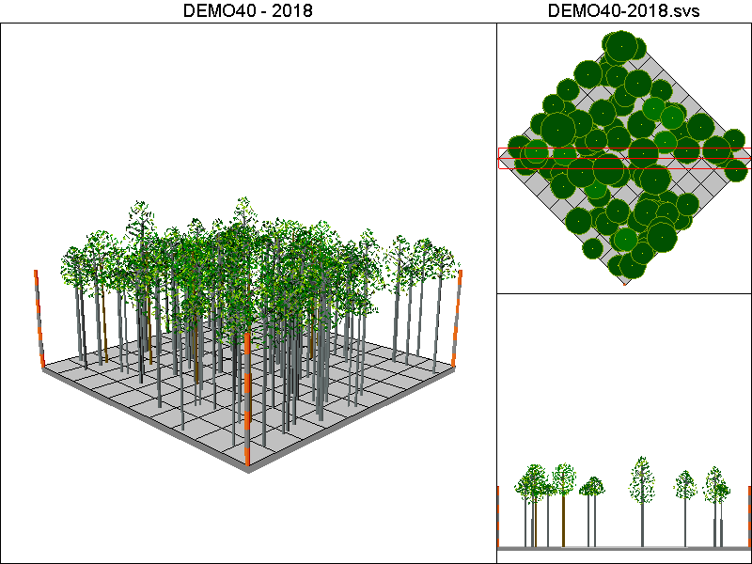
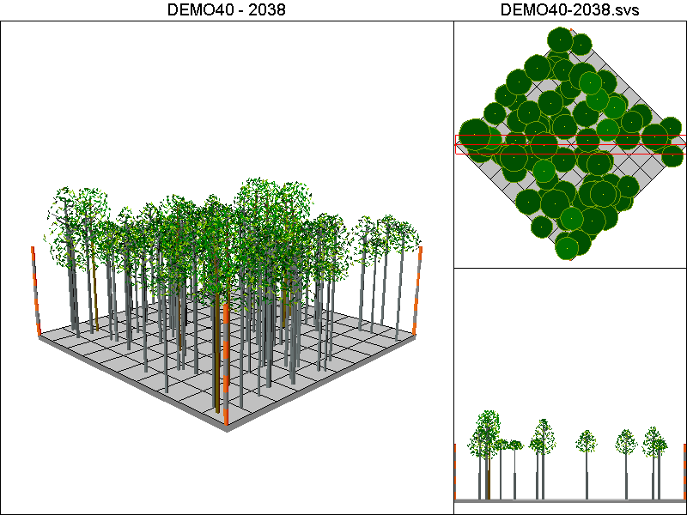
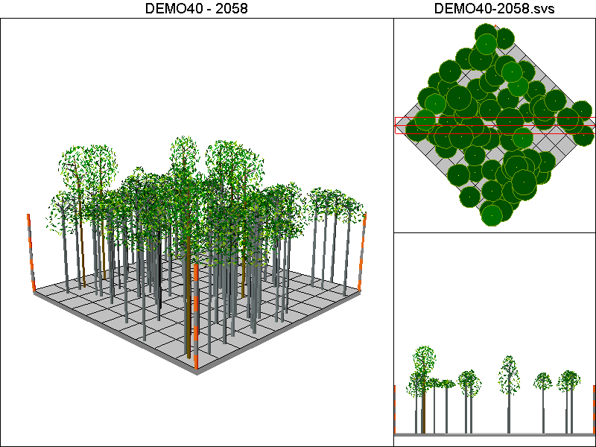
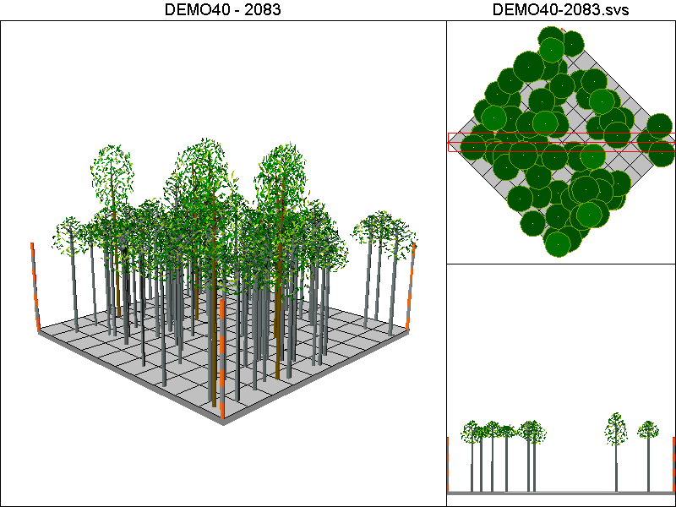

Hanseen10-40 Pathway:

Harvest Operations:
2008: Harvest leaving 4 TPA, plant 400 TPA of Douglas-fir
2023: Thin to 220 TPA <12”DBH leaving all trees >12”DBH
2038: Thin to 220 TPA <12”DBH leaving all trees >12”DBH
2048: Harvest leaving 4 TPA, plant 400 TPA of Douglas-fir
2063: Thin to 220 TPA <12”DBH leaving all trees >12”DBH
2078: Thin to 220 TPA <12”DBH leaving all trees >12”DBH

Cover Type by Period:
1998 | H3
2003 | H3
2008 | B
2013 | B
2018 | M2
2023 | M2
2028 | C3T
2033 | C3T
2038 | C3
2043 | C3
2048 | B
2053 | B
2058 | M2
2063 | M2
2068 | C3T
2073 | C3T
2078 | C3
2083 | C3

Habitat Suitability Index values for all four species:
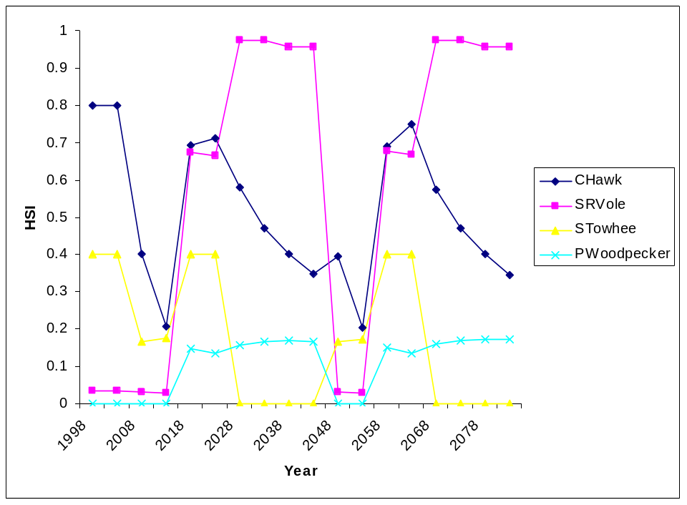

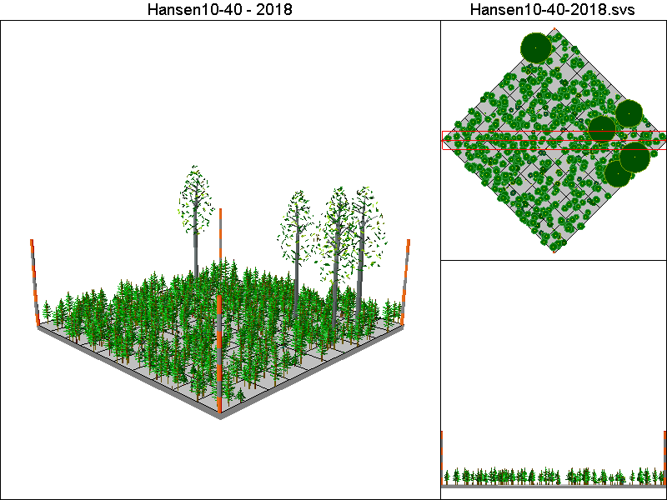
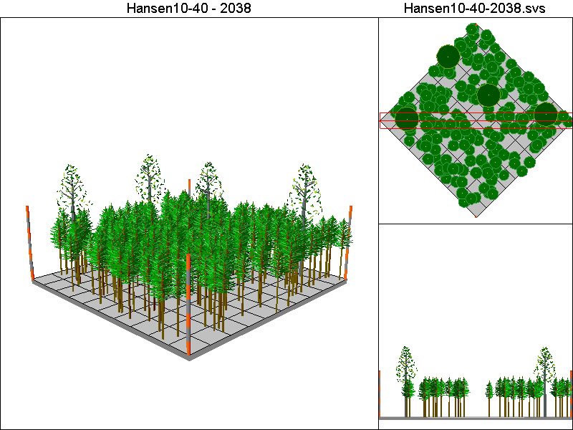
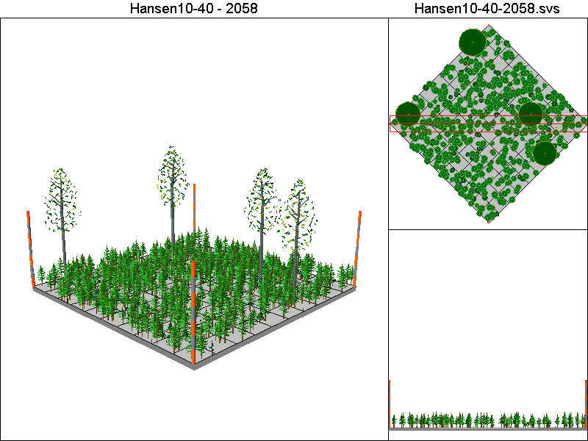
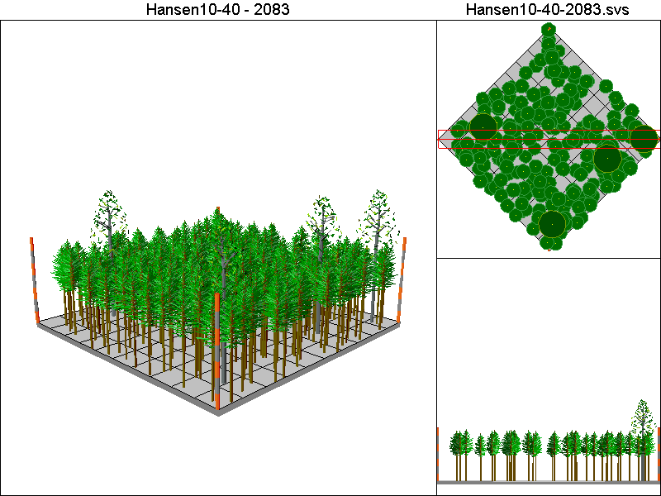

Hansen150-120 Pathway

Harvest Operations:
2008: Thin to 60 TPA, plant 400 TPA of Douglas-fir
2023: Thin to 220 TPA <12”DBH leaving all trees >12”DBH
2038: Thin to 220 TPA <12”DBH leaving all trees >12”DBH

Cover Type by Period:
1998 | H3
2003 | H3
2008 | H3
2013 | H3
2018 | H3
2023 | H3
2028 | H3
2033 | H3
2038 | H3
2043 | M3
2048 | M3
2053 | M3
2058 | M3
2063 | M3
2068 | M3
2073 | M3
2078 | M3
2083 | M3

Habitat Suitability Index values for all four species:
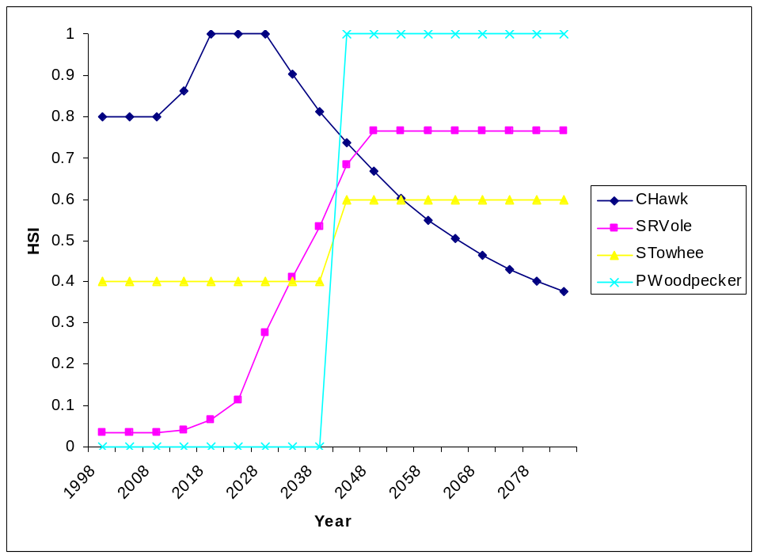

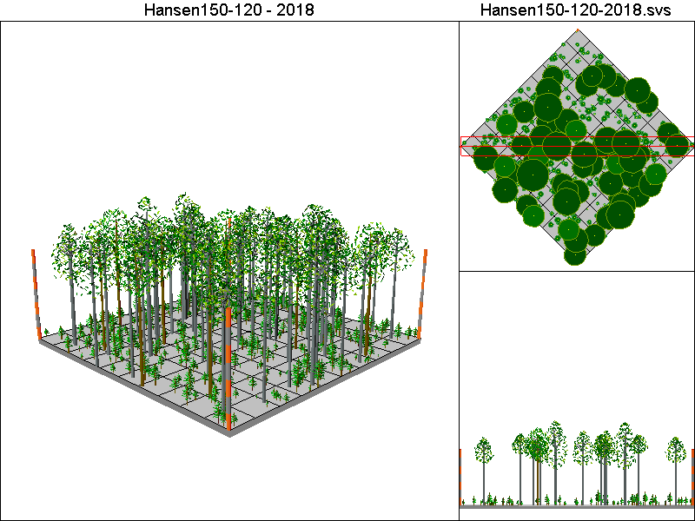
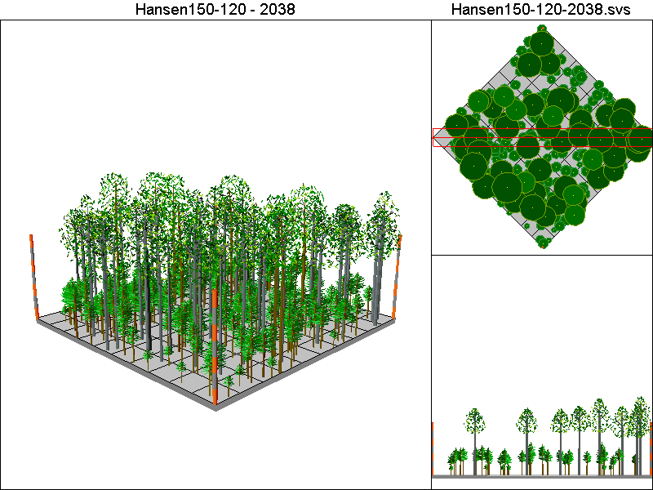
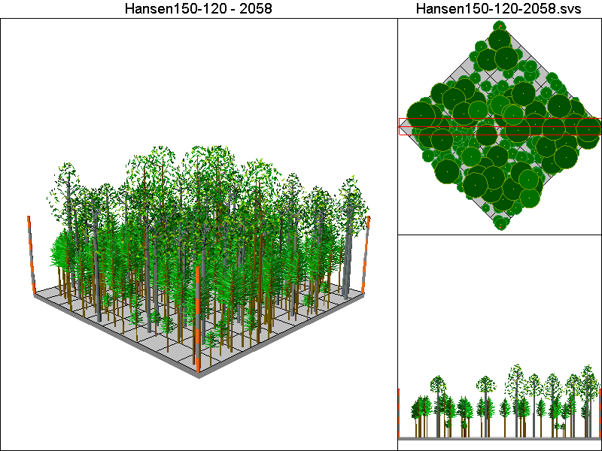
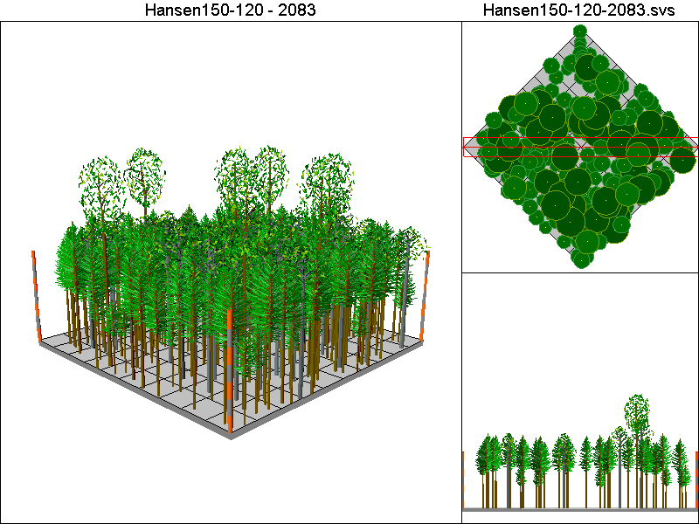

Hansen150-40 Pathway

Harvest Operations:
2008: Thin to 60 TPA, plant 400 TPA of Douglas-fir
2023: Thin to 220 TPA <12”DBH leaving all trees >12”DBH
2038: Thin to 220 TPA <12”DBH leaving all trees >12”DBH
2048: Thin to 60 TPA, plant 400 TPA of Douglas-fir
2063: Thin to 220 TPA <12”DBH leaving all trees >12”DBH
2078: Thin to 220 TPA <12”DBH leaving all trees >12”DBH

Cover Type by Period:
1998 | H3
2003 | H3
2008 | H3
2013 | H3
2018 | H3
2023 | H3
2028 | H3
2033 | H3
2038 | H3
2043 | M3
2048 | H3
2053 | H3
2058 | H3
2063 | H3
2068 | H3
2073 | H3
2078 | H3
2083 | H3

Habitat Suitability Index values for all four species:
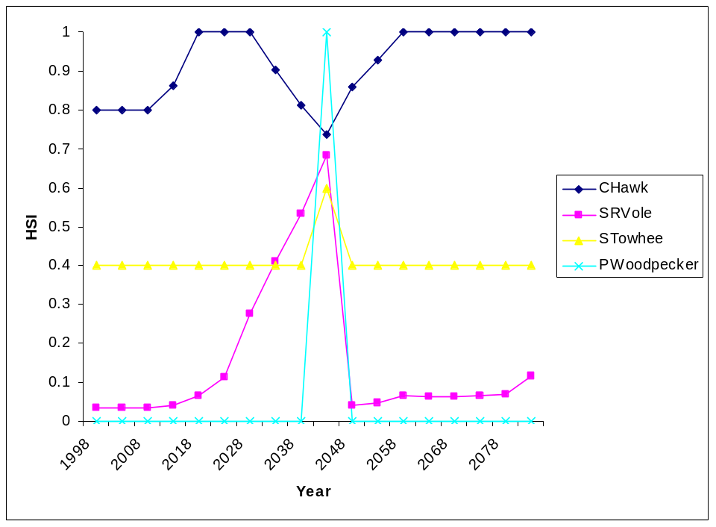

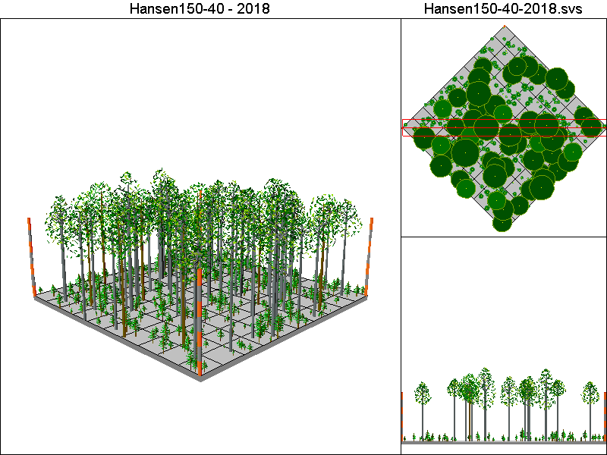
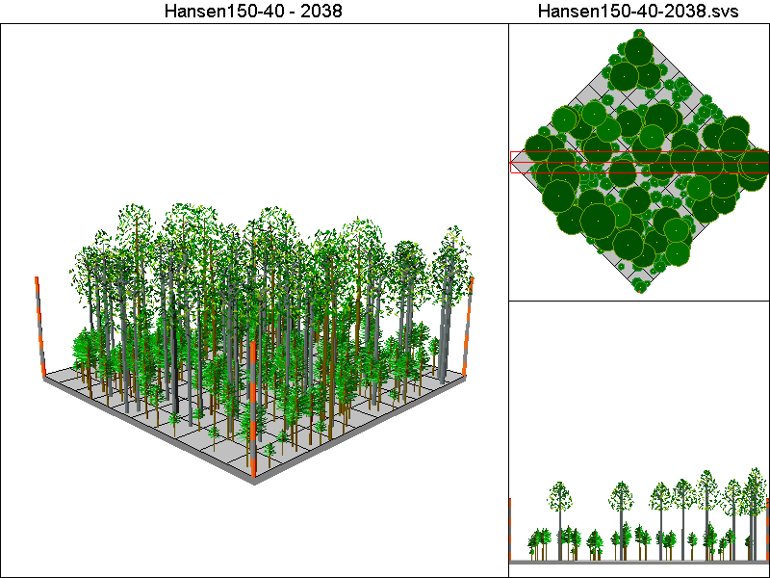
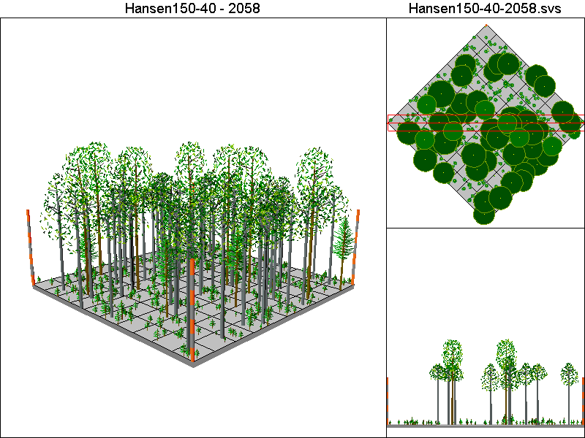
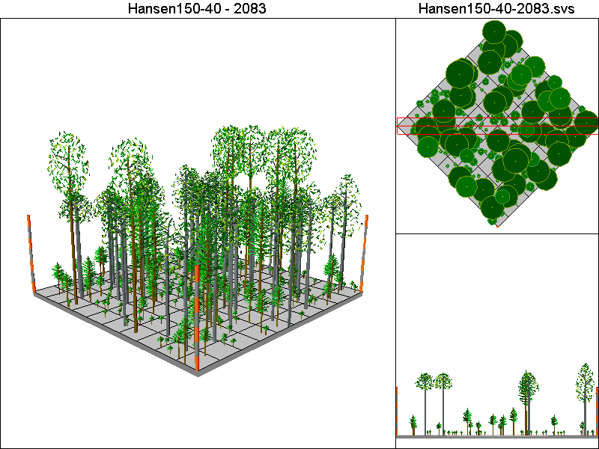

Hansen150-80 Pathway

Harvest Operations:
2008: Thin to 60 TPA, plant 400 TPA of Douglas-fir
2023: Thin to 220 TPA <12”DBH leaving all trees >12”DBH
2038: Thin to 220 TPA <12”DBH leaving all trees >12”DBH

Cover Type by Period:
1998 | H3
2003 | H3
2008 | H3
2013 | H3
2018 | H3
2023 | H3
2028 | H3
2033 | H3
2038 | H3
2043 | M3
2048 | M3
2053 | M3
2058 | M3
2063 | M3
2068 | M3
2073 | M3
2078 | M3
2083 | M3

Habitat Suitability Index values for all four species:

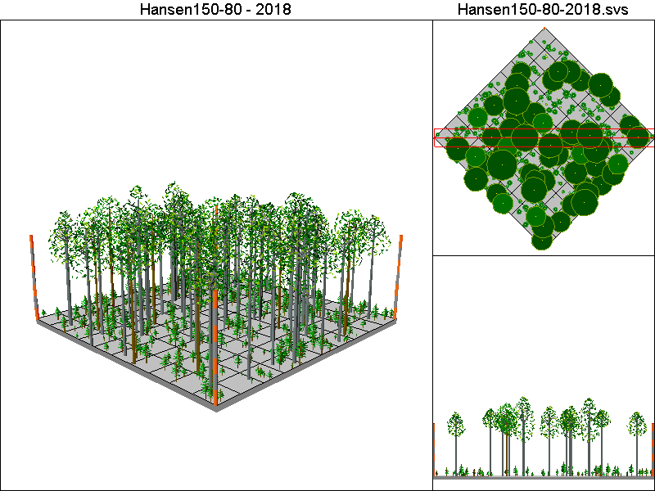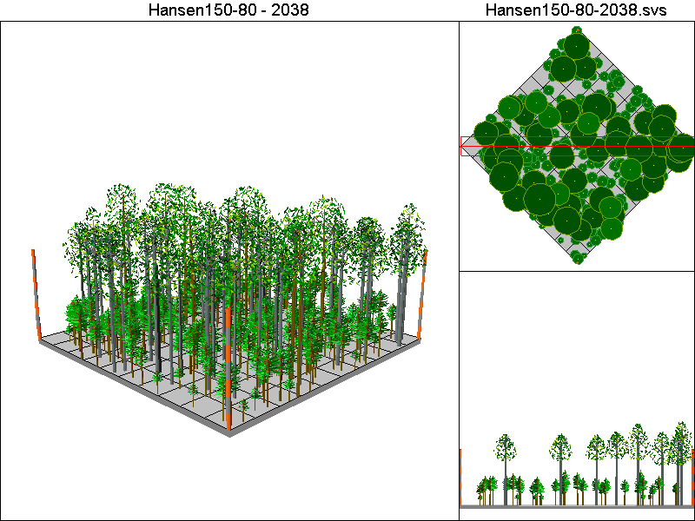
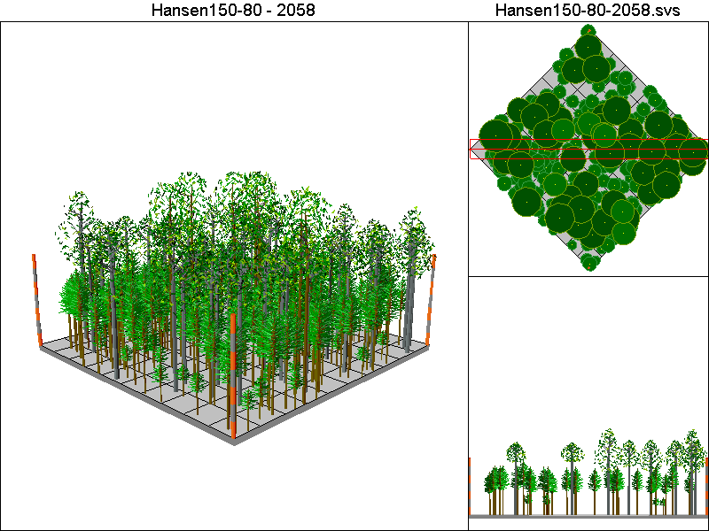
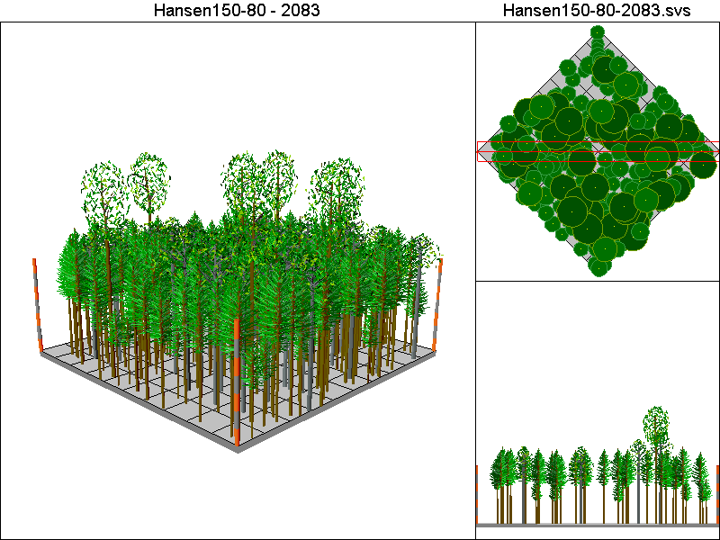

Hansen30-40 Pathway

Harvest Operations:
2008: Thin to 12 TPA, plant 400 TPA of Douglas-fir
2023: Thin to 220 TPA <12”DBH leaving all trees >12”DBH
2038: Thin to 220 TPA <12”DBH leaving all trees >12”DBH
2048: Thin to 12 TPA, plant 400 TPA of Douglas-fir
2063: Thin to 220 TPA <12”DBH leaving all trees >12”DBH
2078: Thin to 220 TPA <12”DBH leaving all trees >12”DBH

Cover Type by Period:
1998 | H3
2003 | H3
2008 | B
2013 | B
2018 | M2
2023 | M3T
2028 | M3T
2033 | M3T
2038 | M3
2043 | C3
2048 | B
2053 | B
2058 | M2
2063 | M3T
2068 | M3T
2073 | M3T
2078 | M3
2083 | C3

Habitat Suitability Index values for all four species:
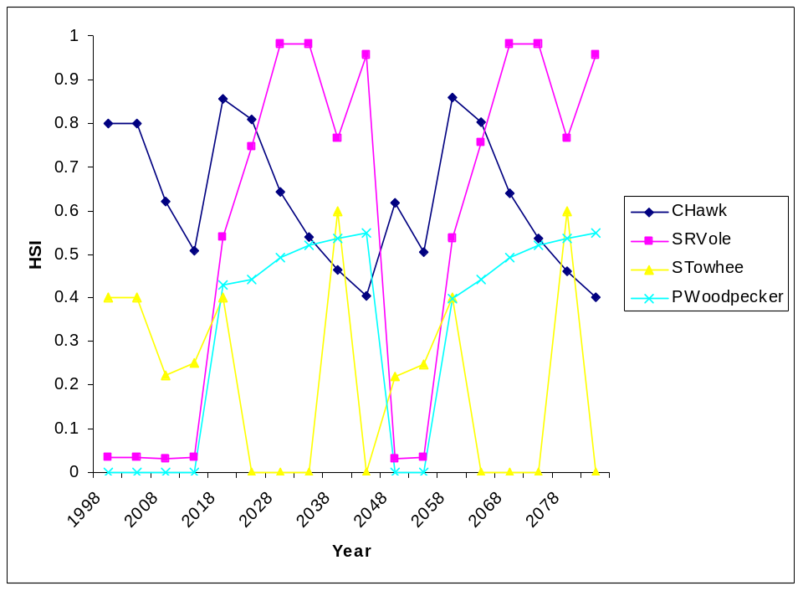

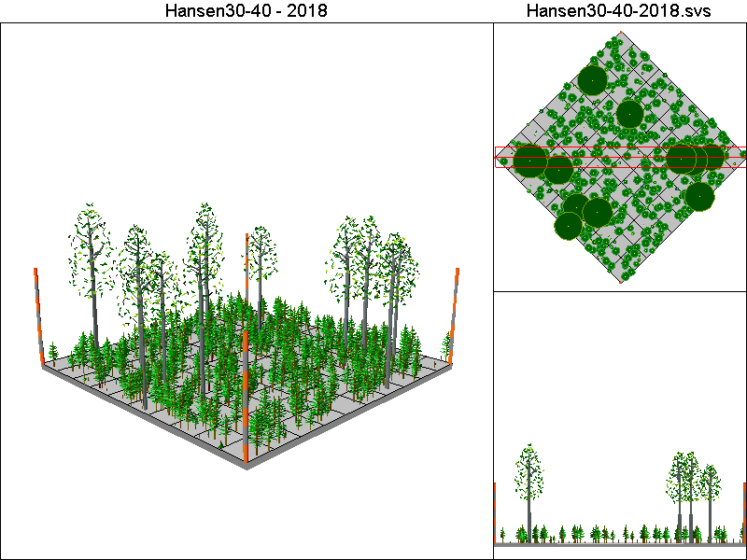
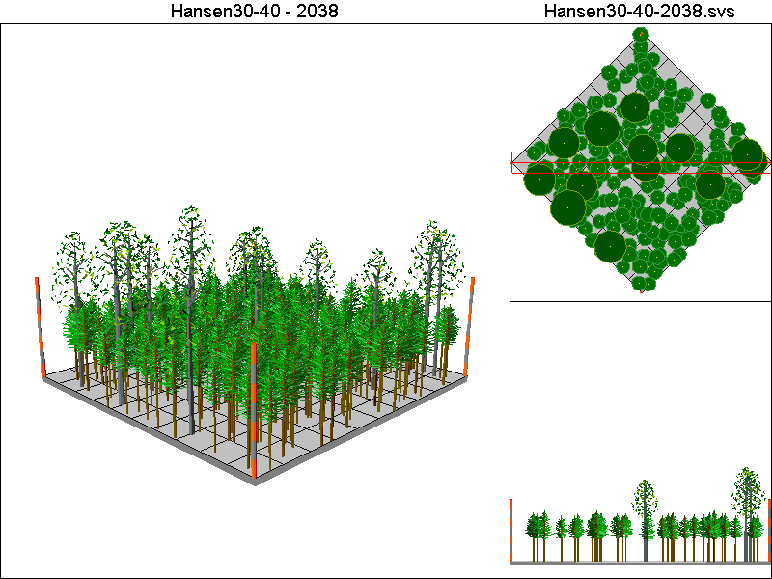
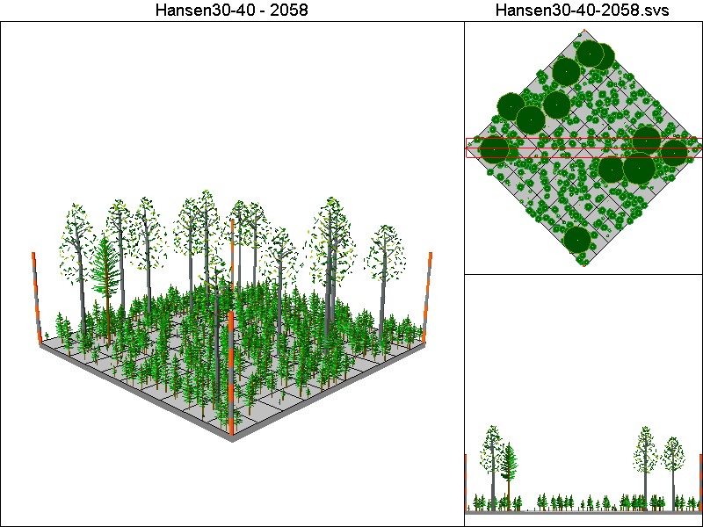
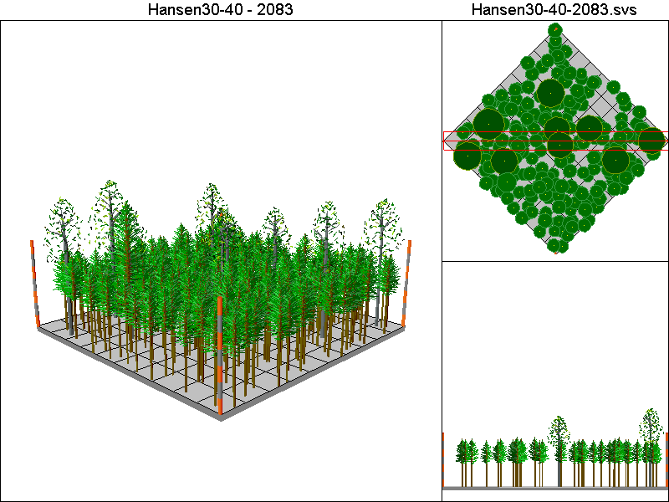

Hansen50-40 Pathway

Harvest Operations:
2008: Thin to 20 TPA, plant 400 TPA of Douglas-fir
2023: Thin to 220 TPA <12”DBH leaving all trees >12”DBH
2038: Thin to 220 TPA <12”DBH leaving all trees >12”DBH
2048: Thin to 20 TPA, plant 400 TPA of Douglas-fir
2063: Thin to 220 TPA <12”DBH leaving all trees >12”DBH
2078: Thin to 220 TPA <12”DBH leaving all trees >12”DBH

Cover Type by Period:
1998 | H3
2003 | H3
2008 | B
2013 | B
2018 | H3
2023 | M3T
2028 | M3T
2033 | M3T
2038 | M3
2043 | M3
2048 | B
2053 | B
2058 | H3
2063 | M3T
2068 | M3T
2073 | M3T
2078 | M3
2083 | M3

Habitat Suitability Index values for all four species:
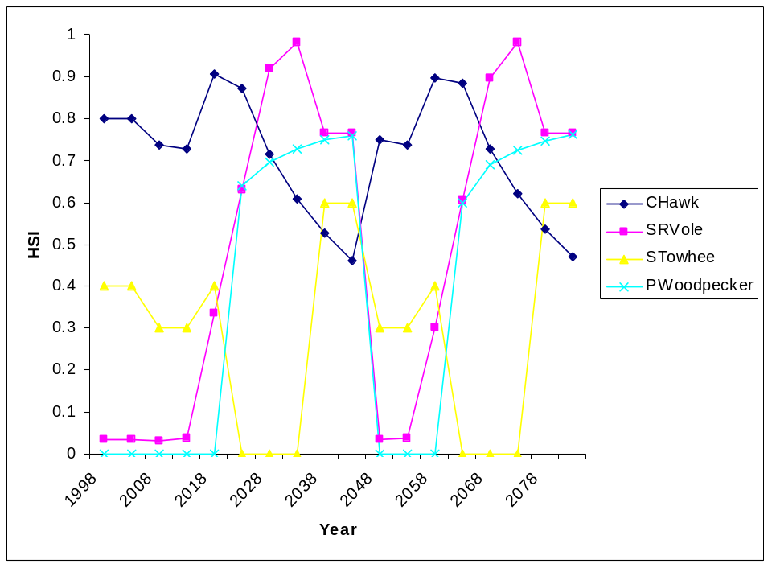

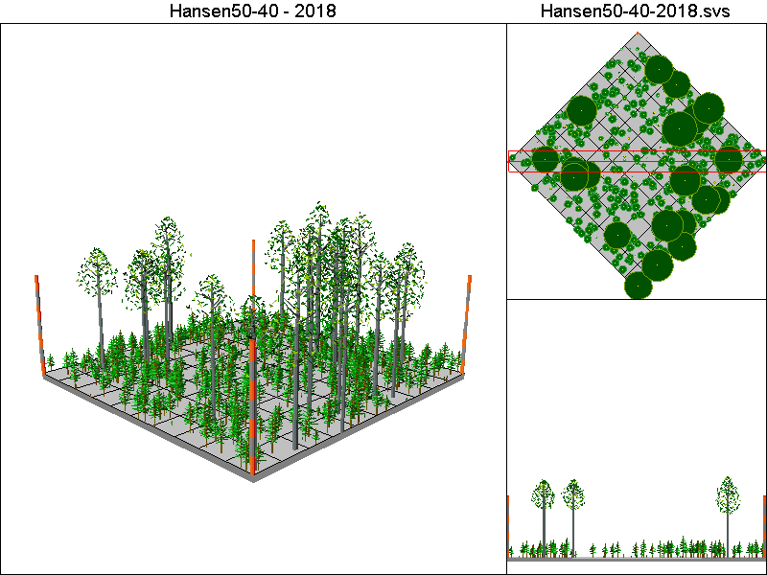
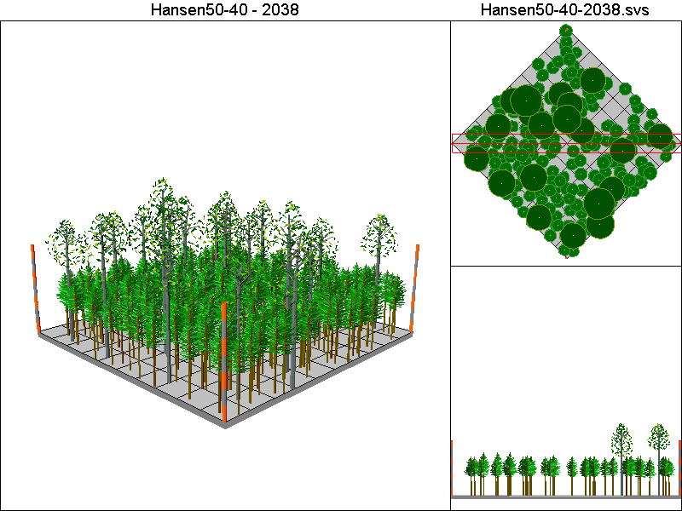
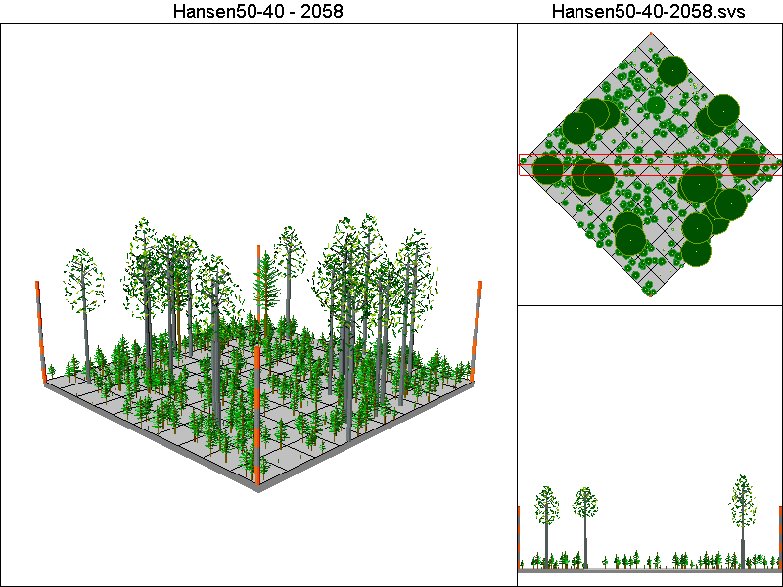
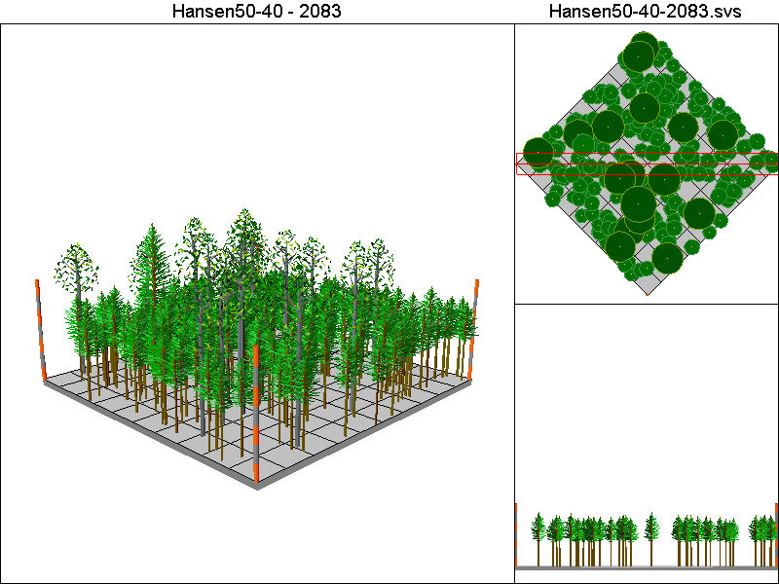

Hansen5-40 Pathway

Harvest Operations:
2008: Thin to 2 TPA, plant 400 TPA of Douglas-fir
2023: Thin to 220 TPA <12”DBH leaving all trees >12”DBH
2038: Thin to 220 TPA <12”DBH leaving all trees >12”DBH
2048: Thin to 2 TPA, plant 400 TPA of Douglas-fir
2063: Thin to 220 TPA <12”DBH leaving all trees >12”DBH
2078: Thin to 220 TPA <12”DBH leaving all trees >12”DBH

Cover Type by Period:
1998 | H3
2003 | H3
2008 | B
2013 | B
2018 | M2
2023 | B
2028 | C2
2033 | C3T
2038 | C3
2043 | C3
2048 | B
2053 | B
2058 | M2
2063 | B
2068 | C2
2073 | C3T
2078 | C3
2083 | C3

Habitat Suitability index values for all four species:
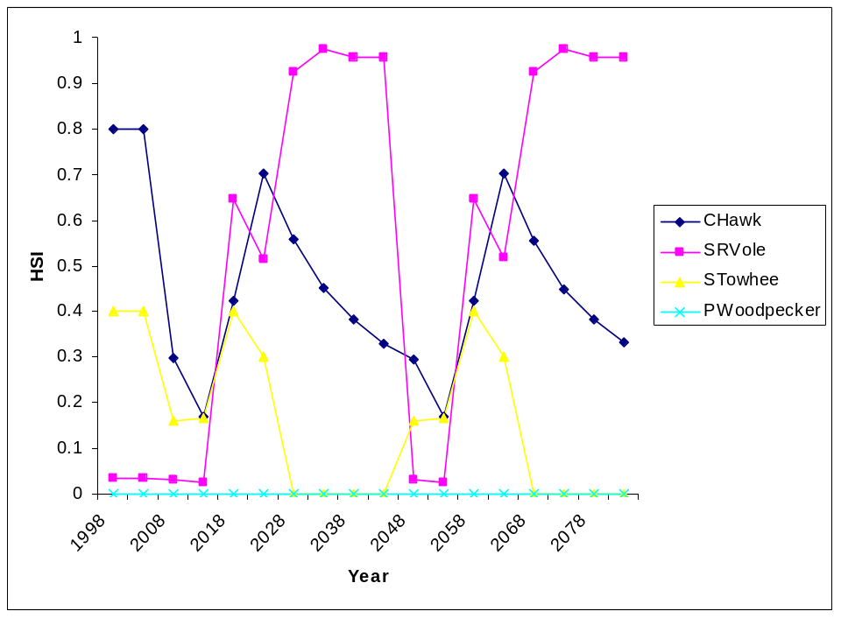

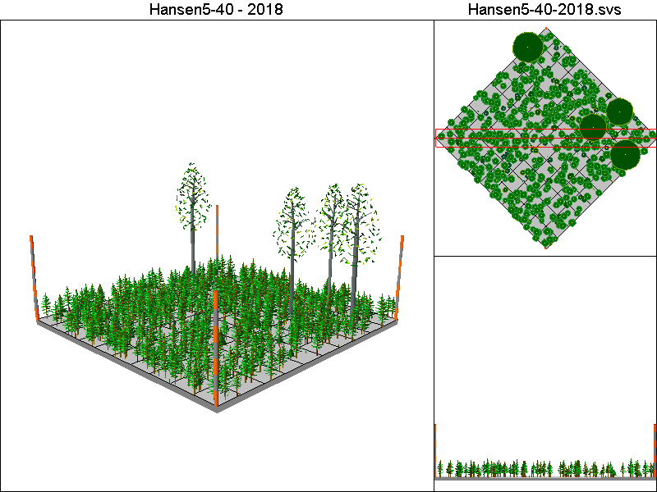
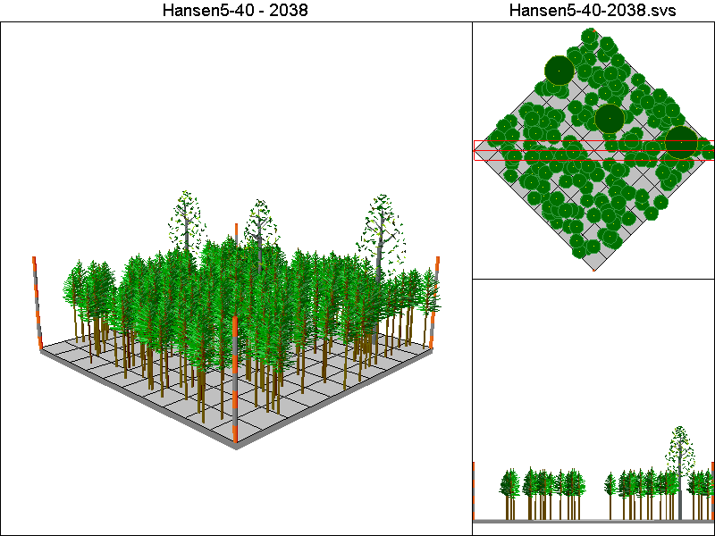
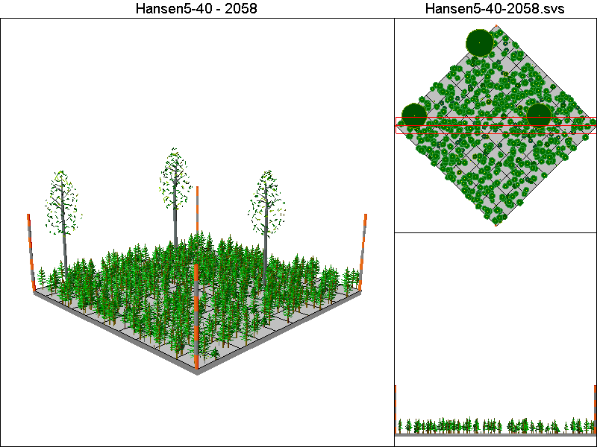
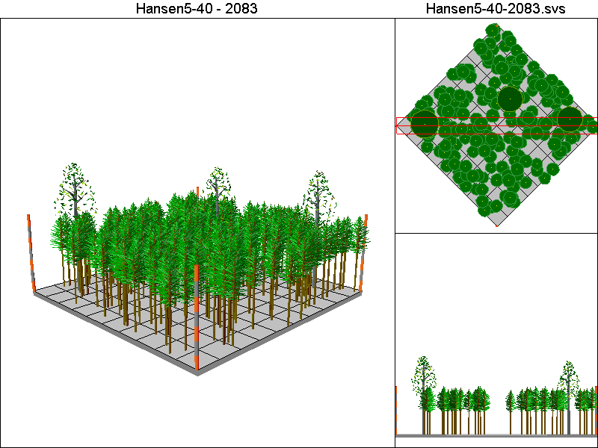

Marzluff-IE-G4 Pathway

Harvest Operations:
2008: Thin to 25 TPA in 8” – 20”DBH class, thin to 25 TPA >20”DBH
2048: Thin to 25 TPA in 8” – 20”DBH class

Cover Type by Period:
1998 | H3
2003 | H3
2008 | B
2013 | B
2018 | B
2023 | B
2028 | B
2033 | B
2038 | B
2043 | B
2048 | M3T
2053 | M3T
2058 | M3T
2063 | M3T
2068 | M3T
2073 | M3T
2078 | M3T
2083 | M3T

Habitat Suitability Index values for all four species:
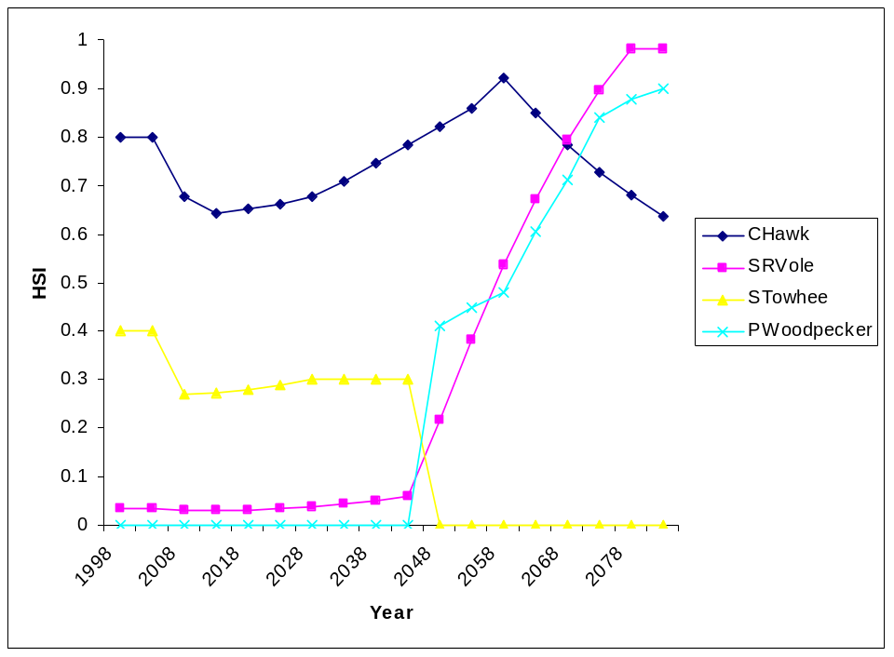

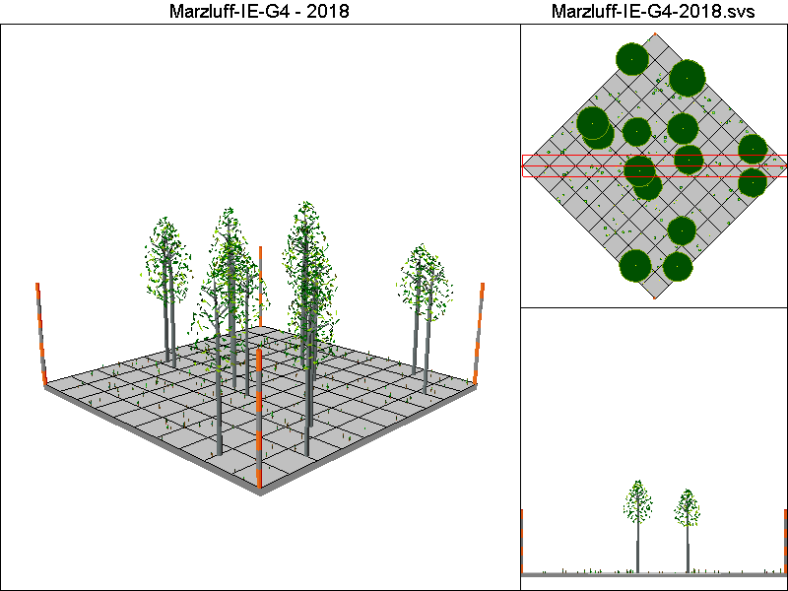
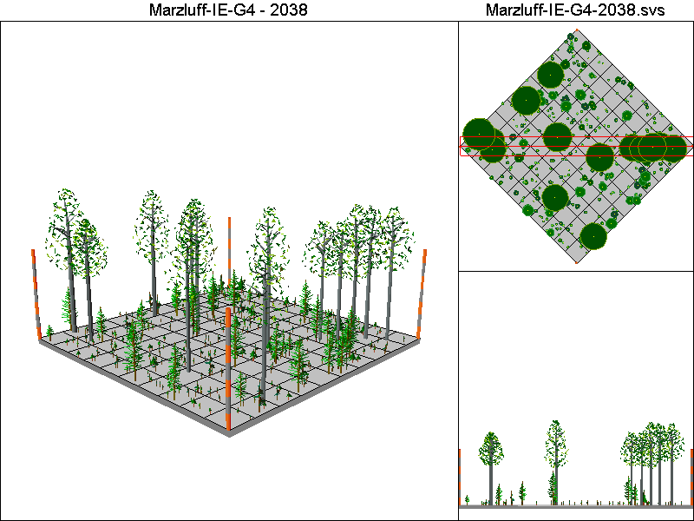
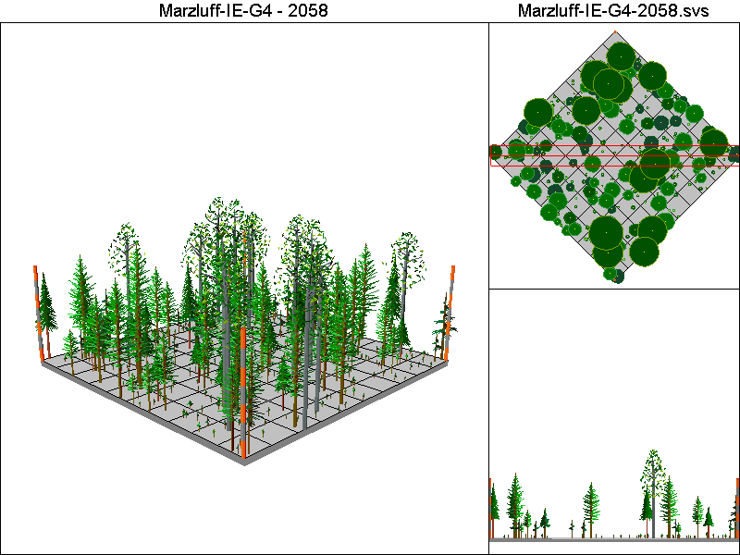
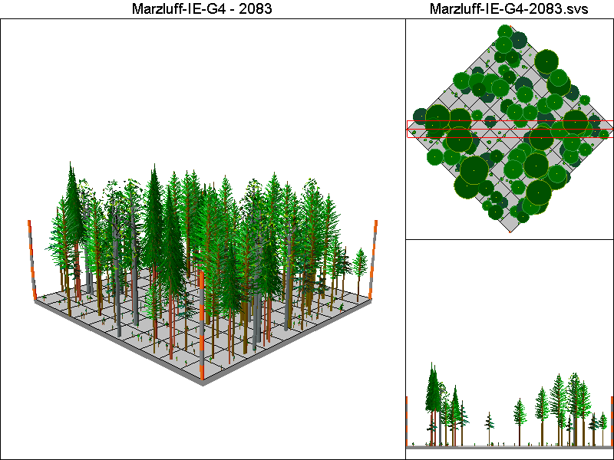

McCombMS Pathway

Harvest Operations:
2008: Thin to 24% of initial TPA, plant 16 TPA of Douglas-fir and 104 TPA of western hemlock
2033: Thin to 84% of initial TPA >12”DBH, thin to 55% of initial TPA <12”DBH, plant 16 TPA of Douglas-fir and 104 TPA of western hemlock
2058: Thin to 84% of initial TPA >12”DBH, thin to 55% of initial TPA <12”DBH, plant 16 TPA of Douglas-fir and 104 TPA of western hemlock
2083: Thin to 84% of initial TPA >12”DBH, thin to 55% of initial TPA <12”DBH, plant 16 TPA of Douglas-fir and 104 TPA of western hemlock

Cover Type by Period:
1998 | H3
2003 | H3
2008 | H3
2013 | H3
2018 | H3
2023 | H3
2028 | H3
2033 | H3
2038 | H3
2043 | H3
2048 | H3
2053 | H3
2058 | H3
2063 | H3
2068 | H3
2073 | H3
2078 | H3
2083 | H3

Habitat Suitability Index values for all four species:
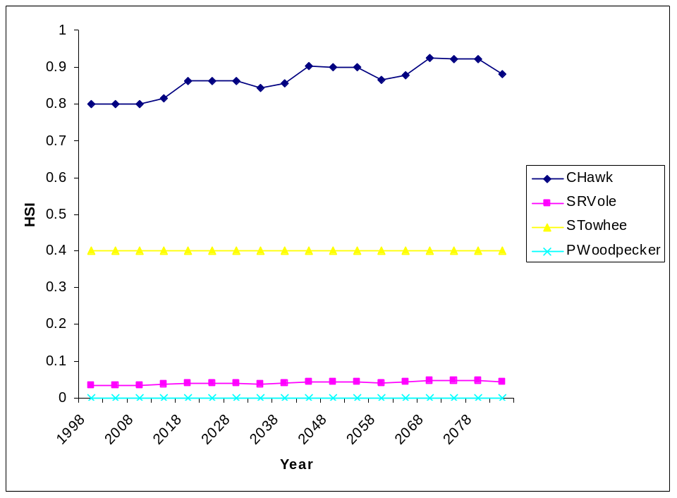

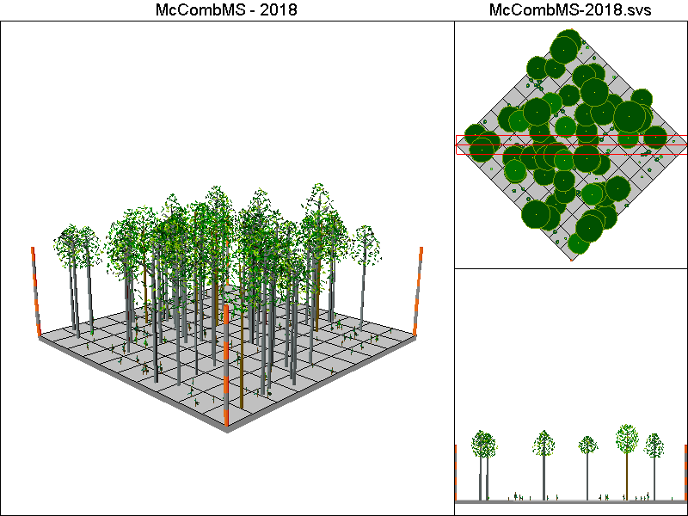
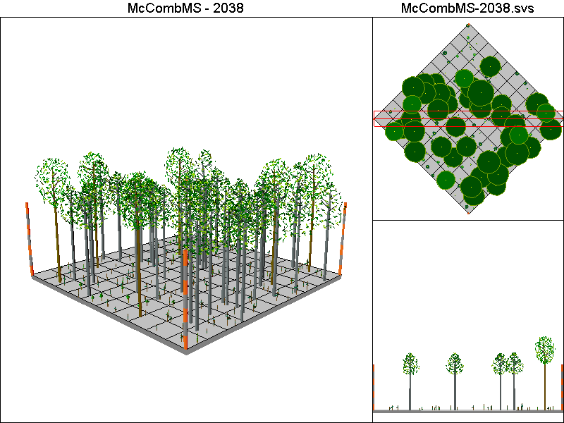
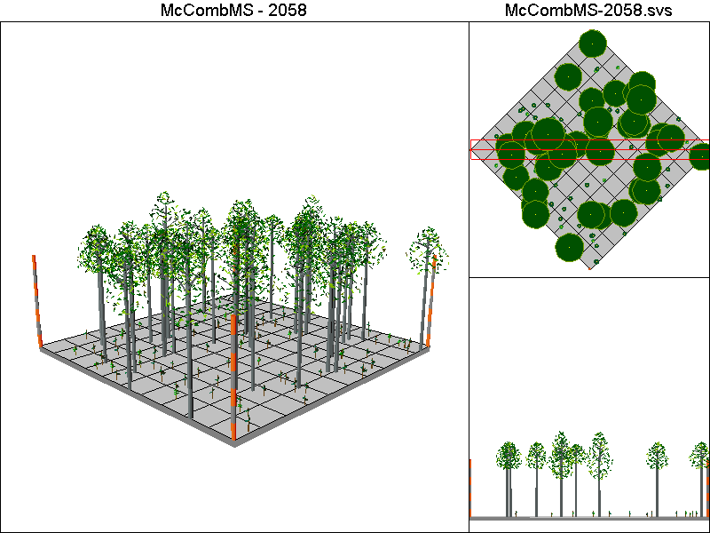
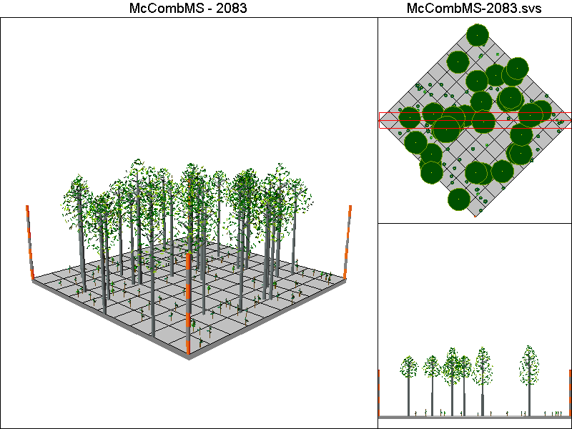

McCombSS Pathway

Harvest Operations:
2008: Harvest leaving 2 TPA, stand is allowed to regenerate naturally
2053: Thin to 70% of initial TPA <12”DBH
2078: Harvest leaving 2 TPA, stand is allowed to regenerate naturally

Cover Type by Period:
1998 | H3
2003 | H3
2008 | B
2013 | B
2018 | B
2023 | B
2028 | C2
2033 | C3
2038 | C3
2043 | C3
2048 | C3
2053 | C3
2058 | C4T
2063 | C4
2068 | C4
2073 | C4
2078 | B
2083 | B

Habitat Suitability Index values for all four species:


